#### Resources

#### Attendance and Homework

Regular attendance and punctuality are necessary requirements to ensure the educational success of each student.

Students are expected to be present in class for all exams.

Homework

It is essential that students have completed and corrected all assignments on a daily basis. Answer keys are provided in the text as well as on the virtual classroom.

# Technology

TI-Nspire or **TI-Nspire CX** calculator is recommended for this course.

Access to the internet at home is beneficial for this course as we will be referring to our virtual classroom for resources for learning.

# Semester 1

# Sept 2012 – Jan 2013

**Math 20-1**

**Archbishop O’Leary HS**

Ms. MacKay

Pre-Calculus 11 Text

McGraw Hill Ryerson

Pre-Calculus 11 Student Workbook is available in the business office.

A Virtual Classroom for Math 20-1 is located on the myECSD.net portal. Each student will have a username and password to login to the website. Please visit the site to explore the online resources including

* Calendar of important dates and content covered in each class
* Shared documents and solution keys
* Discussion space for students to collaborate
* Links to lesson notes and tutorials.

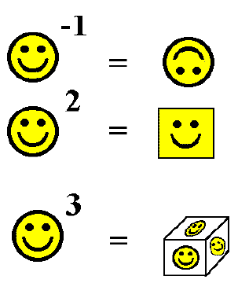

#### www.myecsd.net

stephanie.mackay@ecsd.net

Phone: 780.476.6251

# Term Work

Each chapter is assigned a percentage weight.

Within each chapter:

Exams 70%

Other Assessment

Items 30%

# Course Mark

Term Work 75%

Final Exam 25%

# Course Outline and Tentative Chapter Exam Dates

3. Quadratic Functions (12%) Sept 18

4. Quadratic Equations (13%) Oct 3

5. Radical Expressions Oct 16

and Equations (11%)

6. Rational Expressions Oct 30

and Equations (11%)

7. Absolute Value and Nov 14

Reciprocal Functions (11%)

1. Sequences and Series (12%) Nov 27

2. Trigonometry (13%) Dec 12

8. Systems of Equations (9%) Dec 20

9. Linear and Quadratic Jan 11

Inequalities (8%)

Review Jun 14-18

# Assessment

The Mathematics Department at Archbishop O’Leary uses a continuous evaluation system for measuring each student’s performance. Assessment may vary from student to student to adapt to the differences in needs, learning styles, preferences and paces. Assessment for Learning, Assessment as Learning and Assessment of Learning items will be included in each unit of study.

# Philosophy

Students construct their understanding of mathematics by developing meaning based on a variety of learning experiences. The use of manipulates, visuals and a variety of pedagogical approaches can address the diversity of learning styles and the developmental stages of students. I will provide experiences in the classroom which may increase each student’s chance for success and to allow individual progress to take place. However, I also expect each student to accept responsibility for his/her own learning. This includes completing assigned tasks to the best of their ability, participating in classroom discussions and activities, and conducting themselves in a manner that will enhance the learning process.

Students may experience the greatest degree of success if we work as a team with parents. Please insure that you have access to **Powerschool** and keep up to date with your progress in Math 20-1.

#### Information for Math 20-1