#### www.myecsd.net

Pre-Calculus 11 Text

McGraw Hill Ryerson

A Virtual Classroom for Math 20-1 is set up on the myECSD.net portal. Each student will have a username and password to login to the website. Please visit the site to explore the online resources including

* Calendar of important dates and content covered in each class
* Shared documents and solution keys
* Discussion space for students to collaborate

#### Resources

#### Attendance and Homework

Regular attendance and punctuality are necessary requirements to ensure the educational success of each student.

Students are expected to be present in class for all exams.

A mark of 0% will be assigned for students missing exams with an unexcused absence. Please have parents phone in to verify an excused absence. An alternate exam date may be scheduled for excused absences.

Homework

It is essential that students have completed and corrected all assignments on a daily basis. Answer keys are provided on the virtual classroom.

# Technology

TI-Nspire or TI-Nspire CX calculator is recommended for this course.

Access to the internet at home is beneficial for this course.

# Semester 1

# Sept 2011 – Jan 2012

**Math 20-1**

**Archbishop O’Leary HS**

Mrs. MacKay

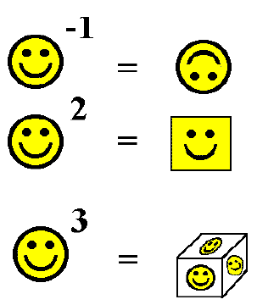

stephanie.mackay@ecsd.net

Phone: 780.476.6251

# Course Mark

Within chapter:

Exams 65%

Other Chapter Assessment

Items 35%

Each chapter 10%

Midterm Exam 5%

Daily Evaluation 5%

Term Work 75%

Final Exam 25%

# Course Outline and Tentative Chapter Exam Dates

1. Sequences and Series Sept 16

2. Trigonometry Sept 29

3. Quadratic Functions Oct 13

4. Quadratic Equations Oct 26

5. Radical Expressions Nov 7

and Equations

6. Rational Expressions Nov 21

and Equations

7. Absolute Value and Dec 2

Reciprocal Functions

8. Systems of Equations Dec 13

9. Linear and Quadratic Dec 23

Inequalities

Review Jan 9 - 18

# Assessment

The Mathematics Department at Archbishop O’Leary uses a continuous evaluation system for measuring each student’s performance. Assessment may vary from student to student to adapt to the differences in needs, learning styles, preferences and paces. Assessment for Learning, Assessment as Learning and Assessment of Learning items will be included in each unit of study.

# Philosophy

Students construct their understanding of mathematics by developing meaning based on a variety of learning experiences. The use of manipulates, visuals and a variety of pedagogical approaches can address the diversity of learning styles and the developmental stages of students. I will provide experiences in the classroom which may increase each student’s chance for success and to allow individual progress to take place. However, I also expect each student to accept responsibility for his/her own learning. This includes completing assigned tasks to the best of their ability, participating in classroom discussions and activities, and conducting themselves in a manner that will enhance the learning process.

Students may experience the greatest degree of success if we work as a team with parents. Please insure that you have access to **Powerschool** and keep up to date with your progress in Math 20-1.

#### Information for Math 20-1