Explore Learning Gizmos for Alberta Teachers

**Alberta Learning has purchased free access to Gizmos for all Alberta teachers and students. You must enter through the Learn Alberta website.**

1. Navigate to http://www.learnalberta.ca

2. When teachers or students are not on a school computer the login credentials must be entered:

• Username: LA12

• Password: 2953



**In the section Find Resources, you can refine you search.**

1. Click “More Search Options” in the *Find Resources* box.

2. Refine your search by selecting the following items in each category: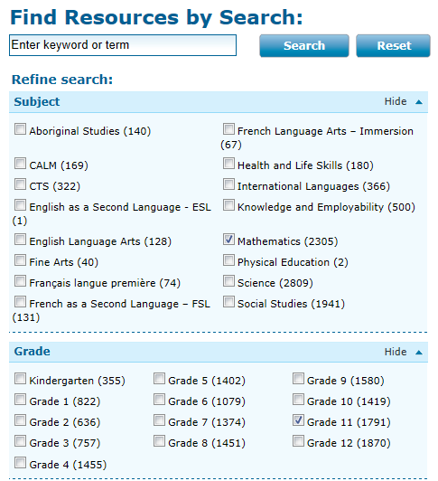

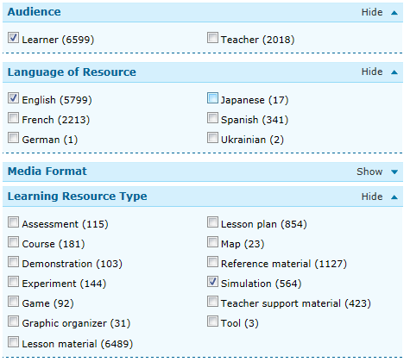

3. Click the “Search” button. The right hand pane will the list of resources generated.

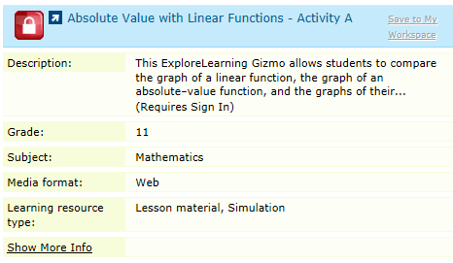

4. Select the Gizmo you would like to use. When the Gizmo appears on your screen, you can now copy the URL address and can add the link directly into your Notebook file, PowerPoint, or Word document.

*** You must be signed in to Learn Alberta to open and use the Gizmo. Once you are signed in you can minimize the browser and access the Explorelearning Gizmo through your Notebook file, PowerPoint, or Word document. ***

Gizmos can also be used to create questions. There is a “copy screen” button in the bottom right corner of the simulation. This copies the information on the simulation and allows you to place it in another file to create questions based on the information provided. Another alternative is to use the Snipping Tool in Windows 7.