**Math 20-1 Trigonometry 2. 1 and 2.2 Worksheet**

1. In which quadrant would the terminal arm of an angle in standard position be in when:

a)  and  b)  and 

1. 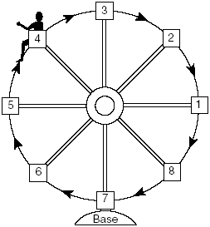Suppose the position of the person on the Ferris wheel could be represented by an angle in standard position. What is the measure of the angle in standard position and the measure of the corresponding reference angle?
2. Plot the following points on a coordinate grid.

R (5, -12) S (-4,- 6)

a) Sketch each angle in standard position so that the terminal arm passes through each point

b) Determine the exact values of the sine, cosine and tangent ratios for each angle formed.

c) Calculate the measure of the angle in standard position.

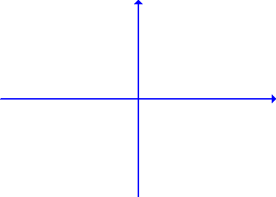 

1. An angle is in standard position with its terminal arm in the stated quadrant. Determine the exact values for the other two primary trigonometric ratios.

sin θ = ; quadrant III

1. Solve sin θ = 0.7760 for 0° ≤ θ < 360°.
2. Fill in the table with the exact ratio values.

|  |  |  |  |
| --- | --- | --- | --- |
| angle | sine ratio | cosine ratio | tangent ration |
| 30° |  |  |  |
| 60° |  |  |  |
| 45° |  |  |  |

1. Calculate the value of each of the following ratios. Give the exact ratio when possible.

a)  b)  c) 

d)  e)  f) 

1. Solve each equation, for 0° ≤ θ < 360°.

a)  b)  c) 

d) sin θ =  e)  f) 

1. Calculate the area of the triangle.

