**Math 20-1 Trigonometry Review**

1. Sketch an angle in standard position with each given measure.

**a)** 24° **b)** 104°

1. State the reference angle for each angle in standard position.

**a)** 55° **b)** 155°

**c)** 255° **d)** 355°

1. Determine the measure of the three other angles in standard position, 0° < θ < 360°, that have a reference angle of

**a)** 40° **b)** 72°

1. Determine if the pair of angles has the same reference angle.

**a)** 50°, 140° **b)** 200°, 290°

1. Use trigonometric ratios to determine the exact value of the length of side DE.

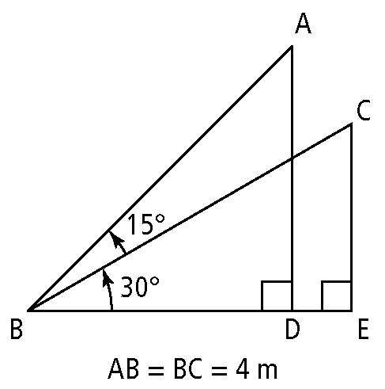

1. Sketch the angles in standard position so that the terminal arm passes through each point. Write the sine, cosine, and tangent ratios for each angle as an exact value.

**a)** (1, 5) **b)** (4, –3)

1. Determine the exact values of the sine, cosine, and tangent ratios for the angle in standard postition.

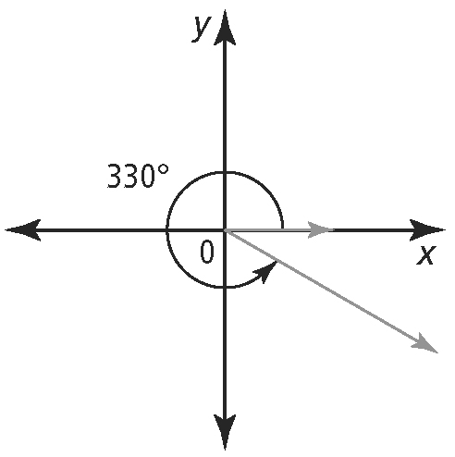

1. Without using a calculator, state whether each ratio is positive or negative. Explain your reasoning.

**a)** sin 100° **b)** cos 200°

**c)** tan 300° **d)** sin 350°

1. An angle is in standard position with its terminal arm in the stated quadrant. Determine the exact values for the other two primary trigonometric ratios for each.

**a)** sin θ = ; quadrant III **b)** tan θ = ; quadrant II

1. Solve each equation for 0° ≤ θ < 360°. Use a diagram involving a special right triangle.

**a)** sin θ =  **b)** tan θ = 

**c)** cos θ = 

1. Solve each equation, for 0° ≤ θ < 360°.

**a)** sin θ = 0.7760 **b)** cos θ = – 0.8090

**c)** tan θ = – 0.9004

1. Sketch each triangle. Then, determine the unknown side and angles. Identify the ambiguous case and determine all solutions.

**a)**In △ABC, AB = 15 m, BC = 5 m, and ∠A = 20°.

**b)**In △PQR, PQ = 12.5 cm, QR = 13.0 cm, and ∠P = 103°.

1. A golf green is 6 m wide. Within what angle must a player hit the ball in order to land on the green from a position about 20 m from the green?

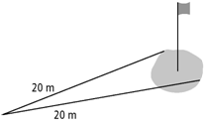

1. Two planes left an airport and are flying in different directions. The angle between their flight path is 47°. One hour later, plane A has travelled 850 km and plane B has travelled 900 km. How far apart are the two planes at this time? Round the distance to the nearest kilometer.

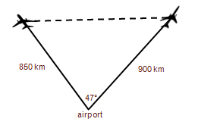

1. Devin wants to approximate the height of the tree outside his house. From the ground, he measures the angle of elevation to the top of the tree to be 65degrees. He paces 3 m farther away from the tree and measures the angle of elevation to be 55 degrees. Determine the height of the tree to the nearest hundredth of a metre.

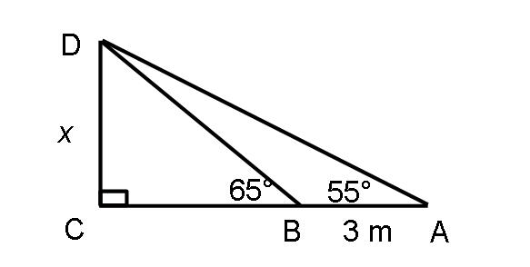

1. Given triangle ABC, ∠A = 30° and *b* = 42 cm. Determine the range of values for the length of side *a* that could create each situation.

a) no triangle b) one right triangle

c) two oblique triangles