**3.1 and 3.2 Quadratic Functions in Vertex Form and in Standard Form**

1. Circle the equations that represent quadratic functions.

  

  

1. Match the quadratic function with its graph.

A.  B.  C.  D. 

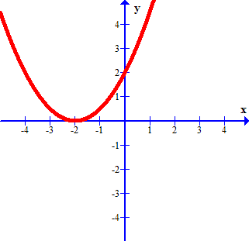______ ______

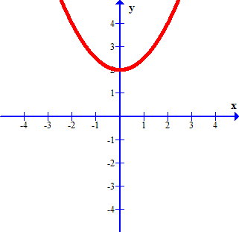

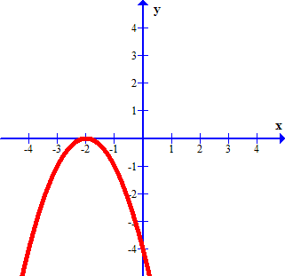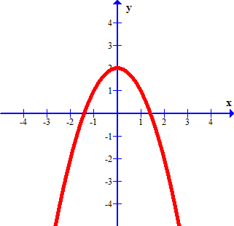______ ______

1. Consider the vertex form of a quadratic function, . Identify the parameter, (*a*, *p* or *q*), that would cause the graph of the function to :

a) shift up b) move to the left

c) open downward d) open upward and shift to the right

1. Write the letters of the quadratic functions in order from widest to narrowest graph.

A.  B.  C. D. 

1. Given the quadratic function, graph the parabola using the vertex, axis of symmetry and two other points on the graph.

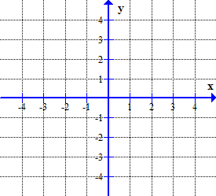

|  |  |  |
| --- | --- | --- |
|  | *x* | *y* |
| Vertex |  |  |
| First point |  |  |
| Second point |  |  |

1. Determine the characteristics of the following quadratic functions: (intercepts rounded to 0.1)

*y* = (*x* – 2)2

Quick sketch with vertex and intercepts labelled.

Vertex: ________________________

Axis of Symmetry: ______________

Domain: ______________________

Range: ________________________

*x*-intercepts: ___________________

*y*-intercept:____________________

Max or Min Value:______________

Direction of opening:____________

*y* = -2(*x* + 7)2 + 9

Quick sketch with vertex and intercepts labelled.

Vertex: ________________________

Axis of Symmetry: ______________

Domain: ______________________

Range: ________________________

*x*-intercepts: ___________________

*y*-intercept:____________________

Max or Min Value:______________

Direction of opening:____________

1. Consider the graph of the quadratic function show to the right.

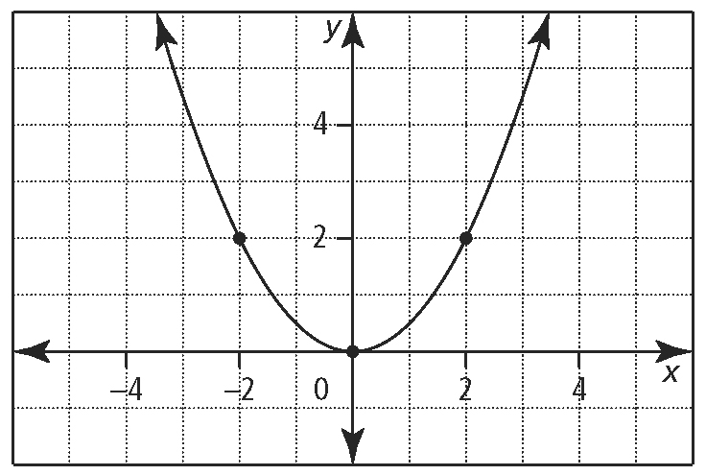**a)** Write the quadratic function equation in vertex form that represents the parabola.

**b)** Suppose the graph of the parabola from part a) opened downward. Write the quadratic function, in vertex form, of the transformed parabola.

**c)** Suppose the graph of the parabola from part a) is moved 6 units to the left. Write the quadratic function, in vertex form, of the transformed parabola.

**d)** Suppose the graph of the parabola from part a) is moved 3 units down. Write the quadratic function, in vertex form, of the transformed parabola.

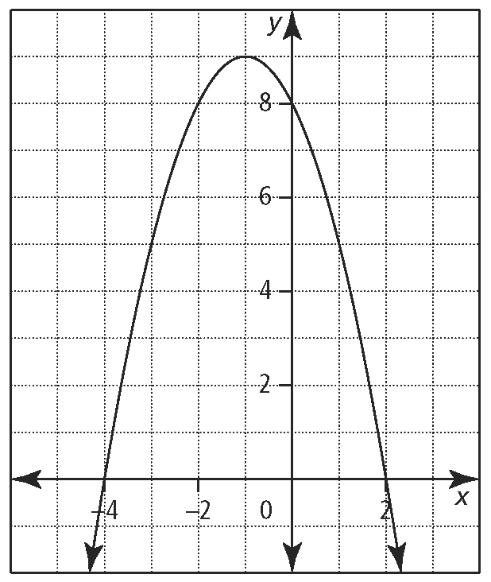



1. Given each quadratic function in vertex form, rewrite the equation in the standard form, 
2.  b) 
3. Determine a quadratic function, in the form, that has the given characteristics.
4. The vertex is at (2, 0) and passes through the point (1, 3)

**b)** The vertex at (4, 1) and has a *y*-intercept of (0, –15)

1. 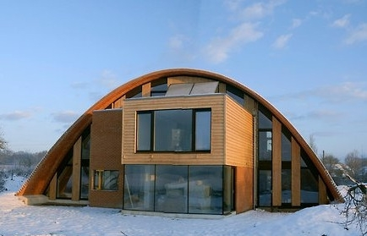The Crossways Eco Arch house is constructed around a unique parabolic arch constructed from handmade clay tiles glued together. The house is 8.5metres high at its maximum peak and spans 20 metres.

a) Write a quadratic function in vertex form that models the shape of the roof of the house.

Crossways Eco Arch House http://www.sphc.co.uk/crossway

b) Determine the height of the arch that is 2.5 meters from its outer edge.

1. A pumpkin is fired from cannon at 105 m/s that is on top of a 100-m cliff. The function that models the height, *h* in metres, of the pumpkin in relation to time, *t* in seconds, is

*h*(*t*) = –5*t*2 + 105*t* + 100.

1. Using technology, graph the function and adjust the window settings so the intercepts and vertex are clearly shown in the calculator window.

Sketch the graph shown on your calculator and indicate the axes max and min values.

Label the axes with the appropriate name for this situation.

1. Determine the *h-*intercept of the function. What does the *h-*intercept represent?
2. What is the maximum height of the pumpkin?
3. At what time does the pumpkin fall to a height of 20m?
4. List the domain of this situation.