**Math 20-1 Chapter 3 Quadratics Math and Music Project**

Sample



Task: Choreograph a quadratic function dance to a song of your choice. Quadratic functions will be graphed on separate graph pages of the TI-Nspire handheld. The dance movement can be simulated by flipping pages on the handheld similar to a **flipbook**.

Part A

Flipbook

* Transformations of the parent function  to  will simulate movement by changing the parameters ***a***, ***p***, or ***q***. When the pages are turned it will appear as if the shape moved.

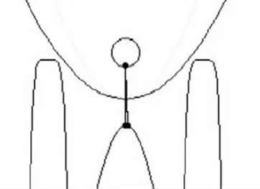 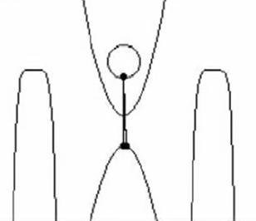 *In this example the* ***a*** *value was altered.*

* Function equations must be expressed in the form .
* Your dance song must last 30 seconds.
* Each member of the group must create a minimum of two pages.
* The quadratic functions graphed must include horizontal and vertical translations of the parent function . Positive and negative ***a*** values must also be included.
* A template for each page must be made that includes a sketch of the graph page with all graphs labeled.
* You may insert images as a background on the graph page.

Part B

* You may choose to do a live presentation of your math and music project or you may record your math dance as a video that will be shown in class. Flex Block time may be used to practice or record the video.

Part C

* Each member of the group must choose two equations used in the math dance and complete the following:

a) List the characters of the quadratic function including vertex, direction of opening, equation of the axis of symmetry, domain and range.

b) Rewrite each equation from vertex form to standard form .

**Sample Math and Music Project with Quadratic and Cubic Functions**

**Math and Music Staying Alive**

**Part A Slides with function equations.**

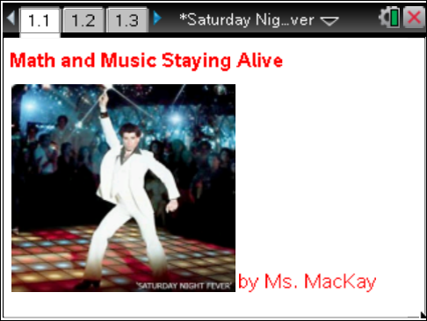 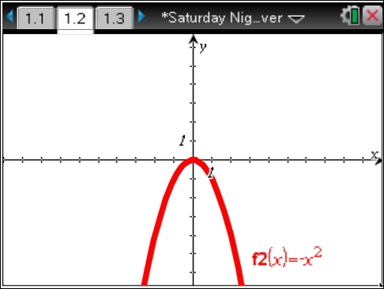 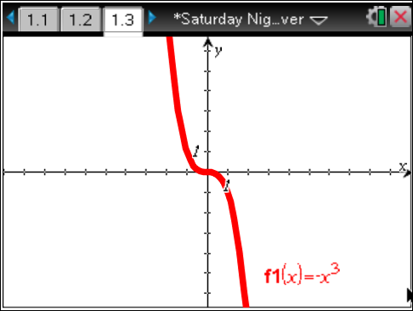 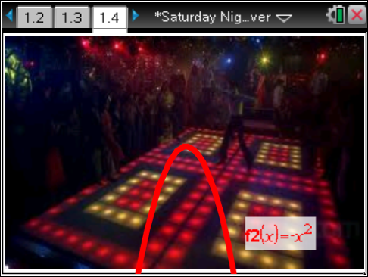 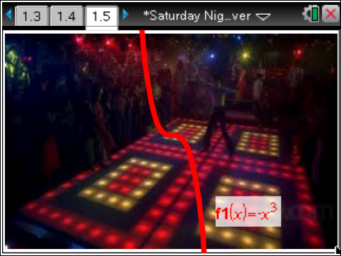

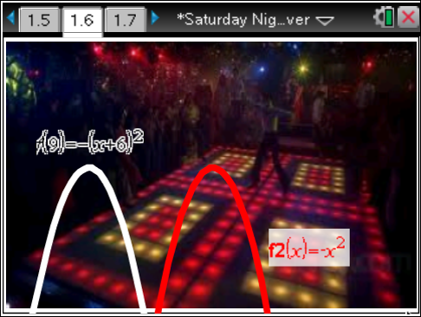 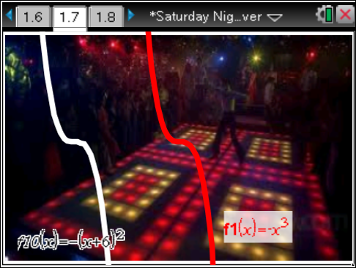

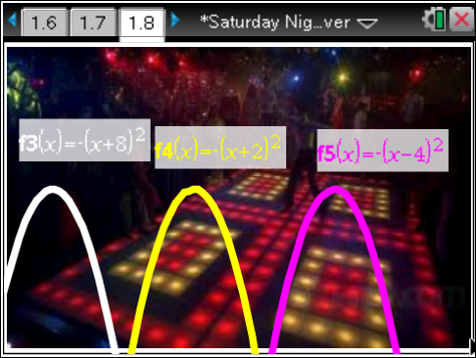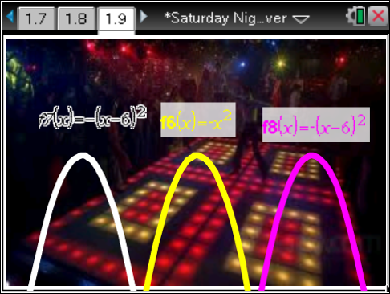

**Music was taken from Staying Alive by the Bee Gees. Toggle between pages of quadratic and cubic graphs to simulate John Travolta’s signature disco dance move.**

**Part B**

**Making the Video or Presenting Live in Class**

**Part C**

 

Vertex (4, 0) Vertex (-8, 0)

Opens downward Opens downward

Axis of Symmetry x – 4 = 0 or x = 4 Axis of Symmetry x + 8 = 0 or x = -8

Domain all real numbers or  Domain all real numbers or 

Range  Range 

 