Quadratic Word Problems Sample Problems
1. Find the dimensions of the rectangle where the length of a rectangle is 6 inches more than its width. The area of the rectangle is 91 square inches.
Step 1 - Draw the picture of the  rectangle | Since the length is 6 more than the width let the  width = x and the length = x + 6  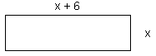
Step 2 - Write the equation using the  formula Area = LW | x(x + 6) = 91
Step 3 - Solve the equation | x² + 6x = 91  x² + 6x - 91 = 0  (x - 7)(x + 13) = 0
 | 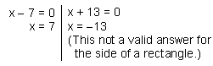
 | The length is 7 and the width is 13

2. Find two consecutive odd integers where their product is 1 less than four times their sum. Two consecutive odd integers could be written as:
Let: n = 1st number
n + 2 = 2nd number
Step 1 - Write the equation
Step 2 - Solve the equation | n² + 2n = 4[2n + 2] - 1  n² + 2n = 8n + 8 - 1  n² + 2n = 8n + 7  n² - 6n - 7= 0  (n - 7)(n + 1) = 0
There are  TWO sets of answers:  7 and 9  - 1 and 1 | 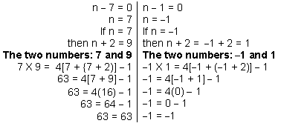

3. The hypotenuse of a right triangle is 6 more than the shorter leg. The longer leg is three more than the shorter leg. Find the length of the shorter leg.
Use the Pythagorean Theorem which states that in a right triangle:
The sum of the squares of the legs is equal to the square of the hypotenuse.
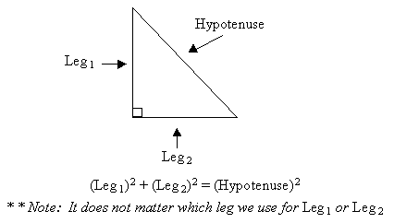
To work out the problem define the sides of the triangle according to the figure below:
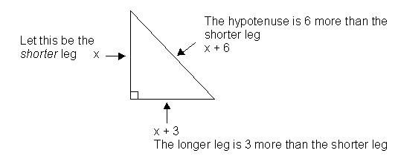
Step 1 - Write the equation | x² + (x + 3)² = (x + 6)²
Step 2 - Solve the equation | By using the SQUARE OF A BINOMIAL FORMULA  x² + x² + 6x + 9 = x² + 12x + 36  2x² + 6x + 9 = x² + 12x + 36  x² - 6x - 27 = 0  (x - 9)(x + 3) = 0
 | 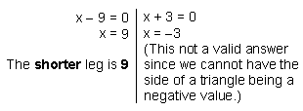

Solve the following WORD PROBLEMS:
1. The length of a rectangle is 2 times its width. The area of the rectangle is 72
square inches. Find the dimensions of the rectangle.
2. The length of a rectangle is 4 times its width. The area of the rectangle is 144
square inches. Find the dimensions of the rectangle.
3. The length of a rectangular garden is 4 yards more than its width. The area of
the garden is 60 square yards. Find the dimensions of the garden.
4. The width of a rectangle is 11 inches less than its length. Find the dimensions
of the rectangle if the area is 80 square inches.
5. The length of a rectangle exceeds its width by 3 inches. The area of the
rectangle is 70 square inches, find its dimensions.
6. The length of a rectangle is 3 centimeters more than the width. The area is 108
square centimeters. Find-the length and width of the rectangle.
7. The width of a rectangle is 5 meters less than its length. The area is 84 square
meters. Find the dimensions of the rectangle.
8. The length of a rectangle is twice the width. The area is 50 square inches.
Find the dimensions of the rectangle.
9. The length of a rectangle is 1 foot more than twice the width. The area is 55
square feet. Find the dimensions of the rectangle.
10. The length of a rectangle is 2 less than three times the width. Find the
dimensions of the rectangle if the area is 65 square meters.
11. The length of a rectangle is 7 meters less than twice the width. Find the
dimensions if the area is 60 square meters.
12. The product of two consecutive integers is 56. Find the integers.
13. The product of two consecutive odd integers is 99. Find the integers.
14. Find two consecutive even integers such that the square of the smaller is 10
more than the larger.
15. The product of two consecutive odd integers is 1 less than twice their sum.
Find the integers.
16. The product of two consecutive integers is three less than three times their sum.
Find the integers.
17. The product of two consecutive even integers is 6 more than three times their
sum. Find the integers.
18. The product of two consecutive odd integers is 77 more than twice the larger.
Find the integers.
19. The product of two consecutive integers is 5 more than three times the larger.
Find the integers.
20. Find three consecutive integers such that four times the sum of all three is 2
times the product of the larger two.
21. Find three consecutive integers such that three times the sum of all three equals
the product of the larger two.
22. The medium side of a right triangle is 7 more than the shortest side. The longest side is 7 less than 3 times the shortest side. Find the length of the shortest side of the triangle.
23. One leg of a right triangle is one inch shorter than the other leg. If the hypotenuse is 5 inches, find the length of the shorter leg.
24. The longer leg of a right triangle is two inches more than twice the length of the shorter leg. The hypotenuse is two inches less than three times the length of the shorter leg. Find the length of the hypotenuse.
25. The longer leg of a right triangle is ten less than three times the shorter leg. The
hypotenuse is 4 more than the shorter leg. Find the length of the shorter leg.
26. The hypotenuse of a right triangle is 3 less than twice the shorter leg. The length
of the other leg is 3 more than the shorter leg. Find the length of the shorter leg.
27. The hypotenuse of a right triangle is 1 centimeter longer than the longer leg. The
shorter leg is 7 centimeters shorter than the longer leg. Find the length of the
longer leg of the triangle.
28. The longer leg of a right triangle is 1 meter longer than the shorter leg. The
hypotenuse is 1 meter shorter than twice the shorter leg. Find the length of the
shorter leg of the triangle.
29. A ladder is resting against a wall. The top of the ladder touches the wall at a
height of 15 feet. Find the distance from the wall to the bottom of the ladder if the
length of the ladder is one foot more than twice its distance from the wall.
30. Two cars leave an intersection. One car travels north; the other travels east.
When the car traveling north had gone 24 miles, the distance between the cars
was four miles more than three times the distance traveled by the car heading
east. Find the distance between the cars at that time.
 | ANSWERS
1. W = 6, L = 12 | 11. W = , L = 8 | 22. 7, 8, 9 & - 1, 0, 1
2. W = 6, L = 24 | 12. 7, 8 & - 8, - 7 | 22. 8
3. W = 6, L = 10 | 13. 9,11 & -11, -9 | 23. 3 inches
4. W = 5, L = 16 | 14. 4 & 6 | 24. 13 inches
5. W = 7, L = 10 | 15. 3, 5 & -1, 1 | 25. 6
6. W = 9, L = 12 | 16. 0, 1 & 5, 6 | 26. 9
7. W = 7, L = 12 | 17. -2, 0 & 6, 8 | 27. 12
8. W = 5, L = 10 | 18. -9, -7 & 9, 11 | 28. 3
9. W = 5, L = 11 | 19. 4, 5 & -2, -1 | 29. 8 feet
10. W = 5, L = 13 | 20. 4, 5, 6 & - 1, 0, 1 | 30. 25 miles

