Vocabulary for the Chapters on Quadratic Functions and Equations

How does it all relate to one another?

Quadratic Function | Quadratic Equation
f(x) = ax² + bx + c  y = ax² + bx + c  y = a(x-p)² + q | ax² + bx + c = 0
f(x) = 2x² + 3x + 5  y = 2x² + 3x + 5  y = 2(x-1)² -4  - Characteristics include vertex, axis of symmetry, zeros, maximum or minimum, domain and range.  - (x, y) represent points on the graph of the function.  - (p, q) represents the vertex  - The graph is in the shape of a parabola  - The zeros of the function are where the height of the graph is 0 or where the y coordinate of an ordered pair on the graph is zero (x, 0)  - The zeros are related to the x-intercepts of the graph (x, 0) | 2x² + 3x + 5 = 0  (x+2)(x-3) = 0  This is an equation.  The roots are considered the solutions to the equation.  Roots can be calculated by:  - determining the x-intercepts of the graph of the corresponding function  - determining the zeros of the related function  - factoring the quadratic equation and applying the zero property  - completing the square to factor the equation then solve for the variable  - using the quadratic formula

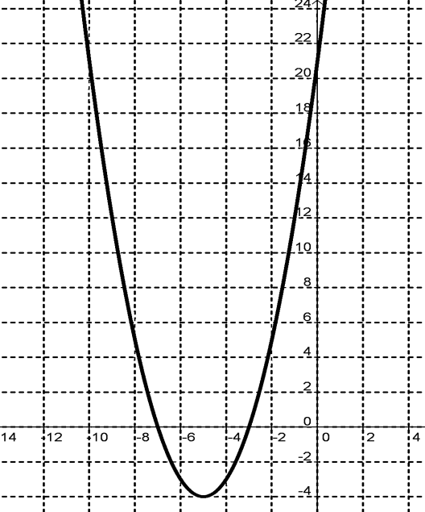
The Graph of a Quadratic Function
x-intercept of the graph of the function(x, 0)
The zero of the function.

x-intercept of the graph of the function (x, 0)
The zero of the function.
y-intercept of the graph
(0, y)
Vertex of the graph of the gunction

