**Group Activity**

1. Students were randomly placed in groups of three.

2. Students began with Part A, Expressing an Absolute Value expression as a piecewise function.

Students were given mini-white boards to do rough work.

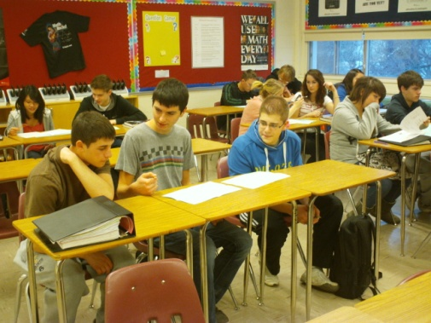 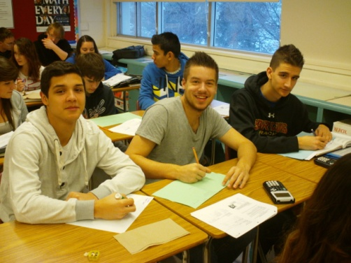 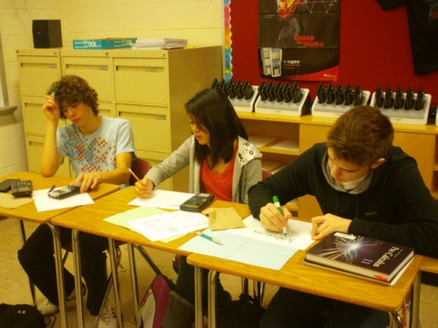

3. Students were encouraged to visit other groups and verify their expressions. Groups that were having difficulty could ask other groups for help on how to get started.

4. Once students had Part A correct, they continued on to Part B, Solving Absolute Value Equations. Once again, if students had difficulty they could visit another group to get help.

|  |  |
| --- | --- |
|  |  |
|  |  |

**Express each as a Piecewise Function**

**Solve the Following Absolute Value Equations. Indicate which equation cannot be solved.**



|  |  |
| --- | --- |
| **Solution** | **Solution** |
| **Verify** | **Verify** |
| **Solution** | **Solution** |
| **Verify** | **Verify** |
| **Cannot be Solved** | **Explanation** |