Math 20-1 Chapter 8 Systems of Equations Review

Key Ideas | Description or Example
Determining the solution of a system of linear- quadratic equations graphically. | Isolate the y variable for each function equation.  Graph the line and the parabola on the same grid.  The solutions are the points of intersection of the graph, (x, y).  The ordered pair satisfies both equations.  Verify your solutions in the original function equations.
There are three possibilities for the number of intersection and the number of solutions of a system of linear-quadratic equations. | 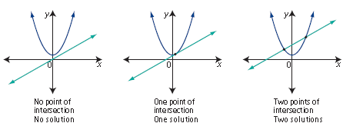
Determining the solution of a system of quadratic-quadratic equations graphically | Isolate the y variable for each function equation.  Graph both parabolas on the same grid.  The solutions of a quadratic-quadratic equation are the points of intersection of the two graphs, (x, y).  Verify the solutions in the original form of the equations.
There are three possibilities for the number of intersections and the number of solutions of a system of quadratic-quadratic equations.  If one quadratic is a multiple of another, there will be an infinite number of solutions. | 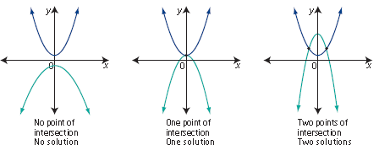
Determining the solution of a system of linear-quadratic equations algebraically.  Two Methods to choose from  Substitution or Elimination | Linear Quadratic Systems  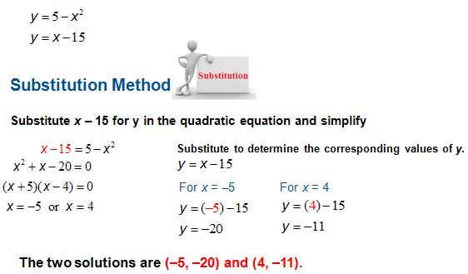  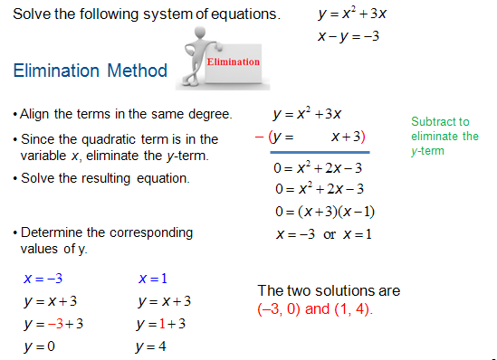
Determine the solution to a system of quadratic-quadratic equations algebraically.  You can use Substitution or Elimination. | 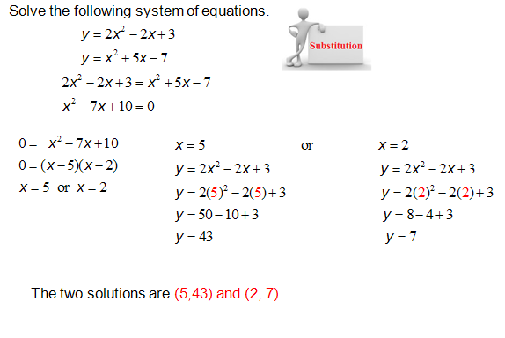  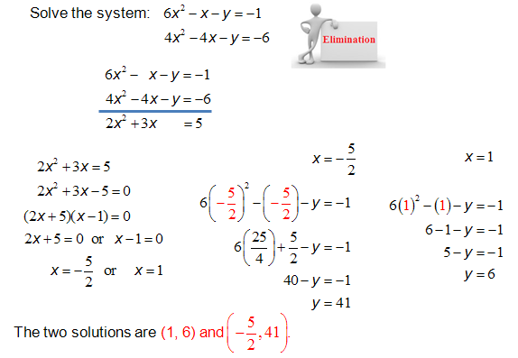

Vocabulary | Definition
System of linear-quadratic equations | A linear equation and a quadratic equation involving the same variables. A graph of the system involves a line and a parabola.
System of quadratic-quadratic equations | Two quadratic equations involving the same variables. The graph involves two parabolas.
Solution | With a system of equations or system of inequalities, the solution set is the set containing value(s) of the variable(s) that satisfy all equations and/or inequalities in the system. All the points of intersection of the two graphs. The ordered pairs (x, y) that the two function equations have in common.
Method of substitution | An algebraic method of solving a system of equations. Solve one equation for one variable. Then, substitute that value into the other equation and solve for the other variable.
Method of elimination | An algebraic method of solving a system of equations. Add or subtract the equations to eliminate one variable and solve for the other variable.

Common Errors | Description
Isolating a variable | Making errors with signs when isolating a variable.
Subtraction | Only subtracting the first term when eliminating and adding the other terms.
Not checking solutions properly. | After obtaining your solutions to a quadratic-quadratic or linear-quadratic equation not substituting your solution for x and y to verify your answer.

