Key Ideas | Description or Example
Solving Linear Inequalities in Two Variables | The solution is a shaded half-plane region with a dashed boundary line if the inequality is < or >. The boundary line is solid if the inequality is < or >.
y is “less than or equal to”  solid boundary line, shade below  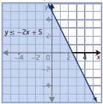 | y is ”greater than”  dashed boundary line, shade above  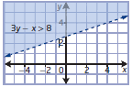
Method One: Isolate the y-variable in the linear inequality and graph with technology. | Method Two: Graph using x- and y-intercepts and use Test point to determine shaded region.  Method Three: Isolate the y-variable and graph using slope and y-intercept, then use test point to determine which side of the boundary line to shade. If the test point makes the inequality “true”, the point lies in the solution region, this side of the boundary should be shaded. If the test point makes the inequality “false” shade the region on the opposite side of the boundary.
Solving Quadratic Inequalities in One Variable | The solution set contains the intervals of x-values where the y-values of the graph are above or below the x-axis (depending on the inequality).
Graphical Method: Graph the related function; determine zeros and intervals of x-values where y-values are above or below x-axis. | Alternate Method: Determine the roots of the related function and use Case analysis or sign analysis with test points.  Determine zeros of the related function  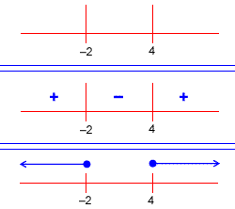  Indicate solution region.  Use test points in each domain region to determine if the function is positive or negative  The solution interval for
The solution interval for is written as | The solution interval for is written as  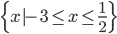
Quadratic Inequalities in Two Variables | The solution is a shaded region with a solid or broken boundary parabolic curve.
y “is greater than”  dashed boundary, shade above  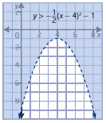 | y is “greater than or equal to”  solid boundary, shade above  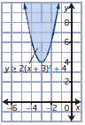
Vocabulary | Definition
Boundary Line | Solid line if inequality symbol is .  Dashed line if inequality symbol is < or >.
Solution Region | All points in the Cartesian plane that makes the inequality true. The Shaded region contains all of the solutions to the inequality.
Case Analysis or Sign Analysis | A number line is divided into intervals depending on the roots of the related equation. Inequality expressions describe each interval. A test point is used to determine if the interval is true or false.

Common Errors | Description
simplifies to | The direction of the inequality must be reversed when divided by a negative number.
Broken or Solid Boundary Line | < or > is shown with a broken line or parabolic curve.  is shown with a solid line or parabolic curve.
Test point is on the Boundary Line | The test point (0, 0) may be used for most inequalities. Do not use the point (0, 0) when the boundary line or parabolic curve goes through the origin.

