**Math 20-1 Chapter 9 Inequalities Review**

1. Graph each inequality. Use a test point to determine the solution region.

**a)** 3*x*  *y*  4 **b)** 4*x*  5*y*  20

Isolate y ______________ Isolate y ________________

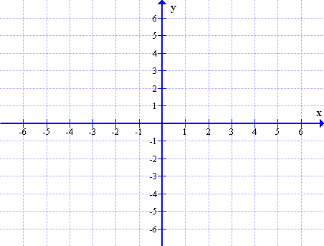



Test Point Calculations: Test Point Calculations:

2. Determine the solution interval for each quadratic inequality.

* Use Case analysis or sign analysis to determine the solution interval.
* Graph the solution interval on the number line.

a)  b) 





3. Which ordered pairs are solutions to the given inequality?

**a)** *y*  *x*2  4*x*  3

**A.** (2, 1) **B.** (0, 0) **C.** (3, 2) **D.** (1, 1)

**b)** *y*  (3*x*  1)(*x*  2)

**A.** (2, 0) **B.** (1, 3) **C.** (5, 10) **D.** (0, 5)

4. Consider the quadratic function *f* (*x*)  *x*2  6*x*.

a) Solve the inequality for *f* (*x*)  0 b) Solve the inequality for *f* (*x*)  5

5. Graph each quadratic inequality and shade the solution region.

a)  b) 



c) 



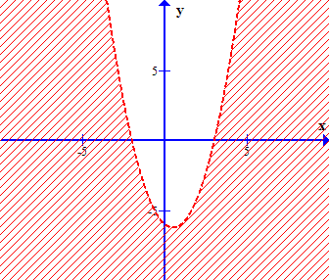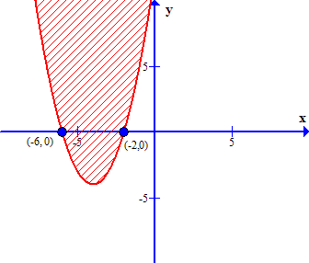6. Write an inequality to describe each graph. 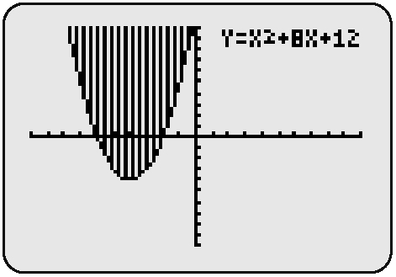 Boundary line 

7. Ben is buying snacks for his friends. He has $10.00. The choices are apples for $0.80 and muffins for $1.25.

1. Write an inequality in two variables to model this situation. Define your variables.
2. State the restrictions on the variables.
3. Graph the inequality.

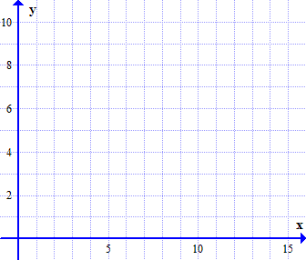

**d)** Explain in words why is (5, 4.8) not a solution for this situation.

8. A women’s clothing store makes an average profit of $125 on each dress sold and $50 on each blouse. The manager’s revenue target is to make at least $500 a day on sales from dresses and blouses.

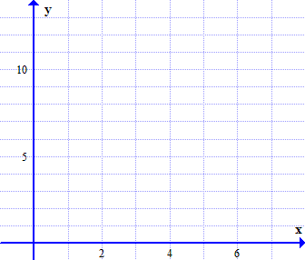**a)** Write an inequality using two variable to represent the numbers of dresses and blouses that can be sold each day to reach the target.

**b)** Graph the inequality.

**c)** If equal numbers of dresses and blouses are sold, what is the minimum number needed to reach the target?

9. Gwen wants to buy some used CDs that cost $10 each and some used DVDs that cost $13. She has $40 to spend.

**a)** Write an inequality to represent the situation, where *c* is the number of CDs she buys and *d* is the number of DVDs.

**b)** Graph the inequality.

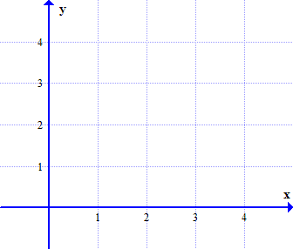

**c)** Can she buy two CDs and three DVDs? Explain.