1. Does the given value of *x* make the inequality a true or a false statement?

**a)**  *x* = 2

**b)** 3*x*  1  *x*  4, *x*  2

1. Sketch the graph of each linear inequality. Use a test point to determine shading.

a)  b) 

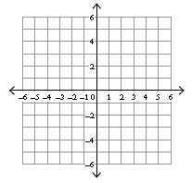 

c)  d) 

 

e)  f) 

 

1. Write the inequality for each graph.

a) b)

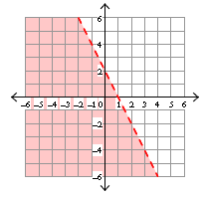 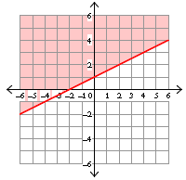

**Quadratic Inequalities Activity**

**Example: Graph the quadratic inequality.**

**Step 1:** Graph the boundary function.

|  |  |
| --- | --- |
| Vertex | (0, 0) |
| Direction of Opening | up |
| Critical Point | (1, 1) |
| Critical Point | (-1, 1) |

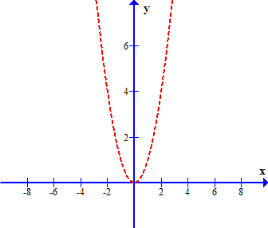The boundary function must be dashed since the inequality is only greater than.

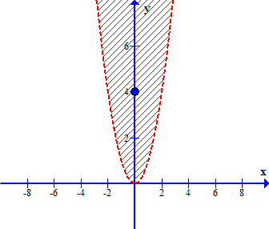**Step 2:** Use a test point to determine shading.

(Don’t choose (0, 0) since it is a point on the curve.)

Test Point (0, 4)



This is a true statement.

Shade the side of the boundary that contains the test point.

**Example: Graph the quadratic inequality.**

**Step 1:** Graph the boundary function.

|  |  |
| --- | --- |
| Vertex | (0, 0) |
| Direction of Opening | up |
| Critical Point | (1, 1) |
| Critical Point | (-1, 1) |

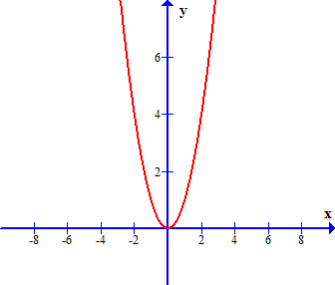The boundary function must be solid since the inequality is equal to or less than.

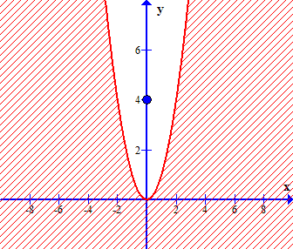**Step 2:** Use a test point to determine shading.

(Don’t choose (0, 0) since it is a point on the curve.)

Test Point (0, 4)



This is a false statement.

Shade the side of the boundary that does not contain the test point.

1. Sketch the graph of each quadratic inequality. Use a test point to determine shading.

a)  b) 

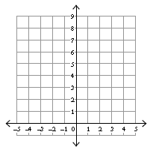 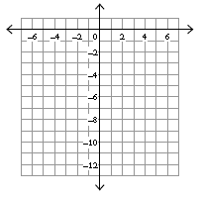

c)  d) 

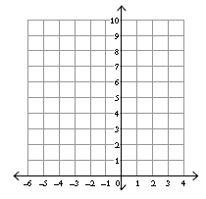 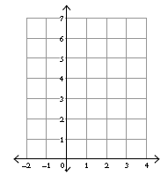

1. Write an inequality for each graph given the equation for the boundary function. (Change the = sign to >, < >, or < to write the inequality. You may want to use a test point to decide which side to shade.

a)  b) 

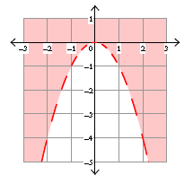 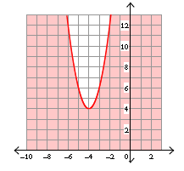

**Practicing Foundation Math Skills**

1. Solve each quadratic equation by factoring.

**a)** *x*2  9  0

**b)** *x*2  6*x*  7  0

**c)** 2*x*2  13*x*  15  0

**d)** 3*x*2  5*x*  2

1. Use the quadratic formula to determine the roots of *y*  2*x*2  3*x*  1.