Unit 2:Time Allotted: 1 week
Properties of Angles and Triangles

Assessment Standards
Geometry
General Outcome: Develop spatial sense

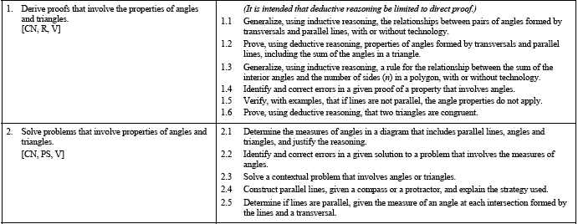

What do the Student know from Math 10-C?
Nothing

What do Student know from Math 20-1?
Nothing

What is Coming in Math 30-2
Nothing

