**Math 20 Foundations**

**C:\Documents and Settings\Eastlyn\Local Settings\Temporary Internet Files\Content.IE5\JK8BUQAJ\MC900233966[1].wmfC:\Documents and Settings\Eastlyn\Local Settings\Temporary Internet Files\Content.IE5\IV18QUKH\MC900290652[1].wmfChapter 2: Properties of Angles and Triangles**

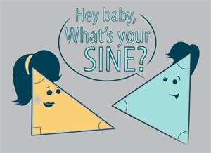

**Chapter 2: Properties of Angles and Triangles**

**Outcome FM20.4:**

**Demonstrate understanding of properties of angles and triangles including:**

* **deriving proofs based on theorems and postulates about congruent triangles**
* **solving problems.**

**Indicators:**

1. Identify and describe situations relevant to self, family, or community that involve parallel lines cut by transversals.
   * 2.1
2. Develop, generalize, explain, apply, and prove relationships between pairs of angles formed by transversals and parallel lines, with and without the use of technology.
   * 2.1, 2.2
3. Prove and apply the relationship relating the sum of the angles in a triangle.
   * 2.3
4. Generalize, using inductive reasoning, a rule for the relationship between the sum of the interior angles and the number of sides (n) in a polygon, with or without technology.
   * 2.4
5. Apply knowledge of angles formed by parallel lines and transversals to identify and correct errors in a given proof.
   * 2.3
6. Explore and verify whether or not the angles formed by non-parallel lines and transversals create the same angle relationships as those created by parallel lines and transversals.
   * 2.1
7. Solve situational problems that involve:
   * angles, parallel lines, and transversals
   * angles, non-parallel lines, and transversals
   * angles in triangles
   * angles in polygons.
     + Throughout all of unit 2.
8. Develop, generalize, explain, and apply strategies for constructing parallel lines.
   * 2.2 investigation

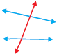**Chapter 2 Definitions**

**___________________:** A line that intersects two or more other lines at distinct points.

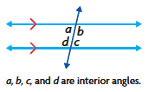

**___________________:** Any angles formed by a transversal and two parallel lines that lie inside the parallel lines.

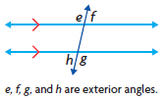

**___________________:** Any angles formed by a transversal and two parallel

lines that lie outside the parallel lines.

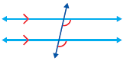

**___________________:** One interior angle and one exterior angle that are

non-adjacent and on the same side of a transversal

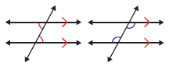**___________________:** A statement that is formed by switching the premise and the conclusion of another statement.

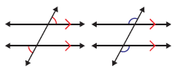**______________________________:** Two non-adjacent interior angles on opposite sides of a transversal.

**_____________________________:** Two exterior angles formed between two lines and a transversal, on opposite sides of the transversal.

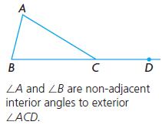**_____________________________:** The two angles of a triangle that do not have the same vertex as an exterior angle.

**__________________________**: A polygon in which each interior angle

measures less than 180°.

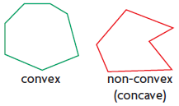

**2.1: Exploring parallel lines**

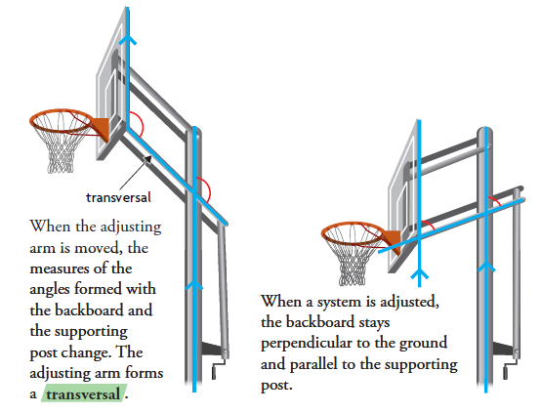

**Using a protractor, measure the angles created in the diagrams above. Make a conjecture about the angles:**

**What are some other real world examples of parallel lines cut by a transversal?**



**When a transversal intersects two parallel lines, how are the angle measures related?**

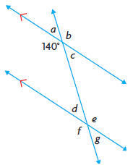Use the conjecture you developed to predict the measures of as many of the angles *a* to *g* in this diagram as you can.

**Predictions**

∠a=

∠b=

∠c=

∠d=

∠e=

∠f=

∠g=

**Actual Measurements**

∠a=

∠b=

∠c=

∠d=

∠e=

∠f=

∠g=

**Do your conjectures about angle measures hold when a transversal intersects a pair of non-parallel lines?**

**Do your conjectures about angle measures hold when a transversal intersects a pair of non-parallel lines? Use diagrams to justify your decision.**

**Key Ideas:**

* **Angle Rules:** When two parallel lines are cut by a transversal the following angle rules apply.
* 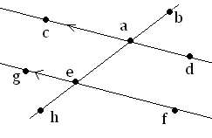Alternate interior angles are congruent
* Corresponding angles are congruent
* Vertical angles are congruent
* When a transversal intersects a pair of non-parallel lines, the corresponding angles are **_______** equal.
* Remember that two angles that lie on a straight line are **___________________** (add to 180o)

**2.1 Assignment:** Nelson Foundations of Mathematics 11, Sec 2.1, pg. 72 (Questions: 2, 5, 6)

**Section 2.2: Angles forms by parallel lines**

**How can you use a straight edge and a compass to draw parallel lines?**

**A. Draw the first line. Place a point, labeled *P*, above the line. *P* will be a point in a parallel line.**

**B. Draw a line through *P*, intersecting the first line at *Q*.**

**C. Using a compass, construct an arc that is centred at *Q* and passes through both lines. Label the intersection points *R* and *S*.**

**D. Draw another arc, centred at *P*, with the same radius as arc *RS*. Label the intersection point *T*.**

**E. Draw a third arc, with centre *T* and radius *RS* that intersects the arc you drew in step D. Label the point of intersection *W*.**

**F. Draw the line that passes through *P* and *W*. Show that *PW* *QS*.**

**G. How is related to ?**

**H. Are there any other pairs of equal angles in your construction? Explain.**

**Example 1** **– Make a conjecture that involves the interior angles on the same side of the transversal. Prove your conjecture.**

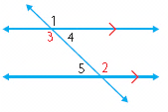**Conjecture:** Interior angles on the same side of the transversal are…

* We will try to prove that ∠3 and ∠5 are **___________________**

|  |  |
| --- | --- |
| **Statement** | **Reason** |
|  |  |
|  |  |
|  |  |
|  |  |
|  |  |

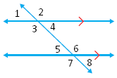**Example 2- Make a conjecture that involves the exterior angles formed by parallel lines and a transversal. Prove your conjecture.**

**Conjecture:** Alternate exterior angles are…

* We will need to prove that ∠1 and ∠8 are **________________**.

|  |  |
| --- | --- |
| **Statement** | **Reason** |
|  |  |
|  |  |
|  |  |

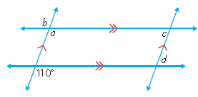**Example 3** **– Determine the measures of *a*, *b*, *c* and *d*.**

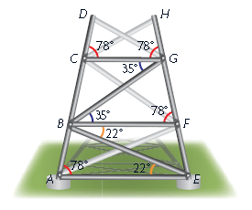**Example 4** – **One side of a cellphone tower will be built as shown. Use the angle measures to prove that braces *CG*, *BF* and *AF* are parallel.**

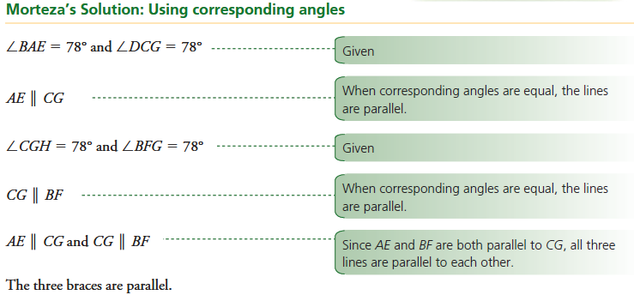

**Key ideas:**

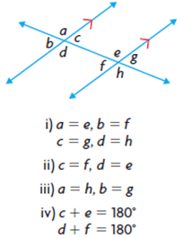When a transversal intersects two parallel lines,

i) the **___________________** angles are equal.

ii) the **___________________**angles are equal.

iii) the **___________________**angles are equal.

iv) the **___________________**on the same side of the transversal are supplementary.

• If a transversal intersects two lines such that

i) the corresponding angles are equal, or

ii) the alternate interior angles are equal, or

iii) the alternate exterior angles are equal, or

iv) the interior angles on the same side of the transversal are supplementary, then the lines are **___________________**.

**2.2 Assignment:** Nelson Foundations of Mathematics 11, Sec 2.2, pg. 78-82

Questions: 2, 3, 4, 8ab, 12, 15

**2.3: Angle Properties in Triangles**

**Can you prove that the sum of the measures of the interior angles of any triangle is 180o?**

**A. Draw an acute triangle, *RED*. Construct line *PQ* through vertex *D*, parallel to *RE*.**

**B. Identify pairs of equal angles in your diagram. Explain how you know that the measures of the angles in each pair are equal.**



**C. What is the sum of the measures of *PDR*, *RDE*, and *QDE*? Explain how you know.**



**D. Explain why . (prove)**

|  |  |
| --- | --- |
| **Statement** | **Reason** |
|  |  |
|  |  |
|  |  |
|  |  |

**E. Repeat parts A to D, first for an obtuse triangle and then for a right triangle. Are your results the same as they were for the acute triangle?**

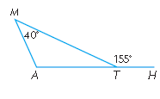**Example 1 – In the diagram, *MTH* is an exterior angle of *MAT*. Determine the measures of the unknown angles in *MAT*.**

* 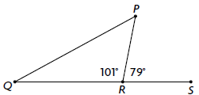If you are given one interior angle and one exterior angle of a triangle, can you always determine the other interior angles of the triangle? Explain, using diagrams.

**Example 2 – Determine the relationship between an exterior angle of a triangle and its non-adjacent interior angles.**

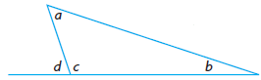

So an exterior angle is equal to the **_________** of the two non-adjacent interior angles of a triangle.

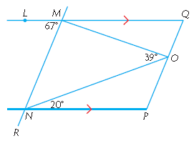**Example 3** –

**(a) Determine the measures of *NMO*, *MNO*, *QMO*.**

**(b) If *QPMR*, determine the measures of *MQO*, *MOQ*, *NOP*, *OPN*, and *RNP.***

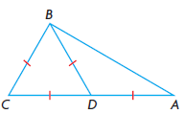**Example 4: Prove: ∠*A* = 30°v**

∆BCD is an **___________________** triangle which means all 3 **______________** are the same and all 3 **_____________** are the same. If all of the angles need to add to **______** and all of the angles are the same, the angles must each equal **_________**

∆ADB is an **___________________** triangle. This means that ____ sides are equal (**_______________**) and _____ angles are equal (**___________________**).

This means the other two angles in ∆ADB need to add to ______ (because all three need to add to 180o and one of the angles is known to be 120o). We also know that the two angles we have left need to have the same measure (since this is an isosceles triangle).

Therefore: ∠A = 30o

**Key Ideas:**

* You can prove properties of angles in triangles using other properties that have already been proven.
* In any triangle, the sum of the measures of the interior angles is proven to be 180o.
* The measure of any exterior angle of a triangle is proven to be equal to the sum of the measures of the two non-adjacent interior angles.

**2.3 Assignment:** Nelson Foundations of Mathematics 11, Sec 2.3, pg. 90-93

Questions: 2, 3, 6, 7, 9, 12a, 14

**2.4: Angle Properties in Polygons**

**How is the number of sides in a polygon related to the sum of its interior angles and the sum of its exterior angles?**

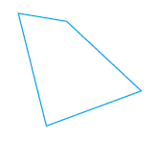PART 1 – INTERIOR ANGLES

**A. Use the fact that the sum of the measures of the interior angles in a triangle is 180o to determine the sum of the measures of the interior angles of any quadrilateral.**

* One diagonal separates the quadrilateral into ______ triangles. The angles of the triangles form the angles of the quadrilateral. Since there are two triangles and the sum of the angles in a triangle is ________ this means the sum of the measures of the angles in the quadrilateral is _________. **OR**
* Draw diagonals and notice that they cut the quadrilateral into ________ triangles. The sum of the measures of the angles in the four triangles is ________ or ________. But one angle in each triangle occurs where the two diagonals intersect (not part of the interior angles of the quadrilateral). The sum of the measures of these angles in the center is ________. This means we must subtracted ________ from ________, giving the correct sum of the measures of the angles in the quadrilateral.

**B. Draw the polygons listed in the table below. Create triangles to help you determine the sum of the measures of their interior angles. Record your results in the table.**

|  |  |  |  |
| --- | --- | --- | --- |
| **Polygon** | **Number of Sides** | **Number of Triangles** | **Sum of Angle Measures** |
| Triangle | 3 | 1 |  |
| Quadrilateral | 4 |  |  |
| Pentagon | 5 |  |  |
| Hexagon | 6 |  |  |
| Heptagon | 7 |  |  |
| Octagon | 8 |  |  |

**C. Make a conjecture about the relationship between the sum of the measures of the interior angles of a polygon, *S*, and the number of sides of the polygon, *n*.**

The number of triangles in a polygon is ________ less than the number of sides. To determine the sum of the measures of the angles in any polygon, subtract ________ from the number of sides and then multiply by ________.

**Our Conjecture:**

The sum of the measures of the interior angles in a polygon, *S*(*n*), is:

We can also think of it like our second explanation in A where we drew the diagonals and then multiplied 180o by the number of triangles formed and subtracted 360o from that (to account for the angles in the center).

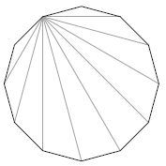**D. Use your conjecture to predict the sum of the measures of the interior angles of a dodecagon (12 sides).**

I predict that the sum of the measures of the angles in a dodecagon is

Look at the diagram to the right. All of the diagonals are drawn from one of the vertices. There are ________ triangles in the diagram, so the sum of the measures of the angles in a dodecagon is ______________or ________.

**PART 2 – EXTERIOR ANGLES**

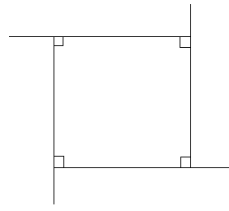**E. Draw a rectangle. Extend each side of the rectangle so that the rectangle has one exterior angle for each interior angle. Determine the sum of the measure of the exterior angles.**

**F. What do you notice about the sum of the measures of each exterior angle of your rectangle? Would this relationship also hold for the exterior and interior angles of the irregular quadrilateral shown? Explain.**

**G. Make a conjecture about the sum of the measures of the exterior angles of any quadrilateral. Test your conjecture.**

**Conjecture**: The sum of the measure of the exterior angles of any quadrilateral is ________.

* 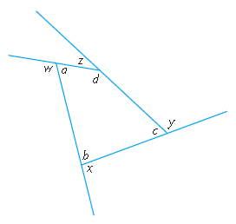To test our conjecture, we will write each exterior angle as the ________________ of its adjacent interior angle a, b, c and d.

**H. Draw a pentagon. Extend each side of the pentagon so that the pentagon has one exterior angle for each interior angle. Based on your diagram, revise your conjecture to include pentagons. Test your revised conjecture.**

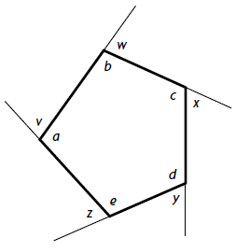**Revised conjecture**: The sum of the measures of the exterior angles of a pentagon…

Write exterior angle as the ________________ of its adjacent interior angle.

**I. Do you think your revised conjecture will hold for polygons that have more than five sides? Explain.**

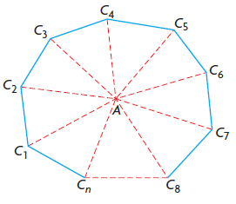**Example 1 – Prove that the sum of the measures of the interior angles of any *n*-sided convex polygon can be expressed as 180o(*n* – 2).**

Start by drawing an n sided figure: The figure to the right is an n sided figure. The nth side is represented by a dashed line to show that more sides can be ________________ or ________________.

There are n triangles in an n sided polygon.

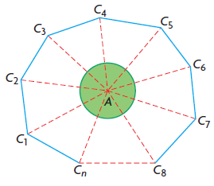Each triangle has a sum of angles equal to ________. We need to subtract the angles in the ________________ of the polygon from the sum of the angles in the triangles, since these angles are not part of the interior angles in the polygon. As you can see in the diagram below, the sum of all of the angles in the center of the polygon is ________. This means we need to subtract ________ from the ________ of all of the triangles.

**Example 2** **– Outdoor furniture and structures like gazebos sometimes use a regular hexagon in their building plan. Determine the measure of each interior angle of a regular hexagon.**

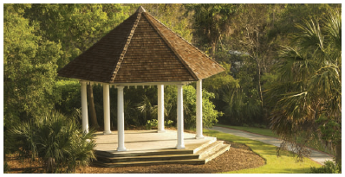

Let *S*(*n*) represent the sum of the measures of the interior angles of the polygon, where *n* is the number of sides of the polygon.

**Key Ideas**

* You can prove properties of angles in polygons using other angle properties that have already been proved.
* The sum of the measures of the interior angles of a convex polygon with *n* sides can be expressed as ________________
* The measure of each interior angle of a regular polygon is ________________
* The sum of the measures of the exterior angles of any convex polygon is ________.

**2.4 Assignment:** Nelson Foundations of Mathematics 11, Sec 2.4, pg. 99-103

Questions: 1, 3, 8, 10, 11, 16, 18

**Sec 2.1 Assignment**

**2.** Which pairs of angles are equal in this diagram? Is there a relationship between the measures of the pairs of angles that are not equal?

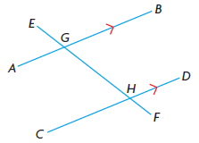

**5.** In each diagram, is *AB* parallel to *CD*? Explain how you know.

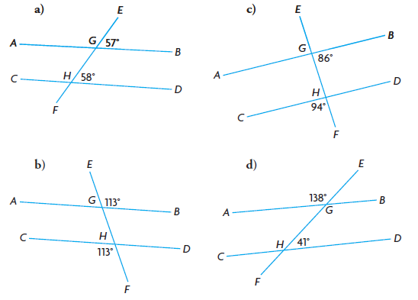

**6.** Nancy claims that the diagonal lines in the diagram below are not parallel. Do you agree or disagree? Justify your decision.

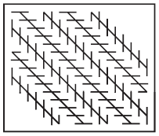

**2.2 Assignment Questions**

**2.** For each diagram, decide if the given angle measures prove that the blue lines are parallel. Justify your decisions.

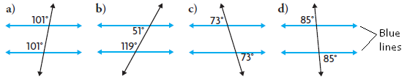

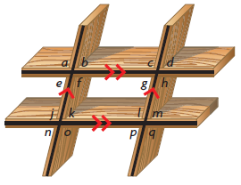

**3.** A shelving unit is built with two pairs of parallel planks. Explain why each of the following statements is true.

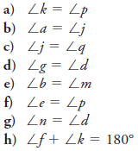

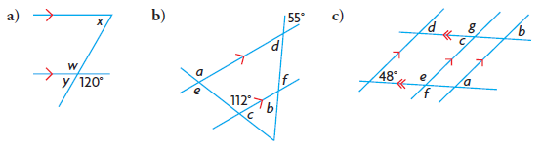**4.** Determine the measures of the indicated angles.

**8. a)** Joshua made the following conjecture: “If *AB* ⊥ *BC* and *BC* ⊥ *CD*, then *AB* ⊥ *CD*.” Identify the error in his reasoning.

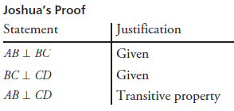

**b)** Make a correct conjecture about perpendicular lines.

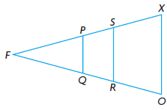

**12.** Given: ∆FOX is isosceles

∠FOX = ∠FRS

∠FXO = ∠FPQ

Prove: PQ || SR and SR|| XO

**15.** Determine the measures of all the unknown angles in this diagram, given *PQ* || *RS*.

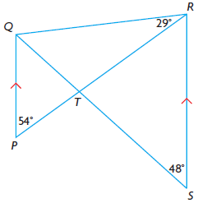

**2.3 Assignment Questions**

**2.** Marcel says that it is possible to draw a triangle with two right angles. Do you agree? Explain why or why not.

**3.** Determine the following unknown angles.

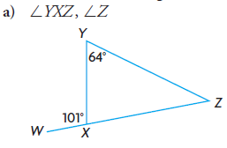 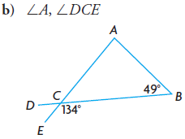

**6.** Determine the measures of the exterior angles of an equilateral triangle.

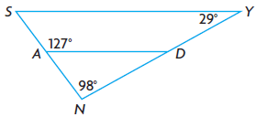**7.** Prove: *SY* || *AD*

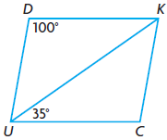**9.** *DUCK* is a parallelogram. Benji determined the measures of the unknown angles in *DUCK*. Paula says he has made an error.

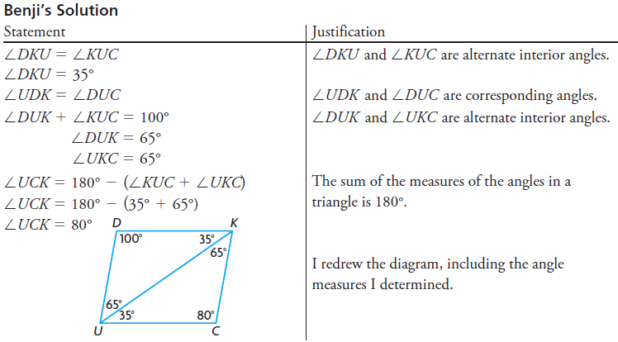

**a)** Explain how you know that Benji made an error.

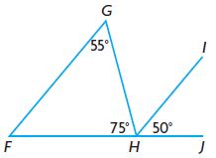**b)** Correct Benji’s solution.

**12. a)** Tim claims that *FG* is not parallel to *HI* because ∠*FGH* ≠ ∠*IHJ*. Do you agree or disagree? Justify your decision.

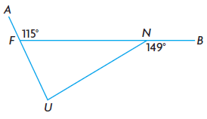

**14.** Determine the measures of the interior angles of ∆*FUN*.

**Section 2.4 Assignment**

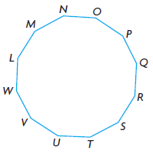

**1. a)** Determine the sum of the measures of the interior angles of a regular dodecagon.

**b)** Determine the measure of each interior angle of a regular dodecagon.

**3.** The sum of the measures of the interior angles of an unknown polygon is 3060°. Determine the number of sides that the polygon has.

**8. a)** Determine the measure of each exterior angle of a regular octagon.

**b)** Use your answer for part a) to determine the measure of each interior angle of a regular octagon.

**c)** Use your answer for part b) to determine the sum of the interior angles of a regular octagon.

**d)** Use the function *S*(*n)* = 180° (*n –* 2) to determine the sum of the interior angles of a regular octagon. Compare your answer with the sum you determined in part c).

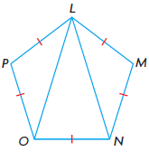**10.** *LMNOP* is a regular pentagon.

**a)** Determine the measure of ∠*OLN*.

**b)** What kind of triangle is ∆*LON* ? Explain how you know.

**11.** Sandy designed this logo for the jerseys worn by her softball team. She told the graphic artist that each interior angle of the regular decagon should measure 162°, based on this calculation:

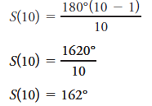

Identify the error she made and determine the correct angle.

**16.** In each figure, the congruent sides form a regular polygon. Determine the values of *a*, *b*, *c*, and *d*.

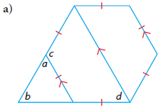 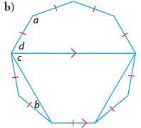

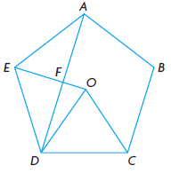

**18.** Given: *ABCDE* is a regular pentagon

with centre *O*.

∆*EOD* is isosceles,

with *EO =* *DO*.

*DO* = *CO*

Prove: ∆*EFD* is a right triangle.

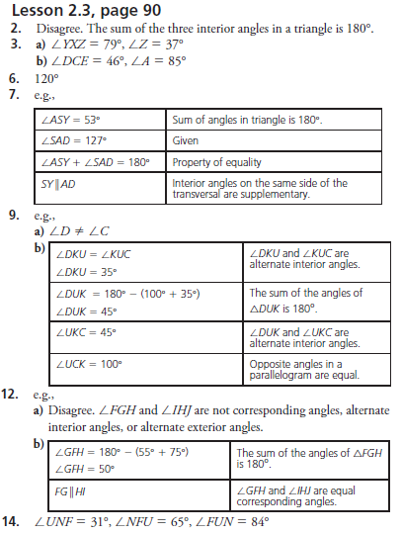

**Chapter 2 Assignment Answer Key**

