In a previous math course, you learned the primary trigonometric ratios and
Pythagorean Theorem.

You may remember these ratios with the acronym SOH CAH TOA. The SOH CAH TOA
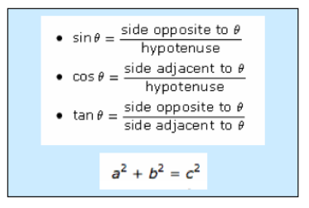
http://www.learnalberta.ca/content/t4tes/courses/senior/math20-2/mm/m1/m20_2_m1_001/m20_2_m1_001.html

Review Question 1
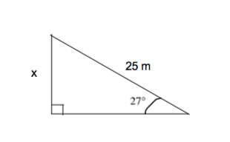

Review Question 2
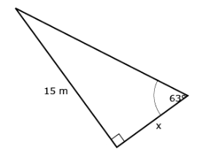

Review Question 3
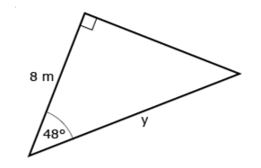

Review Question 4
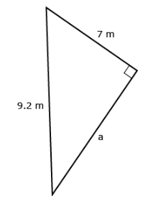

Review Question 5
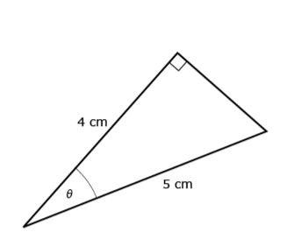

In previous math courses, the emphasis in trigonometry was single triangle problems. In Mathematics 20-2 you will be solving a variety of problems involving more than one triangle. In this section you will examine problems that involve more than one triangle and the strategies for solving for sides and angles.

Eamon was asked to determine the length of side w in the following diagram.

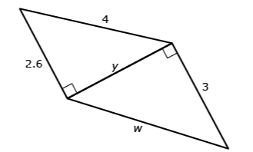

Nasreen was asked to determine the length of side p in the following diagram.
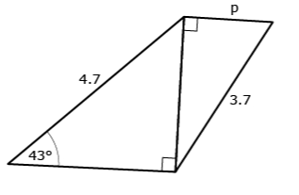

Problems Involving More Than One Triangle

Problems involving more than one triangle that share sides are very common. Using
shared sides in triangles is, in fact, the core of triangulation used in map-making. If
there is not enough information in a triangle to solve it, then a second triangle that
shares one side is often used. Consider the following example.

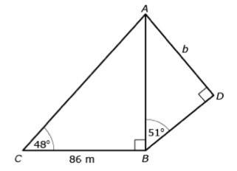

Example:

Complete “Practising” question 5 on page 161 of your textbook.

Example:

Complete “Practising” question 10 on page 168 of your textbook.

