Math 20-2: U3L1 and U3L2 Teacher Notes
Proving and Applying the Sine Law

Key Math Learnings:
By the end of this lesson, you will learn the following concepts:

- I can draw a diagram that represents a problem that involves using the sine
law.
- I can explain the steps in a given proof of the sine law.
- I can use the sine law to determine unknown side lengths or angle
measures in an acute triangle.

Oblique Triangles
An oblique triangle is a triangle that __________ have a ________ angle in it.

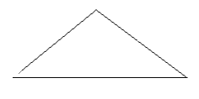

Oblique Triangles are labelled differently:

Instead of labelling the sides as opposite, adjacent and hypotenuse, we label them as lower case letters.
- Lower case "a" will be the side opposite angle ____.

- Lower case ____ will be the side opposite angle ____.

- Lower case _____ will be the side opposite angle ____.

http://www.learnalberta.ca/content/t4tes/courses/senior/math20-2/mm/m1/m20_2_m1_011/m20_2_m1_011.html

Sine Law

For any oblique triangle ABC (a triangle with no right angle), the Sine Law states:

Generally, the sine law is used when you are given:

1) the two angles (therefore three angles) and one side (AAS) or
2) two sides and one angle opposite a given side (SSA)

This mathematical expression could be written in words as:

“The length of a side …

http://www.learnalberta.ca/content/t4tes/courses/senior/math20-2/mm/m1/m20_2_m1_010/m20_2_m1_010.html

Proofing the Sine Law

http://www.youtube.com/watch?v=APNkWrD-U1k

Example:

In , Δ ABC , c = 6 units and a = 12 units. Find the measure of angle C.

Solution:

Example
In, ΔPQR , <P = <R = and side q = 21.3 cm. Solve for side "r" to the nearest tenth.

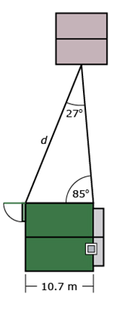
Example:

Khadija is building a walkway from her back door to a shed at the back of her yard. She needs to provide the length to a contractor in order to get a phone estimate for the cost. She knows her house is 10.7 m wide and has measured two angles as shown in the following diagram.

Example:
Complete “Check Your Understanding” question 2.a. on page 138 of your textbook.

Example:
Complete “Practising” questions 3.c. on page 139 of your textbook.

Example
Jeremy is learning how to use a compass in an orienteering
course. The instructions he was given tell him that he must
walk 70 m from Checkpoint A to Checkpoint B. He knows that
Checkpoint A is directly north of him and Checkpoint B is in a
direction of N41°E. He also knows that Checkpoint B is 105 m
from Checkpoint C. He begins by drawing a diagram to
represent his situation.

Jeremy needs to determine the direction to walk when going
from Checkpoint A to Checkpoint B.

From the diagram he drew, he knows that once he
determines angle _ he will be able to state the direction as S_°E. Jeremy looks at the given information and recognizes that
he can use the sine law to determine this angle. His solution
can be seen in the animation Jeremy’s Solution: Example 2.

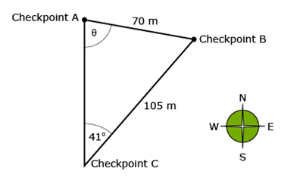

http://www.learnalberta.ca/content/t4tes/courses/senior/math20-2/mm/m1/m20_2_m1_012/m20_2_m1_012.html
Example:
Complete “Check Your Understanding” question 2.b. on page 138 of your textbook.

Example:
Complete “Practising” question 7 on pages 139 and 140 of your textbook. (Note: You are asked to solve a triangle. This means that you must give the measures of all three sides and all three angles.)

