Math 20-2: U3L4 Teacher Notes
Solving Problems Using Acute Triangles

Key Math Learnings:
By the end of this lesson, you will learn the following concepts:

- Draw a diagram to represent a problem that involves the cosine and sine law.
- Solve a contextual problem that requires the use of the sine or cosine law.
- Solve a contextual problem that involves more than one triangle.

Sometimes it’s hard to choose which trigonometric formula to use. In the following activity you will consider what to look for when you need to choose a formula. These are the questions
you should ask yourself using the following example.

Example:
Solve for x.
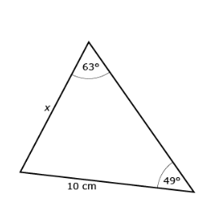

Ask yourself the following questions.

Example:
Solve for y.
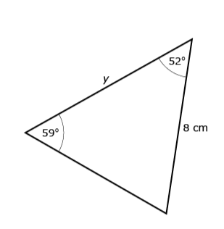

Example:
Solve for x.
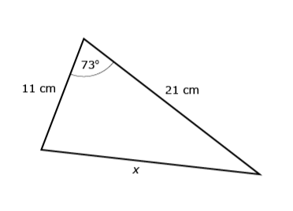

Example:
Solve for y.
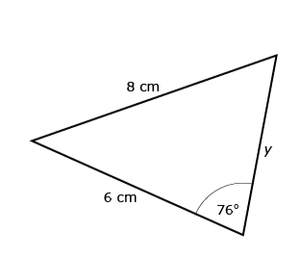

Example:
Katrina has been asked to solve for angle in the following
triangle. She says you can use either the sine law or the
cosine law. Decide whether she is correct. Explain your
answer.

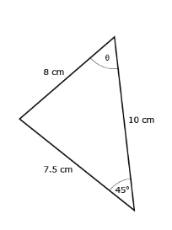

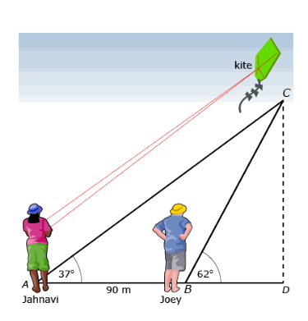
Example

Joey is flying a kite and wants to determine its height. He enlists the help of his friend, Jahnavi, who is standing 90 m away. Joey uses a clinometer and determines that the angle of elevation to the kite is 62°. Jahnavi determines that the angle of elevation is 37°. To keep calculations simple for this question, ignore Joey’s height and assume
that the kite string touches the ground.

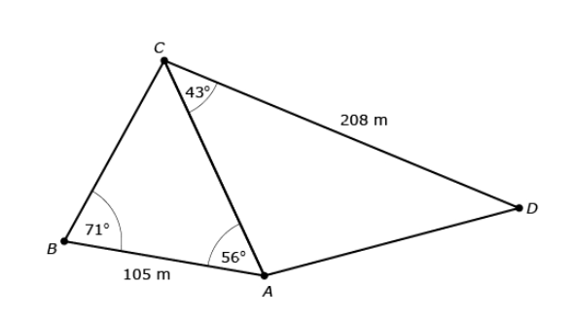
Example
Jeremy is on the third day of his orienteering course and has been asked to determine the distance from point A to point D. He knows some distances and angles as shown in the following diagram.

Example:
Complete “Practising” question 9 on page 162 of your textbook.

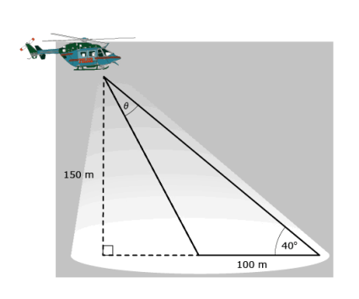
Example:
A police helicopter uses a spotlight to look for suspicious activity at night. One particular night, the helicopter is flying 150 m above the ground and the diameter of the illuminated area is 100 m. Adrian is standing on the ground at the far end of the illuminated area and determines that the angle of elevation to the helicopter is 40°. Adrian has been asked to determine the angular width of the spotlight, marked by _ on the following diagram.

