Unit 4: Radicals

Math 20-2 Assessment Standards
Number and Logic
Specific Outcome 3. Solve problems that involve operations on radicals and radical expressions with numerical and variable radicands (limited to square roots). [CN, ME, PS, R]
3.1 Compare and order radical expressions with numerical radicands.
3.2 Express an entire radical with a numerical radicand as a mixed radical.
3.3 Express a mixed radical with a numerical radicand as an entire radical.
3.4 Perform one or more operations to simplify radical expressions with numerical or variable radicands.
3.5 Rationalize the monomial denominator of a radical expression. 3.6 Identify values of the variable for which the radical expression is defined.

Specific Outcome 4. Solve problems that involve radical equations (limited to square roots or cube roots). [C, PS, R]
(It is intended that the equations have only one radical.)
4.1 Determine any restrictions on values for the variable in a radical equation.
4.2 Determine, algebraically, the roots of a radical equation, and explain the process used to solve the equation.
4.3 Verify, by substitution, that the values determined in solving a radical equation are roots of the equation.
4.4 Explain why some roots determined in solving a radical equation are extraneous. 4.5 Solve problems by modelling a situation with a radical equation and solving the equation.

What do the Student know from Math 10-C?
Math Common students have a unit on exponents and radicals.

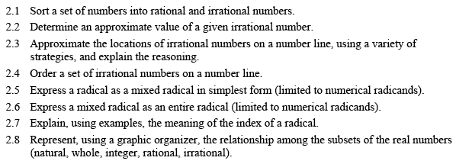
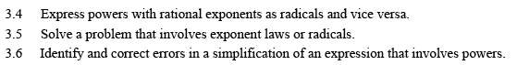

What do Student know from Math 20-1?
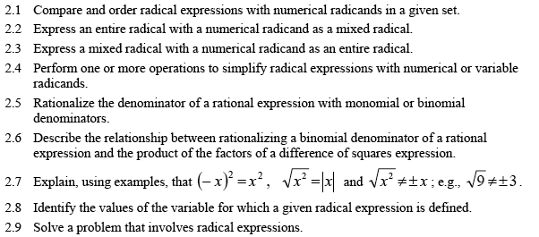
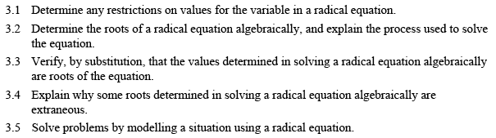

What is Coming in Math 30-2
There is a huge unit on exponents and logarithmic functions and equations.

