**Math 10C**

Name:__________________

**Unit 3 – Factors and Products**

|  |  |
| --- | --- |
| **Outcome** |  |
| **SO 4** | Demonstrate an understanding of the multiplication of polynomial expressions (limited to monomials, binomials and trinomials), concretely, pictorially and symbolically. [CN, R, V] |
| **SO 5** | Demonstrate an understanding of common factors and trinomial factoring, concretely, pictorially and symbolically. [C,CN, R, V] |

**Vocabulary** (define the following)

|  |
| --- |
| * Algebra tiles |
| * Monomial |
| * Binomial |
| * Trinomial |
| * Numerical Coefficient |
| * Constant |
| * Distributive property |
| * Expand |
| * Variable |
| * Polynomial |
| * Common Factor |
| * Factor |
| * Evaluate |

**Description: C:\Users\fowlerk1\AppData\Local\Microsoft\Windows\Temporary Internet Files\Content.IE5\UX6G105B\MC900440428[2].wmfWS #1: Polynomial Review**

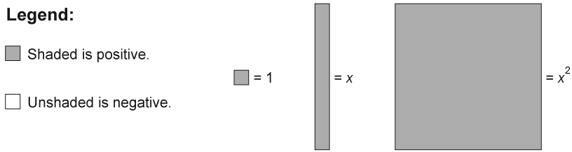

1. Complete the following table. Identify the coefficients, variables, and exponents of the variables in each term of the polynomial expressions. Name any constants, if applicable. Then, determine the type of polynomial. The first row has been completed as an example for you.

|  |  |  |  |  |  |
| --- | --- | --- | --- | --- | --- |
| Expression | Coefficient(s) | Variable(s) | Exponents of the Variable(s) | Constant | Type of Polynomial |
| 4*x*2 + 6*x* + 1 | 4 and 6 | *x* and *y* | 2 and 1 | 1 | trinomial |
| -7*xy* + 5 |  |  |  |  |  |
| 2*m*2 - 3*n*2 |  |  | 2 and 2 |  |  |
|  | -1 | *x* | 2 |  | monomial |

1. Use algebra tiles to model each polynomial. Sketch the algebra tiles.
   1. 2*x* - 3
   2. - 6*x* + 5
   3. -4

1. Identify the degree of each term and each polynomial.
   1. 2*x*2 + *x* - 3
   2. 7*xy*
   3. *m* + 8
   4. 3*x*2 - *xy* - 2

1. Write a polynomial with the given number of terms and degrees.
   1. two terms with a degree of 1
   2. one term with a degree of 0
   3. three terms with a degree of 2
2. Add or subtract the following terms.
3. 
4. 
5. 
6. Determine each product.
7. 
8. 
9. 
10. What is the distributive property?
11. Use the distributive property to expand each expression.
12. 
13. 
14. (-8*n*)(2*n* - 5)
15. 2x(3*x*2 +2*x* - 5)
16. (-2*x*)(3*x* - 8*y*)

WS # 2: Multiplying Binomials

**1.**

1. Complete the multiplication chart.  
   **Description: C:\Users\fowlerk1\AppData\Local\Microsoft\Windows\Temporary Internet Files\Content.IE5\UX6G105B\MC900440428[2].wmf**

|  |  |  |
| --- | --- | --- |
|  | 5*x* | 2 |
| 3*x* |  |  |
| –5 |  |  |

1. What polynomials are being multiplied in this chart?
2. Where are the like terms in the chart?
3. What is the product in simplified form?

1. Substitute *x* = 2 into the expressions for the original polynomials. Then evaluate the product.

1. Substitute *x* = 2 into the expression for the product of the polynomials. Then evaluate.

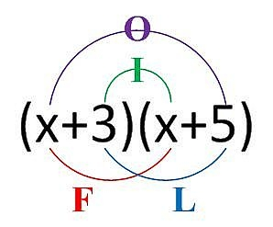

**2. Find Each Product, using the foil method**

**a.** (x + 1)(x + 1)

**b.** (x + 1)(x + 2) **c.** (5x + 2)(x - 3)

**d.** (x + 3)(x + 2) **e.** (x - 4)(x - 3)

**f.** (y + 6)(3y + 5) **g.** (2x + 1)(3x + 2)

**3. Find Each Product, using a table.**

**a.** (x + 5)(3x - 1) **b.** (2x - 1)(x - 3)

**c.** (x + y)(x + y) **d.** (3x + y)(x + y)

**e.** (2x + y)(2x – y) **f.** (3x - y)(x + 2y)

**4. Find the area of each shape.**

**a.** **b.**

x + 3 x + 6

x + 3

x + 3

**c.** **d.**

2x + 7

x - 2 x + 2

4x - 2

5. Binomial multiplication is useful in the design and construction industries, to name a couple. You can use binomials to determine the dimensions of a French door with a glass interior. The height to width ratio of the glass interior is 3 : 1. The frame adds 14 in to the height and 10 in to the width, as shown in the following illustration.

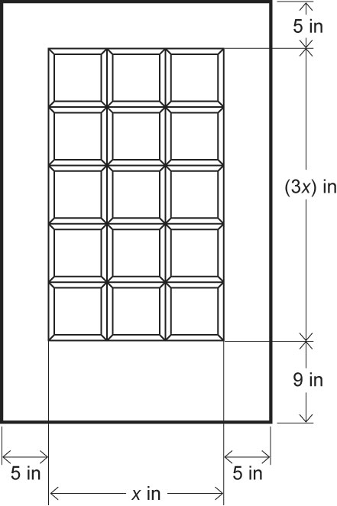

1. Write an expression for the height of the door.
2. Write an expression for the width of the door.
3. Write an expression for the total area of the door including glass interior and frame.
4. Evaluate the area of the door when *x* = 20 in.

6. If the height the door must be equal to 80 in (a standard height for residential interior doors), then determine the following:

**a.** The value of *x*

**b.** The total area of the door

**Description: C:\Users\fowlerk1\AppData\Local\Microsoft\Windows\Temporary Internet Files\Content.IE5\UX6G105B\MC900440428[2].wmfWS #3: Multiplying Two Polynomials**

**1. a.** Complete the multiplication array.

|  |  |  |  |
| --- | --- | --- | --- |
|  | *x*2 | –2*x* | +3 |
| *x* |  |  |  |
| 1 |  |  |  |

**b.** What polynomials are being multiplied in this chart?

**c.** Where are the like terms in this chart?

**d.** What is the product in simplified form?

**e.** Choose any real value of *x*. Substitute this value into the expressions for the original polynomials. Then evaluate the product.

2. Expand and simplify using your method of choice.

a)  b) 

c)  d) 

e)  f) 

g)  h) 

i)  j) 

**Description: C:\Users\fowlerk1\AppData\Local\Microsoft\Windows\Temporary Internet Files\Content.IE5\UX6G105B\MC900440428[2].wmfWS # 4: Factoring Trinomials of the Form *x2* + *bx* + *c***

1. **Factor each of the following**
2. 
3. 
4. 
5. 
6. 
7. 
8. 
9. 
10. 
11. 
12. 
13. 

**Description: C:\Users\fowlerk1\AppData\Local\Microsoft\Windows\Temporary Internet Files\Content.IE5\UX6G105B\MC900440428[2].wmf**

**WS#5: Factoring Trinomials of the Form *ax*2 + *bx* + *c***

**Factor the following:**

a.  b. 

c.  d. 

e.  f. 

g.  h. 

j.  k. 

l.  m. 

n.  o. 

**Description: C:\Users\fowlerk1\AppData\Local\Microsoft\Windows\Temporary Internet Files\Content.IE5\UX6G105B\MC900440428[2].wmfWS #6: Four-Term Polynomial**

Factor by Grouping

a.  b. 

c.  d. 

e.  f. 

g.  h. 

i.  j. 

**Special Polynomials**

k.  l. 

m.  n. 

o.  p. 

q.  r. 

s.  t. 

**Description: C:\Users\fowlerk1\AppData\Local\Microsoft\Windows\Temporary Internet Files\Content.IE5\UX6G105B\MC900440428[2].wmf**

**WS # 7: Review**

*I can demonstrate an understanding of the multiplication of polynomial expressions (limited to monomials, binomials and trinomials), concretely, pictorially and symbolically.*

1. Determine the equation demonstrated by the following sets of algebra tiles. I have only used *x* and ones. White is negative. Grey is positive.

2. Draw algebra tiles to demonstrate the following expressions and solve.

 

3. Simplify the following expressions.

a)  b) 

c)  d) 

e)  f) 

g) 

h) 

*Demonstrate an understanding of common factors and trinomial factoring, concretely, pictorially and symbolically.*

4. Factor by finding the Greatest Common Factor

**a)  b) **

**c)  d) **

5. Factor by grouping

**a) b)**

**c)  d)**

6. Factor using difference of squares.

a)  b) 

c)  d) 

7. Factor the following trinomials.

a) *m*2 – 15*m* + 50 b) 2*r*2 – 20*r* + 18

c) *a*2 – 11*a* + 30 d) 49 – 14*x* + *x*2

e) 2*x*2 + 7*x* + 6 f) 3*t*2 + 8*t* + 5

8. Factor completely.

**a)  b) **

**c)  d) **

**e)  f) **

**g)  h)** 5*m*2 – 40*m* + 35

i) 26*x*2*y*7 – 13*x*3*y*4 j) 4*x*2 + 28*x* + 48

l) 3*y*2 – 27 m) *b*4 + 19*b*2 – 20

n) 11*x*2 + 66 o) 6*y*2 + 1*y* + 3

p) *x*2*y* – 2*x*2- 2*xy* + 4*x* q) *x*2 - 2*x* – 8

r) *x*2 – 6*x* + 72 s) *m*2- 28*m* – 60

t) 5*r*2 –11*r* + 2