**Math 10C**

Name:__________________

**Unit 2 —Trigonometry**

|  |  |
| --- | --- |
| **Outcome** | **Definition** |
| **SO4** | Develop and apply the primary trigonometric ratios (sine, cosine, tangent) to solve problems that involve right triangles.[C, CN, PS, R, T, V] |

**Vocabulary**

|  |
| --- |
| * adjacent side |
| * cosine ratio |
| * hypotenuse |
| * opposite side |
| * proportional |
| * Pythagorean theorem |
| * reference angle |
| * right triangle |
| * sine ratio |
| * solving a triangle |
| * tangent ratio |
| * angle of depression |
| * angle of elevation |
| * clinometer |
| * congruent triangles |
| * similar triangles |

# Trigonometry: Are You Ready?

1. What is a right triangle?

2. In any triangle, what is the sum of the measures of the three angles?

3. Calculate the missing angle in the triangle below.  
  
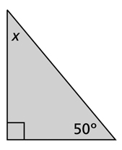

4. State the Pythagorean Theorem, and explain when you would use it.

5. In the following triangle, we know the lengths of two sides. Use the Pythagorean Theorem to calculate the length of the unknown side.

**a.**  **b.**  **c.**

6cm *c* *m* 5 cm 2 m 5m

*y*

3 cm 12 cm

8cm

**d.**   **e.**  **f.**

x25m10m x *g*

k

24 m x 20cm

5 cm

**6.** A suitcase measures 24 inches long and 18 inches high. What is the diagonal length of the suitcase?

7. A ladder is leaning against the side of a 10m house. If the base of the ladder is 3m away from the house, how tall is the ladder? **Please draw a diagram and show all work**.

8. A TV antenna is 16 metres high. A supporting wire is connected to the top from 6 metres away from the base. This is shown in the diagram. What is the length of wire helping to hold up the TV antenna?

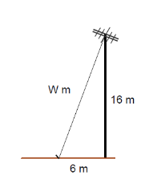

9. Work out the length of the bracket for this shelf. It is the length marked ‘b’.

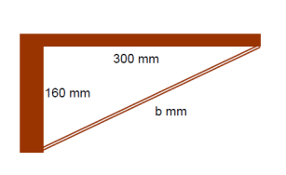

10. What is the length of the truss on this building? It is the side marked ‘t’.

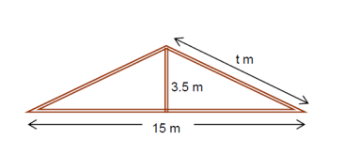

WS #1: Introduction to Trigonometry C:\Users\fowlerk1\AppData\Local\Microsoft\Windows\Temporary Internet Files\Content.IE5\UX6G105B\MC900440428[2].wmf

For each of the following triangles, determine each ratio then calculate each, accurate to four decimal places.

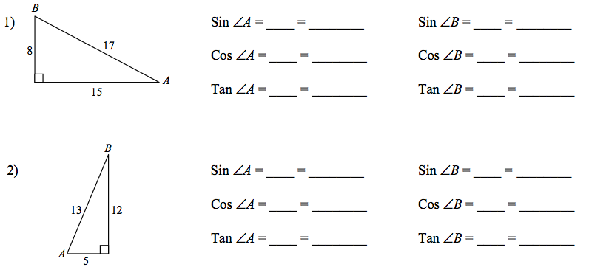

3. Find the measure of each side indicated. Round to the nearest tenth.

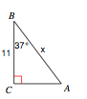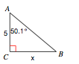

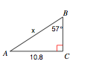

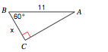

4. Find the indicated angles in each of the triangles below. Round your final answers to the nearest hundredth.

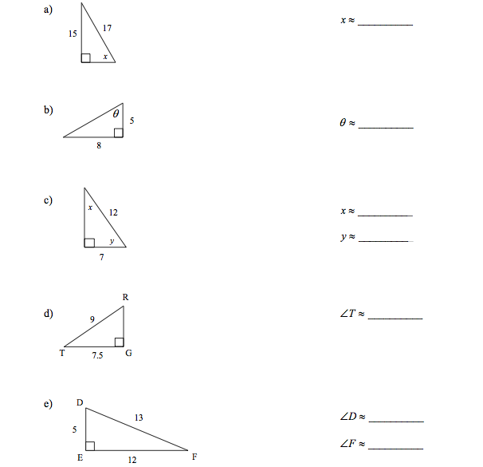

5. There are two problems shown below. For each problem, the answer provided is incorrect.

|  |  |
| --- | --- |
| **Identify the Error** | **Correctly Solve** |
| Solve for the missing side labelled x. | Solve for the missing side labelled x. |
| Solve for the missing side x.        x = 37.74 | Solve for the missing side x. |

6. Find ALL the missing side and angle measures of the triangles below. Round your answers to the nearest hundredth.

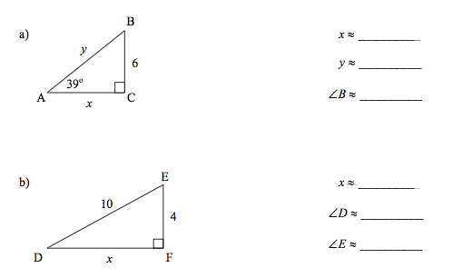

C:\Users\fowlerk1\AppData\Local\Microsoft\Windows\Temporary Internet Files\Content.IE5\UX6G105B\MC900440428[2].wmf

**WS#2: Applications of Trigonometry**

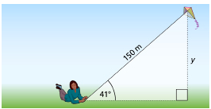

1. A kite has a string 150-m long. If the string makes an angle of 41° with the ground, find the height of the kite above the ground.

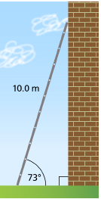

2. A 10.0-m ladder leans against a vertical wall. The angle between the ladder and the ground is 73°. Find the distance from the foot of the ladder to the wall.

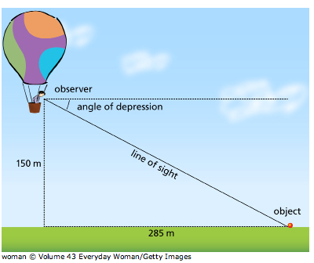3. A person in a hot air balloon is 150 m above the ground. An object is 285 m away from the balloon on a line directly beneath the balloon. What is the angle of depression of the person’s line of sight to the object on the ground rounded to the nearest degree?

4. A helicopter pilot, 500 m above a rescue ship, spots an overturned ship. If the angle of declination is 40° to the horizon, how far away is the wreck from the rescue ship?

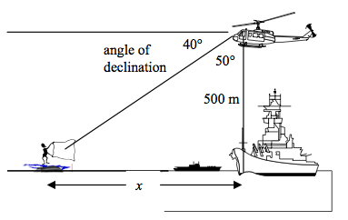

5. From a height of 50 m in a tower, a ranger noticed smoke coming from a position due west of his location. The angle of depression was 8°. A fire truck was due east of him at an angle of depression of 4°. How far is the fire truck from the fire?

