**Math 10C**

**Final Review**

☺

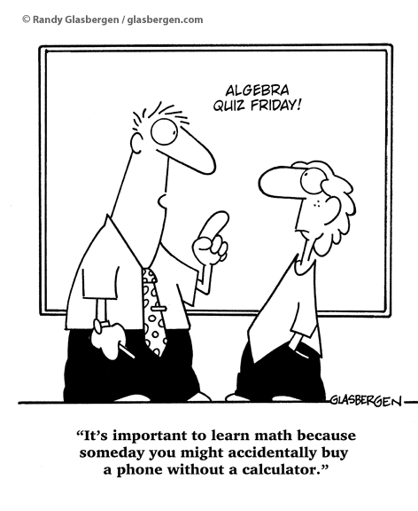

**Unit 1: Number**

**Prime Number:** a whole number with exactly two factors (ex: 3, 7, 19)

**Composite Number:** a whole number with more than two factors (ex: 25, 78, 100)

**Prime Factors:** factors of a number which are prime

**Prime Factorization:** expressing a number as the product of prime factors

Ex: Division Table Tree Diagram

**Greatest Common Factor (GCF):** largest whole number which divides exactly into each of the members of the set

**Lowest Common Multiple (LCM):** lowest multiple common between the members of the set

Ex: Determine the GCF and LCM of 35, 231, and 275

**Rational Numbers:** can be written as a ratio of two integers 🡪 repeat or terminate 🡪 can be converted into fractions

**Irrational Numbers:** both non-repeating and non-terminating 🡪 cannot be converted into fractions

Ex: algebraically and graphically convert  to a fraction in lowest terms

Algebraically: Graphically:

Real Number System:

[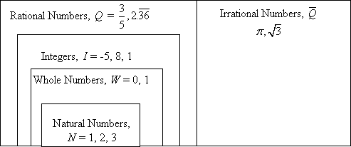](http://www.google.ca/url?sa=i&rct=j&q=real+number+system&source=images&cd=&cad=rja&docid=wARuvEDQevqVkM&tbnid=5WfbIAyv5N7XNM:&ved=0CAUQjRw&url=http://www.ualberta.ca/~cdigout/Other/EDIT_435/Math_10_Pure/htmlfiles/real_lessons.htm&ei=SiGuUam_HpLMywGA4oHwDw&bvm=bv.47244034,d.aWc&psig=AFQjCNHVcUV6QejwHq8uvW7GR6952bwF-g&ust=1370452637954749)

Absolute Value Inequalities:

[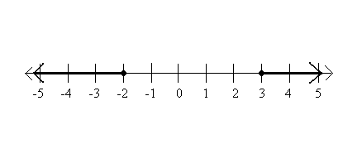](http://www.google.ca/url?sa=i&rct=j&q=absolute+value+inequalities&source=images&cd=&cad=rja&docid=RsAViWrrZXtd2M&tbnid=UeQCq5eCZLyhcM:&ved=0CAUQjRw&url=http://www.sparknotes.com/math/algebra1/absolutevalue/section3.rhtml&ei=tCGuUYXXAsGjyAGW5oCAAw&bvm=bv.47244034,d.aWc&psig=AFQjCNHY9lKdn-rn7IdEHwFVFUUWTLdwkg&ust=1370452776586922)[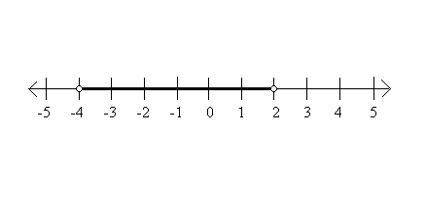](http://www.google.ca/url?sa=i&rct=j&q=absolute+value+inequalities&source=images&cd=&cad=rja&docid=RsAViWrrZXtd2M&tbnid=6tdvkp5PNPou8M:&ved=0CAUQjRw&url=http://www.sparknotes.com/math/algebra1/absolutevalue/section3.rhtml&ei=xSGuUdeaNumkyQH3-ICoBA&bvm=bv.47244034,d.aWc&psig=AFQjCNHY9lKdn-rn7IdEHwFVFUUWTLdwkg&ust=1370452776586922)

[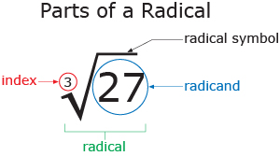](http://www.google.ca/url?sa=i&rct=j&q=radicals+mathematics&source=images&cd=&cad=rja&docid=CpUzJ3eMLlNhbM&tbnid=bJhUTxz4HUI4bM:&ved=0CAUQjRw&url=http://moodle.rockyview.ab.ca/mod/book/print.php?id=97905&ei=PyKuUea4Aov4ywGlo4GYAw&bvm=bv.47244034,d.aWc&psig=AFQjCNGAVdOGY9XRlJQadaUsHEdhx4xxAA&ust=1370452896432421)

The product/quotient of the roots of two numbers is equal to the root of the product/quotient of the two numbers.

The sum/difference of the roots of two numbers is **NOT** equal to the root of the sum/difference of the two numbers.

Ex.



Ex: Convert mixed radicals to entire radicals in simplest form

   

Ex: Convert entire radicals to mixed radicals in simplest form

   

**Unit 2: Exponents**

[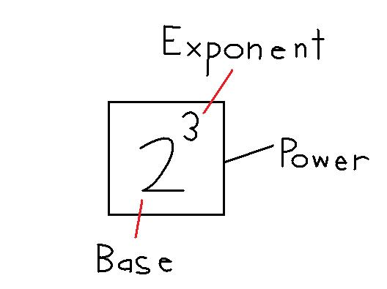](http://www.google.ca/url?sa=i&rct=j&q=exponents+mathematics&source=images&cd=&cad=rja&docid=4nNoAZN_x5rflM&tbnid=qtGzDtXNpSBoMM:&ved=0CAUQjRw&url=http://spmath90510.blogspot.com/2010_11_01_archive.html&ei=pSauUa60IcjzygHbnYDYAg&bvm=bv.47244034,d.aWc&psig=AFQjCNHVg-CtU4Tr4USHlFXBBRaiyy-aVg&ust=1370454000612213)[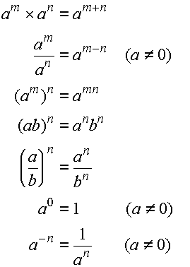](http://www.google.ca/url?sa=i&rct=j&q=exponent+laws+mathematics&source=images&cd=&cad=rja&docid=RyDOgp5WFrgATM&tbnid=SieFTrDApO_aRM:&ved=0CAUQjRw&url=http://gradeninemath.blogspot.com/&ei=KyeuUdSvIoLPywGznYHwBA&psig=AFQjCNHF8LJVWp0IlLmtZD9gEjGZAcATVA&ust=1370454116915735)

Examples:

 



**Scientific Notation:** written in the form **a x 10n**

Ex: Write in radical form then evaluate.

 

Ex: Write an equivalent expression using exponents.

  

**Unit 3: Measurement**

You do **NOT** need to know how to read a micrometer or a Vernier Caliper for the final ☺

**Proportional Reasoning:** useful when only one conversion of units is required

**Unit Analysis**: useful when many units are involved



Ex: convert 50m/s to km/min

Convert 5ft 10in to metres to three decimal places

Determine the linear, area, and volume measurements in centimetres.

[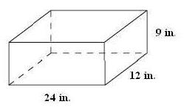](http://www.google.ca/url?sa=i&rct=j&q=surface+area+question&source=images&cd=&cad=rja&docid=7FIDotPbHkUjbM&tbnid=eBcqzlr8RiBPBM:&ved=0CAUQjRw&url=http://static1.tenmarks.com/static/albums/Measurement---Perimeter-Area-and-Volume/Surface-Area-of-Prisms-Cylinders-and-Complex-Solids-practice.html&ei=6mOuUenCFYbSyAGhn4GwAg&psig=AFQjCNHc3EybhO7o0a9sOitt5eh6sojDJw&ust=1370469638451958)

Calculate the surface areas and volumes.

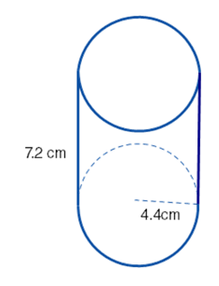 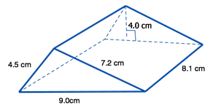

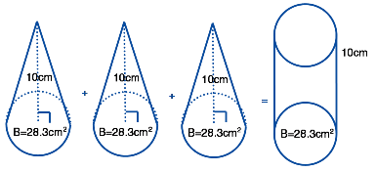 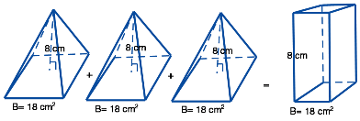

**Unit 4: Trigonometry**

[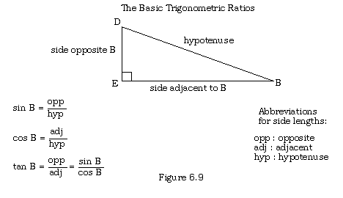](http://www.google.ca/url?sa=i&rct=j&q=sohcahtoa+ratios&source=images&cd=&cad=rja&docid=UvR2RcVLKKLIWM&tbnid=G5kK_2AZSug6lM:&ved=0CAUQjRw&url=http://www.msdgeometry.com/joomla/index.php?option=com_content&view=article&id=160:soh-cah-toa-trigonometry-ratios&catid=51:chapter-8&Itemid=68&ei=IWeuUdj7JYWQyQGu8IDADg&bvm=bv.47244034,d.aWc&psig=AFQjCNFBOcApa6i8wdIM371_466gKMaGdg&ust=1370470556365809)

Calculate x:

 

tan 36o = x sin 78o = x

Solve:

[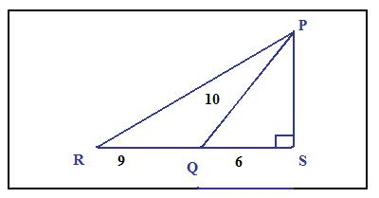](http://www.google.ca/url?sa=i&rct=j&q=solving+a+triangle&source=images&cd=&cad=rja&docid=l-qXryluSIZgrM&tbnid=z0p8yq3F5Y_6yM:&ved=0CAUQjRw&url=http://www.mathcaptain.com/trigonometry/right-angle-triangle.html&ei=VWiuUd7XN_KgyAGUnYDIAw&bvm=bv.47244034,bs.1,d.aWc&psig=AFQjCNF3Ug5AiApkNU31ktKCZCjXqmsMxw&ust=1370470856542969) 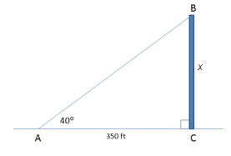

[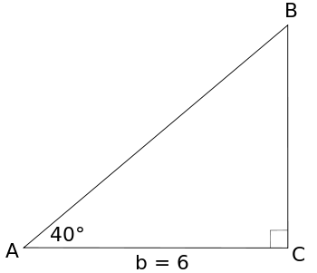](http://commons.wikimedia.org/wiki/File:Applications_of_Right_Triangle_Trigonometry_Example_2.svg)

You are standing 20 feet away from a tree, and you measure the angle of elevation to be 38°. How tall is the tree?

You are standing on top of a building, looking at park in the distance. The angle of depression is 53°. If the building you are standing on is 100 feet tall, how far away is the park? Does your height matter?

**Unit 5: Polynomial Operations**

**Monomial:** number, variable, or the product of a number and a variable 🡪 only one term

**Binomial:** two terms

**Trinomial:** three terms

**Polynomial:** monomial or sum or difference of monomials 🡪 exponents on the variables must be positive integers

**Degree of a Monomial:** sum of the exponents of its variable(s)

**Degree of a Polynomial:** degree of the term with the highest degree

**Constant Term:** term in a polynomial that has no variable

**Leading Coefficient:** the coefficient of the term with the highest power of the variable

**Like Terms:** terms with same variable raised to the same exponent

**Unlike Terms:** terms with different variables or the same variable raised to different exponents

Example: Expand and simplify.



1. 3(x + 5) -7x(2x2 – x) b) 20x3y3 – 4x3y2(3x + 5y – xy)

c) (x + 4)(2x – 1) d) (4a – 3b)2

e) (3x – 1)(2x + 5) – 5(8x + 3)(2x – 7) f) (x2 – 7)(4x2 – 3x – 1)

g) The hypotenuse of a right triangle is (7x + 3)cm long and the lengths of the other two sides are (2x + 1)cm and (3x – 6)cm. Form an equation and solve to determine the sides of each length of the triangle.

**Unit 6: Factoring Polynomial Expressions**

**Factoring:** write the sum or difference of monomials as a product of polynomials

**Rules: 1.** Factor out the Greatest Common Factor from the polynomial

**2.** Difference of Squares?

**3.** Determine the sum and product integers. (a, b)

**4.** No leading coefficient: (x + a)(x + b)

Leading coefficient: method of decomposition.

**5.** Check by expanding.

**Note:** to find the sum and product: if the product is positive, integers must either both be positive or both be negative, depending on the sum. If the product is negative, there must be one positive and one negative integer.

Examples: Factor completely.

a) x2 + 8x + 12 b) 3x3 +21x2 +30x

c) x2 – x – 12 d) 3a2 -15ab -252b2

e) x2 – 49 f) 25x2 – 64y2

g) 24x2 – 90x + 54 h) 6 – 7x – 20x2

i) The height of a triangle is 8mm more than the base. The area is 172.5mm2. Write a polynomial to model this information and determine the height of the triangle.

**Unit 7: Relations and Functions**

**Origin:** usually labeled O, points (0, 0)

**Ordered Pair:** a specific point on a Cartesian plane. The numbers in the ordered plane are called coordinates.

**Coordinates:** x-coordinate and y-coordinate make up an ordered pair 🡪 can be plotted on a Cartesian plane

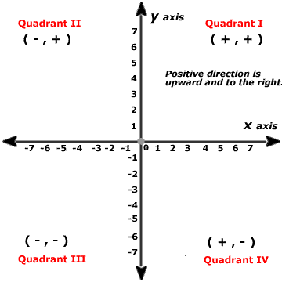

**Discrete Variable:** can only take on limited values

**Continuous Variable:** can take on every value within a particular interval

**Relation:** a comparison between two sets of elements

**Dependent Variable/Output/Range:** y 🡪 vertical axis 🡪 second coordinate

**Independent Variable/Input/Domain:** x 🡪 horizontal axis 🡪 first coordinate

**Y-Intercept:** y-coordinate of the ordered pair where the graph intersects the y-axis 🡪 where x=0

**X-Intercept:** x-coordinate of the ordered pair where the graph intersects the x-axis 🡪 where y=0

Example: Determine the x and y intercepts of the equation 3y = 5x + 15

**Interpolation:** using the graph to find values lying between given points

**Extrapolation:** extending the graph to predict values outside the plotted points

Example: Johnny purchases a new car for $20 000. The value of the car can be represented by the formula V = 20 000 – 1250t, where V is the value of the car in dollars, and t is the age of the car in years.

1. Complete a table of values up to 4 years and plot them on the grid.
2. What does the ordered pair (0, 20 000) represent?
3. Calculate the t-intercept and determine what this number represents.
4. Calculate the value of the car after 3 years and 12 years.
5. When will the car be worth $2000? $5500?

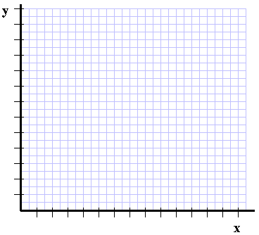

Examples: Calculate the domain and range.

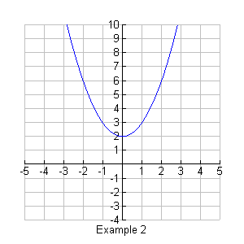 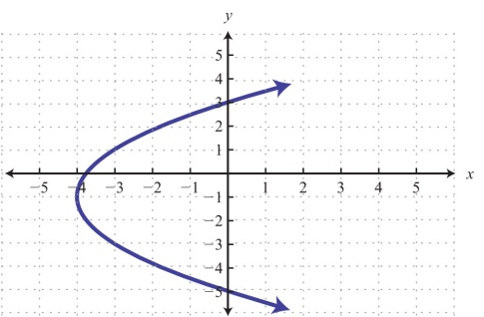 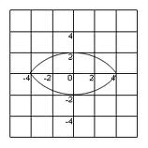

Example: The height of a human cannon ball, “Cano”, can be described by the formula h = 12 + 6t - t2, where h is the height in metres above ground level, and t is the time in seconds. Cano is projected out of a cannon from the top of a building and lands on a soft mat. The mat is placed in a hole in the ground so that the top of the mat is level with the ground.

a) Graph the function and sketch

b) Write down appropriate window you used

c) What is the height of the cannon above the ground?

d) What is the maximum height Cano reaches?

e) How many seconds does it take Cano to reach the highest point on the path he is travelling?

f) To the nearest second, how long does it take Cano to land on the mat?

g) How high is cano one second after he is launched?

h) When will Cano be at the same height he was in g)?

i) Write an appropriate domain and range for this relation.

**Function:**  a special type of relation in which each element of the domain is related to exactly one element of the range. Remember: Vertical Line Test 🡪 only one x for every y

**Unit 8: Characteristics of Linear Relations**

**Distance Formula:** determines the distance of a line on a Cartesian plane

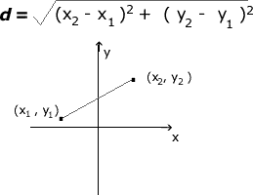

Example: Determine if ∆ABC is a right triangle if A(0, 1), B(-3, -3), and C(-7, 0).

**Midpoint:** point at the center of a line segment

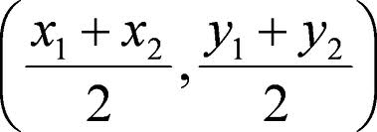

Example: Determine the midpoint of PQ when P(4, 7) and Q(12, 3).

Example: Determine x and y when P(5, x), Q(11, -10) and the midpoint is (y, -6)

**Slope:** of a line segment is the measure of the steepness

**Rise:** change in vertical height between endpoints

**Run:** change in horizontal length between endpoints



**Note:** Horizontal line segments have a slope of 0 and vertical line segments have a slope that is undefined.

A line that rises from left to right has a **positive slope.** A line that falls from left to right has a **negative slope.**

Example: Determine the slope of PQ when P(4, 7) and Q(12, 3).

Example: A line segment has a slope of  and a rise of 12. Calculate the run.

**Collinear:** points that lie on the same line 🡪 have same slopes

**Parallel:** line segments that have the same slope

**Perpendicular:** line segments are negative reciprocals of one another 🡪 product of both slopes is -1

Example: Determine the parallel and perpendicular slopes of a line segment with points A(3, 7) and B(9, 2).

**Unit 9: Equations of Linear Relations**

**Linear Equation:** an equation of the form y = mx + b where m is the slope and b is the y-intercept. The graph of a linear equation is a straight line

**Slope Y-Intercept Form:** y = mx + b

Example: Write an equation of a line with point (0, 2) and slope .

Example: Write and equation of a line passing through the points (0, 9) and (11, 14)

**Standard/General Form:** Ax + By + C = 0 🡪 positive A,B, and C values 🡪 no fractions

Example: Determine the slope of the line 2x – 5y + 3 = 0.

Example: Rewrite the line y = x + 8 in general form.

Example: Write the equation of a line perpendicular to 5x + 2y – 7 = 0 and with the same y-intercept as 7x – 6y + 1 = 0. Answer in general form.

**Slope-Point Form:**   where m is the slope of a line and  is a coordinate.

Example: Determine the equation of a line with the points (4, 2) and (-1, 7).

Example: Determine the slope and coordinate of the line (y + 7) = 2(x – 4).

Example: Find the equation, in general form, of the line perpendicular to the line 9x – 3y + 5 = 0 and same x-intercept as the line 4x – 3y – 3 = 0.

**Rate of Change:** slope 🡪 can be increasing or decreasing

**Unit 10: Systems of Equations**

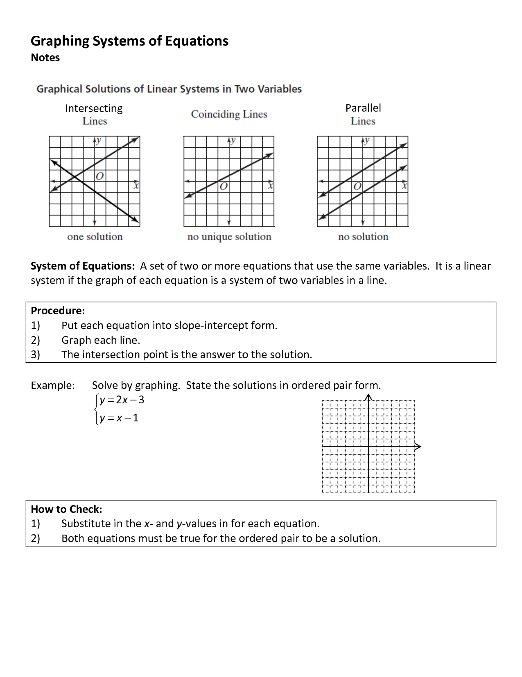

**Graphing:** isolate y 🡪 graph y1 and y2 🡪find intersect

**Substitution:**  isolate one variable 🡪 substitute the solution into the other equation 🡪 solve for the single variable 🡪 substitute that value into original equation to determine value of other variable

**Elimination:** multiply either one or both equations by values to get one of the variables either same or opposite coefficients 🡪 add or subtract to eliminate that variable 🡪 solve for the single variable 🡪 substitute that value into the original equation to solve for the other unknown variable

Example: Solve the following systems of equations using all three methods.

2x + 3y = 4

4x – y = 22

Graph:

Substitution:

Elimination:

5a + 3b = 3

3a – 7b = 81

Graph:

Substitution:

Elimination:

Example: Solve the following system of equations using the method of your choice.

4x + 2y – 13 = 0

3x = 5y +26