***Polynomials Practice Questions***

Complete the following on a separate piece of paper.

1. Write the prime factorization of 360.
2. Given the numbers 12, 54, and 72, determine the:
3. GCF (b) LCM
4. Use algebra tiles or a diagram to model each of the following binomial multiplication statements, then express the product of the multiplication as an expanded polynomial in simplest form.
5.  (b) 

4. Write the multiplication sentence that is represented by the diagram at right.

1. Expand and collect like terms.
2.  (b)  (c)  (d) 
3. Use the distributive property to determine each product.
4.  (b) 

(c)  (d) 

1. Multiply and then collect like terms.

(a)  (b) 

1. 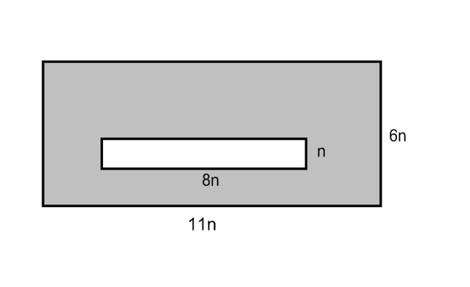A side of a cube is  cm long. Write a polynomial expression for the volume of the cube and then expand and collect like terms.
2. Write a simplified expression for the area of the shaded region:

1. Factor 2*x*2 + 6*x*.
2. Use algebra tiles or a diagram to factor the trinomial *x*2 - 7*x* + 6.
3. Factor the following polynomials.
4.  (b)  (c) 
5. Factor, if possible.

(a)  (b)  (c) 

(d)  (e)  (f) 

(g)  



1. Factor the following, if possible.
2.  (b) (c) 

(d)  (e)  (f) 

15. What is the factored form of the trinomial 30*x*2 – 25*xy* – 30*y*2?

1. The CN Tower in Toronto has a base area that can be expressed as  square units. Factor  to find binomials that could represent the length and the width of the base of the tower.
2. The area of a children’s playground measures  square units.
3. Factor the polynomial to find the binomials that could represent the length and the width of the playground.
4. If *a* represents 13 m, what are the length and the width of the playground, in metres.
5. The area of a square can be given by the expression , where *x* represents a positive integer. Write a possible expression for the perimeter of the square.

***Polynomials Practice Answer Key***

1. 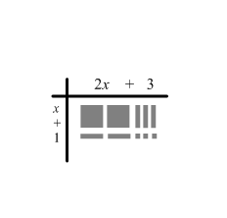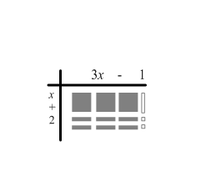 **2. (a)** 6 **(b)** 216

**3. (a) (b)**

** **

1. 
2. **(a)  (b)  (c)  (d) **
3. **(a)  (b)  (c) **

**(d) **

**7. (a)  (b) **

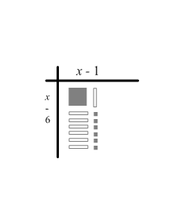**8.**  **9.  10. **

**11.**



**12. (a)  (b)  (c) **

**13. (a)  (b)  (c) **

**(d)  (e)  (f) **

**(g) **

**14. (a)  (b)  (c)** not possible

**(d)  (e)  (f) **

**15. **

**16. **

**17.**  **(b) **

**18. **

***Exponents and Radicals Practice***

1. What is the value of each expression?
2.  (b)  (c) 

2. Evaluate each of the following.

(a)  (b)  (c) 

3. State whether each number is a perfect square or a perfect cube. Show your work.

(a) 1024 (b) 10 648

4. Simplify each expression.

1.  (b)  (c) 

(d)  (e) (f) 

5. Simplify each of the following as far as possible. Leave your answer with positive exponents.

a)  b)  c)  d) 

6. Simplify the following, leave all of your answers as powers using positive exponents, then evaluate.

1.  (b)  (c)  (d) 

1. Simplify each of the following as far as possible. Leave your answer with positive exponents.
2.  (b)  (c) 
3. Use the laws of exponents to simplify. Leave your answers with positive exponents, if applicable.
4.  (b)  (c)  (d)  (e) 

9. Express each power as an equivalent radical and vice versa.

(a)  (b)  (c)  (d) 

(e)  (f)  (g) 

10. Express each mixed radical as an equivalent entire radical.

1.  (b)  (c) 

(d)  (e)  (f) 

11. Express each entire radical as an equivalent mixed radical.

1.  (b) (c) 

(d)  (e) 

12. Arrange the following from least to greatest: 

13. Use estimation to order the following numbers from greatest to least.

, , , 

1. The pressure, *P*, in kilopascals, exerted on the floor by the heel of a shoe is given by the formula: , where *m* is the wearer’s mass, in kilograms, and *x* is the width of the heel, in centimetres. Find the pressure exerted by a 60 kg woman wearing shoes with heels 2 cm wide.
2. The astronomer Johann Kepler found a formula which can be used to determine the number of Earth-days it takes each planet to travel once around the sun. The formula is: , where *R* is the mean distance from the planet to the sun in millions of kilometers and *N* is the number of Earth-days. Determine the number of Earth-days in the year of Saturn if Saturn is 1600 million kilometers away from the sun.
3. The Japanese board game of Tai Shogi is an expanded version of chess. Like chess, it is played on a square board covered with small squares. If each small square has a side length of 2 cm, the diagonal of the whole board measures  cm. How many squares are on the board?

***Exponents & Radicals Practice Answer Key***

1. **(a)** 2 **(b)** 4 **(c)** 12
2. **(a)** 2 **(b) 3 (c)** 10
3. **(a)** Perfect Square **(b)** Perfect Cube
4. **(a)**  **(b)**  **(c)**  **(d)**  **(e)  (f)** 
5. **(a)**  **(b)** 8 **(c)**  **(d)** 1
6. **(a)**  **(b)**  **(c)**   **(d)** -2
7. **(a)  (b)  (c) **
8. **(a)  (b)  (c)  (d)  (e) **
9. **(a)  (b)  (c) **

**(d)  (e)  (f)  (g) **

**10. (a)  (b)  (c)  (d)  (e)  (f) **

**11. (a)  (b)  (c)  (d)  (e) **

**12.  13. **

**14.** 1500 kPa **15.** 12800 days **16.** 625 squares