***Relations and Functions Practice Questions***



1.The following distance-time graph represents the distance (in kilometres) a person bicycled during a 50-min period. Describe a possible scenario.

2. The table of values shows the cost of movie tickets at a local theatre.

|  |  |
| --- | --- |
| **Number of Tickets** | **Cost**  **($)** |
| 1 | 12 |
| 2 | 24 |
| 3 | 36 |
| 4 | 48 |

1. Is this a linear or non-linear relationship? Explain how you know.
2. Assign a variable to represent each quantity in the relation. Which variable is the dependent variable and which is the independent variable?
3. Are the data discrete or continuous? Explain how you know.
4. Graph the data.

3. Determine whether each relation is linear or non-linear. Explain your decision.



1. (b)  (c) {(-2, 5), (1, 3), (4, 1), (10, -3)}

4. At the bowling alley Angela rented shoes for $3. It cost her $2.50 to bowl each game.

(a) Develop an equation that represents the cost of bowling. Use the form , where *C*(*x*) is the total cost, and *x,* is the number of games bowled.

(b) Is this relation a function? Explain.

(c) How much did it cost Angela to bowl four games?

5. Give the domain and range of each graph. Use words, interval notation, and set notation.

(a) (b)

(c) (d)

 

6. Determine whether or not each relation is a function.

1. (2,5), (4,3), (6,1), (8,-1), (9,-2)
2. (3,2), (5,6), (6,8), (3,-2), (6,-4)
3. (8,1), (7,1), (-3,1), (-4,1)

7. Determine whether or not each relation is a function. Explain your answer.

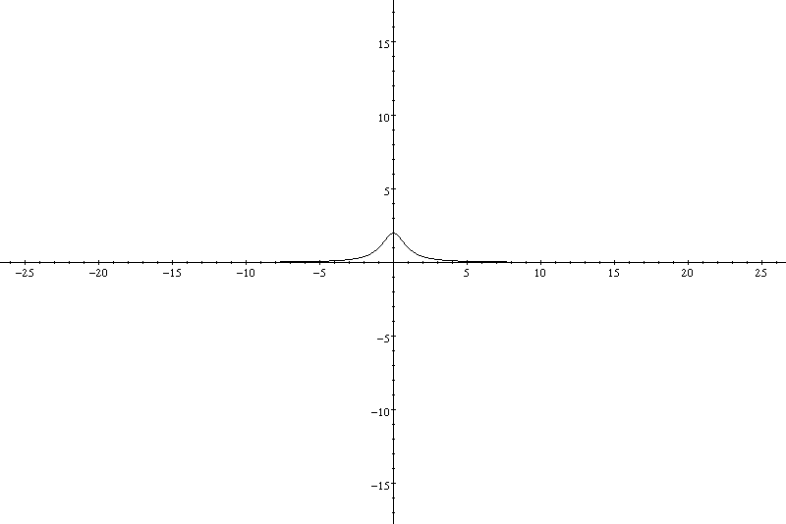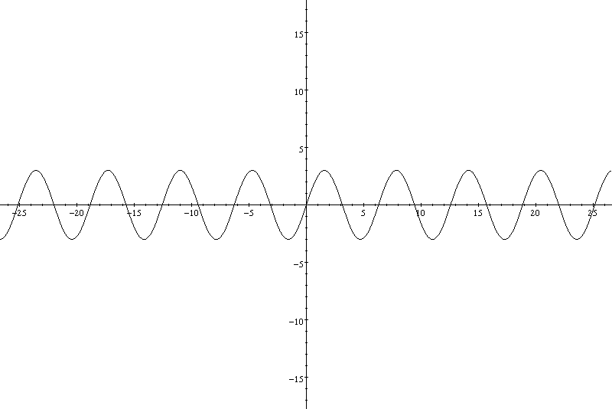

(a) (b)

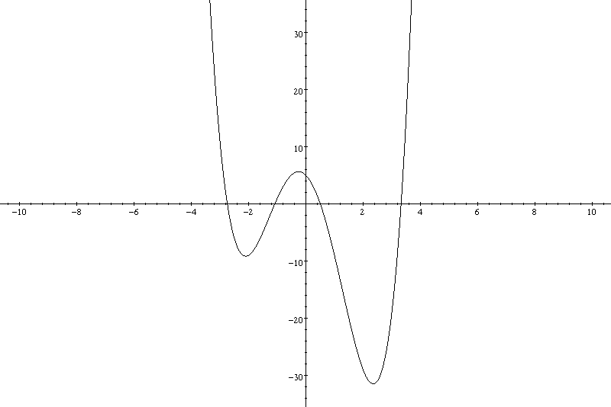

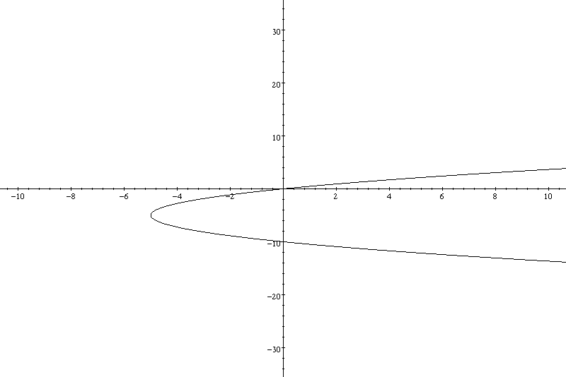(c) (d)

8. If , find:

(a)  (b)  (c)  (d) 

9. Consider the function 

1. What is the value of ? (b) Determine *x* so that 

10. A typical adult dosage for an antihistamine is 24 mg. Young’s rule for determining the dosage size  for a typical child of age *a* is . What should the dosage be for a typical 8-year-old child?

***Relations & Functions Practice Answer Key***

**1.** Answers will vary - For Example:

A cyclist biked away from the starting point at a constant rate for the first 15 min. For the next 15 min, the cyclist pedaled at an increased constant rate. The cyclist then turned around and travelled at a constant speed, returning to the starting point.

**2. (a)** Linear Relation – dependent values increase at a constant rate of 12 for every increase in the independent value.

**(b)** *n* =number of tickets (Independent variable); *C* = Cost (Dependent Variable)

**(c)** Data is discrete- independent values must be whole numbers greater than 0.

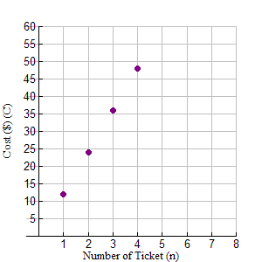**(d)**

**3. (a)** This is a linear relation. With each increase of 1 in the independent variable, *x*, the dependent variable, *y,* increases by 2.

**(b)** This is a non-linear relation.With each increase of 1 in the independent variable, *r*, the

dependent variable, *A,* does not increase by the same amount. It increases by the square

of the increase in .

**(c)** This is a linear relation. With each increase of 3 in the independent variable, *x*, the dependent variable, *y,* decreases by 2.

**4. (a)** In , the fixed cost is $3, so *b* = 3. The slope is the rate per game, so *m* = 2.

**(b)** Yes, this is a function because for every value of *x* there is only one corresponding value for *C*(*x*).

**(c)** *C*(4) = 2.5(4) + 3

*C*(4) = 10 + 3

*C*(4) = 13 The cost to bowl four games is $13.

**5. (a)** *Domain***:** *x* is a member of the Real Number System

Interval:  Set: 

*Range*: *y* is a less than or equal to -1 and *y* is a member of the Real Number System

Interval  Set: 

**(b)** *Domain: x* is greater than -2 and *x* a member of the Real Number System

Interval  Set: 

*Range: y* is a less than 1 and *y* is a member of the Real Number System

Interval  Set: 

**(c)** *Domain: x* is a member of the Real Number System

Interval: Set: 

*Range: y* is a member of the Real Number System

Interval:  Set: 

**(d)** *Domain: x* is greater than or equal to -2 but is less than or equal to 4 and *x* is a member of the Real #’s

Interval:  Set: 

*Range: y* is greater than or equal to -1 but is less than or equal to 5 and *y* a member of the Real Number System Interval:  Set: 

**6. (a)** yes **(b)** no **(c)** yes

**7. (a)** yes **(b)** yes **(c)** yes **(d)** no

**8.** **(a)**15 **(b)**  **(c)**  **(d)** 3995 **9. (a)**  **(b)** 9 **10.** 

***Linear Equations & Graphs Practice Questions***

1. Determine the slope given the rise and the run.

(a) rise = 1, run = 2 (b) rise = 4, run = –1

(c) rise = –3, run = –4 (d) rise = –10, run = –2

2. Determine the slope of the line containing each pair of points.

(a) A(0, 5) and B(–3, 2) (b) C(–2, –3) and D(–6, –11)

(c) E(12, 4) and F(9, 16) (d) G(–100, 50) and H(–200, 100)

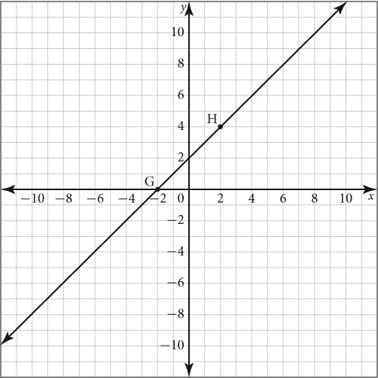  3. Use the graph to answer parts a) to d).

(a) Identify the coordinates of points G and H.

(b) Identify the rise of the line through points G and H.

(c) Identify the run of the line through points G and H.

(d) Identify the slope of the line through points G and H

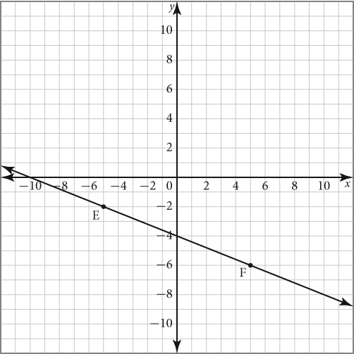 4.Use the graph to answer parts a) to f).

(a) State the coordinates of points E and F.

(b) Determine the rise between points E and F.

(c) Determine the run between points E and F.

(d) Determine the slope of the line containing points E and F.

(e)State the *y*-intercept of the line containing points E and F.

(f)State the equation of the line containing points E and F.

5. Determine the slope of each line.

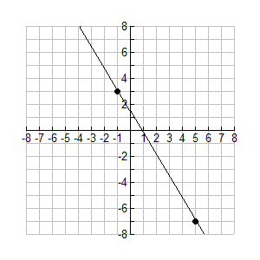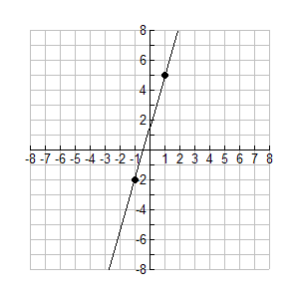

1. (b)

6.Determine the slope and draw the graph of a line with *x*-intercept 5 and *y*-intercept –3.

7. Sketch the lines described below.

1.  (b) 

8. Find the slope and the *y­-*intercept of each line. Then, sketch the line.

(a)  (b) 

9. Write the equation of each line in the form 

(a) slope = 2;  *y*-intercept = 3 (b) slope = ;  *y*-intercept = 

10.Determine the *x*-intercept and *y-*intercept of the line *y* = 1 – *x*. Then, graph the line.

11. Determine the *x*- and *y*-intercepts of each line.

(a)  (b)  (c) 

12. (a) What is the equation of the vertical line that passes through the point (3, 4)?

1. What is the equation of the horizontal line that passes through the point (3, 4)?

13. Express each of the following in slope and *y*-intercept form.

(a)  (b)  (c) 

14. Express each of the following in slope and *y*-intercept form, then sketch the line.

(a)  (b) 

15. Consider the equation . What is each value of *b* if a graph of the line passes through each point?

(a) (4, 11) (b) (-2, -9)

16. Express each of the following in general form, .

(a)  (b)  (c) 

17. Write an equation of the line that passes through the given point and has the given slope. Express the equation in general form.

(a)  (b) 

18. Write an equation of the line that passes through the given points. Express the equation in general form.

1.  (b) 

19. Write an equation in point-slope form of the line through  and .

20. What is the value of the unknown parameter in each equation?

(a)  passing through  (b)  passing through

21. Given the slopes of the two lines, determine whether the lines are parallel, perpendicular, or neither.

(a) m1 = 2; m2 =  (b) m1 = ; m2 = 

(c) m1 = 5; m2 = -5 (d) m1 = ; m2 = 

22. Find the slope of a line perpendicular to a line with the given slope:

(a)  (b)  (c) undefined

23. The slopes of two parallel lines are  and . Find the value of *m.*

24. The slopes of two perpendicular lines are  and . Find the value of *k.*

25. Write an equation of the line in general form through the point  that is parallel to the line with the equation .

26. Determine if the lines  and  are parallel, perpendicular, or neither.

27. Determine an equation for the line, in general form, passing through  and perpendicular to .

28.Jamie’s grandmother gave her $40 when she started high school. Jamie decided to add $5 a week toward the cost of a digital music player. Write an equation in the form

*Ax* + *By* + *C* = 0 to represent Jamie’s savings.

***Linear Equations & Graphs Practice Answer Key***

* + - 1. **(a)**  **(b)**  **(c)**  **(d)** 
      2. **(a)**  **(b)**  **(c)**  **(d)** 
      3. **(a)** *G*(-2,0), *H*(2, 4) **(b)** rise = 4 **(c)** run = 4 **(d) *m*** = 1
      4. **(a)** *E*(-5, -2) *F*(5, -6) **(b)** rise = -4 **(c)** run = 10 **(d)** 

**(e)** *y*-int = -4 **(f) **

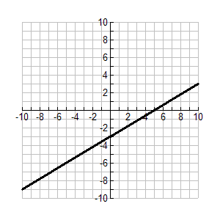**5. (a)**  **(b)**  **6. (a)**  **(b)**

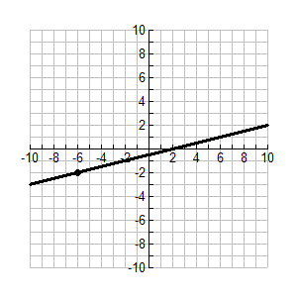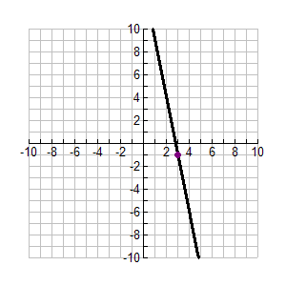

**7. (a) (b)**

**8. (a)** ** **(b)**  **

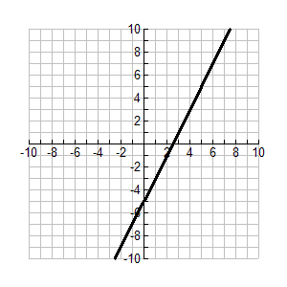 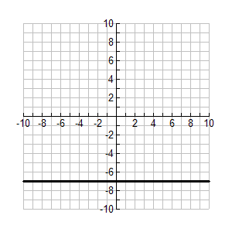

**9. (a)  (b) **

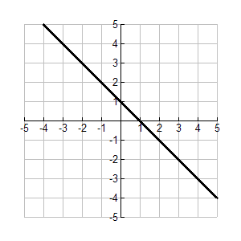**10.** *x-int*: 1; *y-int:*1 **11. (a)** *x-int:* 5 *y-int:* -5

**(b)** *x-int:* 6 *y-int:* -8

**(c)** *x-int:* 3 *y-int:* 1.2

**12. (a)** ** **(b)** **

**13. (a)  (b)  (c) **

**14. (a)  (b) **

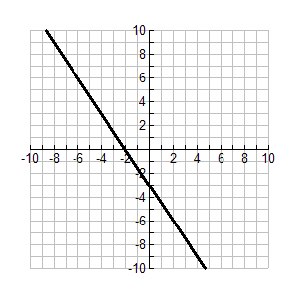 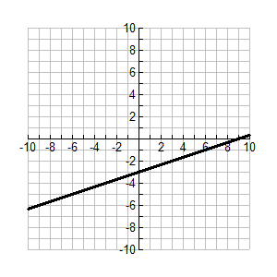

**15. (a) ** **(b) **

**16. (a)  (b)  (c) **

**17. (a)  (b) **

**18. (a)  (b) **

**19. **  or 

**20. (a)  (b) **

**21. (a)** Perpendicular **(b)** Parallel **(c)** Neither **(d)** Perpendicular

**22. (a)** ** **(b)** ** **(c)** **

**23.** ** **24.** ** **25.** ** **26.** Neither

**27.** ** **28.** **

