***Systems of Equations Practice Questions***

1. (a) Explain how graphing can be used to solve a linear system of two equations.

(b) Explain how you could check your solution.

2.Solve the following linear system graphically.

*y* = 5

3*x* + *y* = 3

3. Solve each system of equations graphically and verify your solutions.

(a)  (b) 

(c)  (d) 

4**.** Determine the point of intersection of the lines  and *y* = –*x* + 3 by graphing.

5**.** Determine the number of solutions for the following linear system.

*y* = 3*x* – 2

12*x* – 4*y* – 8 = 0

6.Determine the number of solutions for the following linear system using a graph.

3*x* – 2*y* = –6



7**.** Determine the equation of a line in the form *y* = *mx* + *b* that together with the equation *x* + 3*y* = 9 forms a linear system that has no solution.

8.Identify the equation of a line in the form *y* = *mx* + *b* that together with the equation 2*x* + 2*y* = 12 forms a linear system with an infinite number of solutions.

9. Determine whether each linear system has infinitely many solutions, no solution, or exactly one solution. Justify your answers:

1.  (b)  (c) 

10**.** Explain how the substitution method is used to solve a linear system of two equations.

11. Use the substitution method to solve each linear system.

(a) *x* – 2*y* = 7 (b) *x* + 3*y* = 5

*y* = –*x* + 1 –2*x* + *y* = 4

(c) –*x* + 3*y* + 1 = 0(d) 4*x* – 3*y* = –13

3*x* – *y* + 1 = 0 –2*x* + *y* = 4

12.The three lines *y* = *x* + 1, *y* = 4 – 2*x*, and *y* = –*x* – 5 intersect to form a triangle. Determine the coordinates of the vertices of the triangle.

13.For what values of the coefficients *a* and *b* is the ordered pair (2, –1) the solution to the linear system *ax* + *by* = –7 and 2*ax* – 3*by* = 1?

14. For which of these solutions is  a solution?

(a)  (b)  (c) 

15. Sea otters are found along the shores of the North Pacific. Sea otters were almost extinct in 1910, because they had been over-hunted for their fine, silky brown fur. They are now protected by an international treaty. The two main populations of sea otters are along the coasts of California and Northern BC-Alaska. If *n* represents the approximate number of sea otters in the north, and *s* represents the approximate number of sea otters in the south, the following two equations show how these numbers are related:



Solve the system of equations to find the approximate number of sea otters in each population.

16. For the following questions, assign a variable to each unknown quantity. Then translate the problem into a system of linear equations that could be used to determine each unknown. **Do not solve the system**.

(a) Three footballs and one soccer ball costs $155. Two footballs and three soccer balls costs $220. Determine the cost of one football and the cost of one soccer ball.

(b) Two shirts and one sweater costs $60. Three shirts and two sweaters costs $104. Determine the prices of one shirt and one sweater.

(c) At a sale, all CDs are one price and all tapes are another. Three CDs and two tapes cost $72. One CD and three tapes cost $52. What are the prices of one CD and one tape?

(d) An aerobics club has an initial fee and a monthly fee. The cost for a six-month membership of $220 and the cost for a one-year membership is $340. Write equations to determine the initial fee and the monthly fee.

(e) Evan invested $2050 in the stock market. Part of the money was invested in a stock worth $5 per share and the rest was invested in a stock worth $8 per share. He purchased 350 shares altogether. Write equations to determine the number of shares purchased at each price.

17. Solve each of the following by using the substitution method:

1.  (b)  (c) 

(d)  (e) 

18. The highest point in British Columbia, *f* metres above sea level is on Fairweather Mountain. The highest point in Manitoba, *b* metres above sea level is on Baldy Mountain. The heights are related by the following system of equations:



Solve the system of equations by substitution to find the height of each mountain.

19. A chocolate manufacturer has found by consumer research the most popular mix of hard and soft-centered chocolates. The best profit is given by the equations:



where *s* is the number of soft-centered chocolates and *h* is the number of hard- centered chocolates. Solve the system of equations by using substitution to find the number of each kind of chocolate.

20. Solve each of the following by using the elimination method:

(a)  (b)  (c) 

(d)  (e) 

21. At the cafeteria, three hamburgers and three Cokes cost $9.00. Two hamburgers and one Coke cost $4.75. Use the elimination method to determine the cost of one hamburger and the cost of one Coke.

22. The receipts from 550 people attending a play were $9184. The tickets cost $20 for adults and $12 for students. Use the elimination method to find the number of adults and student tickets sold.

23. Solve the following system of equations by elimination and explain the result.



24. An aircraft travels 5432 km from Montreal to Paris in 7 hours and returns in 8 hours. The wind speed is constant. Determine the wind speed and the speed of the aircraft in still air.

25. A plane flew 9000 km from Seoul, South Korea to London, England with the wind in 10 hours. The return flight against the wind took 11.25 hours. Find the wind speed and the speed of the plane in still air.

26. Sir John A. Macdonald and William Lyon Mackenzie King are two of the longest serving Prime Ministers of Canada. King’s three periods in office totaled three more years than Macdonald’s two periods. Together, Macdonald and King served for 41 years. Determine the number of years that Mackenzie King served in office.

***Systems of Equations Practice Answer Key***

**1. (a)** Example: A linear system can be solved by graphing the lines and then reading the point of intersection from the graph.

**(b)** Example: To check the solution to a linear system, substitute the coordinates of the point of intersection into the original equations. The solution is correct if the value of the left side of the equation is equal to the value of the right side for both equations.

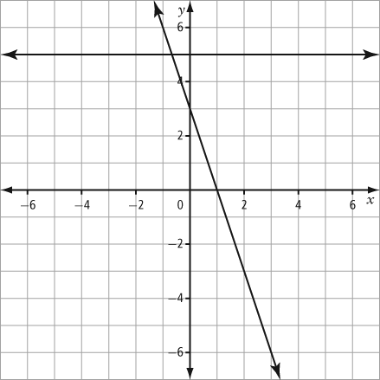**2.**

Solution: 

**3. (a)**   (b)  (c)  (d) infinite solutions

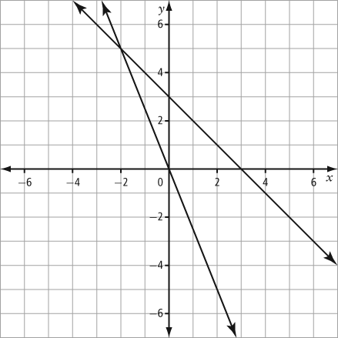**4**.

Point of intersection: (–2, 5)

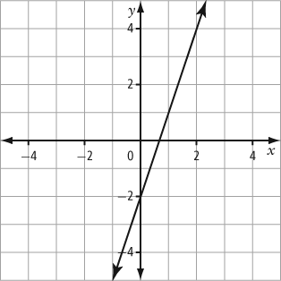**5.**

Because both equations have the same graph, there are an infinite number of solutions.

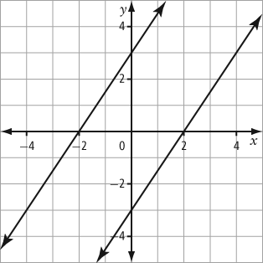**6.**

Because the lines are parallel, the linear system has no solution.

**7.** A parallel line is needed, so the other equation must be  where *b* can be any value except 3.

1. An equivalent equation of the same line is needed. Example: *y* = 6 – *x*
2. **(a)** no solutions **(b)** infinite solutions **(c)** one solution
3. Example: To solve a linear system by substitution, solve the first equation for one variable, and then substitute that expression into the second equation and solve for the second variable. Substitute the value of the second variable into one of the equations and solve for the value of the first variable.

**11. (a)** (3, –2) **(b)** (–1, 2) **(c)**  **(d)** 

**12.** (1, 2) & (–3, –2) & (9, –14)

**13.** *a* = –2 and *b* = 3.

**14. (a)** yes **(b)** no **(c)** yes

**15.** south sea otters = 5000; north sea otters = 125 000

**16 (a)**  **(b)**  **(c)** 

**(d)**  **(e)** 

**17. (a)**  **(b)**  **(c)**  **(d)**   **(e)** 

**18.**  **19.** 

**20. (a)**  **(b)**  **(c)**  **(d)**  **(e)** 

**21.** hamburger = $1.75; Coke = $1.25

**22.** 323 adults; 227 students

**23.**  This is not possible, therefore there are no solutions

**24.** wind speed =  ; speed of aircraft in still air = 

**25.** wind speed =  ; speed of aircraft in still air = 

**26.** Macdonald = 19 years; King = 22 years