**Frequency Distribution**

* Definition: raw data organized into a table or graph with intervals. Each interval shows the number of times (frequency) that the raw data falls into each category.

Frequency distribution can be represented in frequency tables, histograms, or frequency polygons.

Frequency Table

Example: p. 241-242 Red River Flow Rates

|  |  |  |
| --- | --- | --- |
| Flow Rate (m3/s) | Tally | Frequency  (Number of years) |
| 0-500 | ~~llll~~ l | 6 |
| 500-1000 | ~~llll~~ ~~llll~~ l | 11 |
| 1000-1500 | ~~llll~~ llll | 9 |
| 1500-2000 | ~~llll~~ ~~llll~~ llll | 14 |
| 2000-2500 | ~~llll~~ | 5 |
| 2500-3000 | l | 1 |
| 3000-3500 | lll | 3 |
| 3500-4000 |  | 0 |
| 4000-4500 |  | 0 |
| 4500-5000 | l | 1 |

Range of raw data:

Intervals:

Histogram

A frequency table made into a graph. The bars are the intervals.

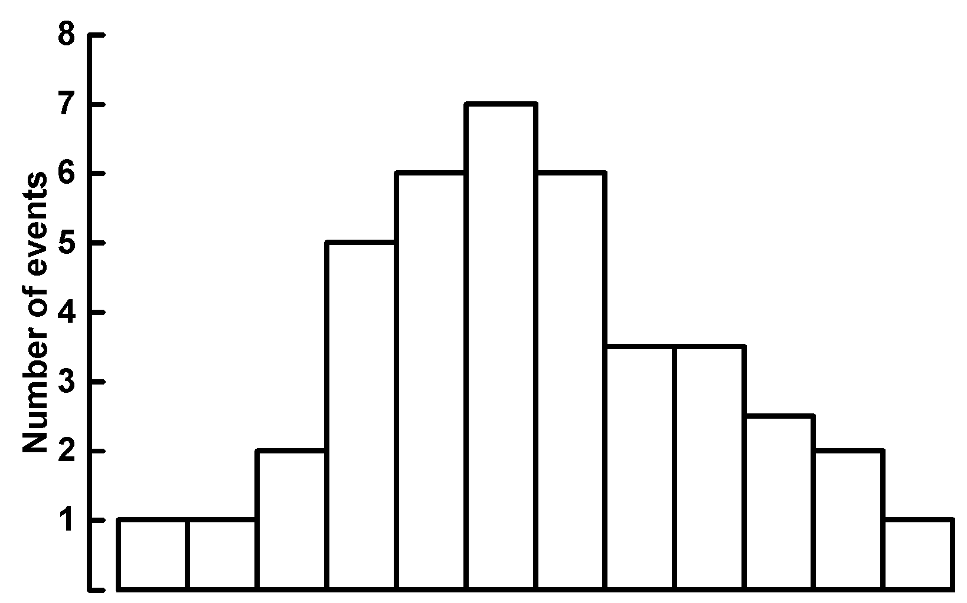

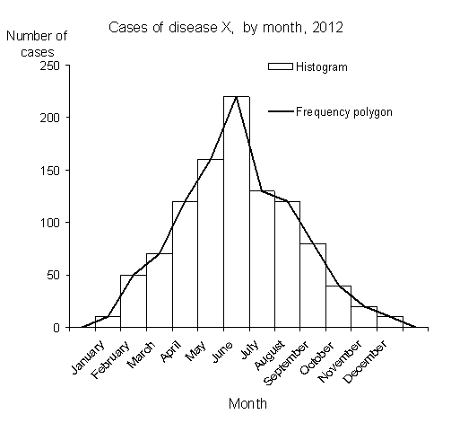Frequency Polygon

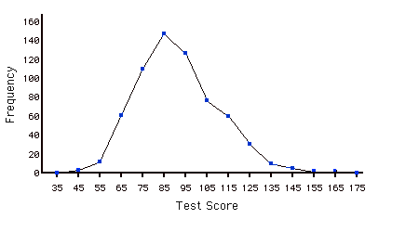

p. 242-244 continued… Reflecting

A. Similarities_________________________________________________________________

__________________________________________________________________

Differences __________________________________________________________________

B. __________________________________________________________________________

C. __________________________________________________________________________

__________________________________________________________________________

D. _________________________________________________________________________

* p. 250 Creating a frequency table #3

|  |  |  |
| --- | --- | --- |
| Heights (in) | Tally | Frequency |
|  |  |  |
|  |  |  |
|  |  |  |
|  |  |  |
|  |  |  |
|  |  |  |

Range of Data: ______________________________

Interval width: __________________ (question says to use 6 intervals)



c) ______________________________________________________________________

p. 251 #6

Describe differences in populations of the two sexes.

p. 251 #7

What conclusions can be made based on the graph?