- The lifetime of a watch battery has a mean of 1.3 years and a standard deviation of 0.25 years. What guarantee should the manufacturer offer, if they want no more than 5% of the batteries returned to them under warranty?
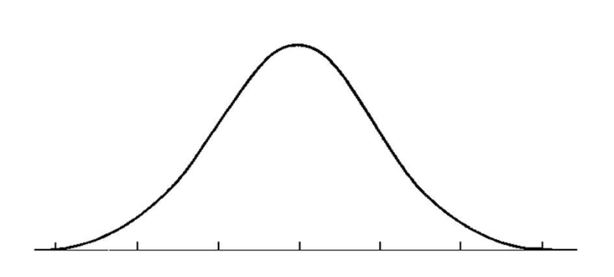

- Cars are undercoated to protect against rust. A car dealer has determined that the mean life of the protection is 65 months with a standard deviation of 4.5 months. What guarantee should the dealer give so that fewer than 15% of the customers will return their cars?

- On a local hiway the average speed of cars is 105 km/hr with a standard deviaton of 6.5 km/hr. In one hour a speed trap detected that 32% of the cars were speeding. What was the radar gun set to, to determine the rate of speeding?

