**Similarities and Differences Between Two Sets of Data**

* Vocabulary:

**1) Measures of Central Tendency**

The term **central tendency** refers to the "middle" value or perhaps a typical value of the data, and

is measured using the **mean**, **median**, or **mode**. Each of these measures is calculated differently, and

the one that is best to use depends upon the situation.

**\*Mean** – the average of the data

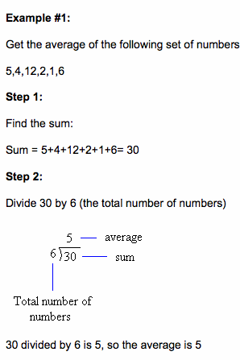

 The mean of the set of data is 5.

**\*Median** – when the numbers are in order, it is the middle number

Example #1: S1 =  Example #2 S1 = 

Put the numbers in order: 9, 11, 15 21, 24, 30, 35

The middle number is 11 so the median is 11 There are two middle numbers so

 then 2 = 27

The median is 27

**\*Mode** – the number/item that occurs most often

Example: 15, 14, 8, 15, 16

The mode of this set is 15 because it shows up twice

2) **Dispersion**

A measure that varies with the spread of the data. Range is the easiest measure of dispersion to calculate.

**\*Range-** the difference between the maximum and minimum values in the data set

Textbook p. 238 Range for the two different types of batteries

Brand X Brand Y

Longest lifespan Longest lifespan

Shortest Shortest

Difference Difference

* Practice

Textbook p. 239 #1a

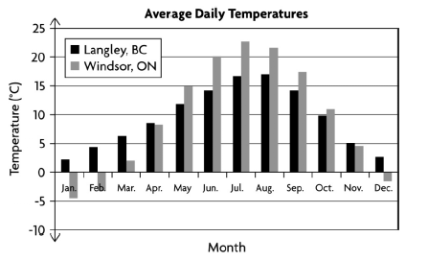

b) Range: Mean: Median:

c)

d)