- The ages of stunt men are normally distributed with a mean of 28 years and a standard deviation of 1.5 years. Find the percentage of men that live to be at least 30 years old.

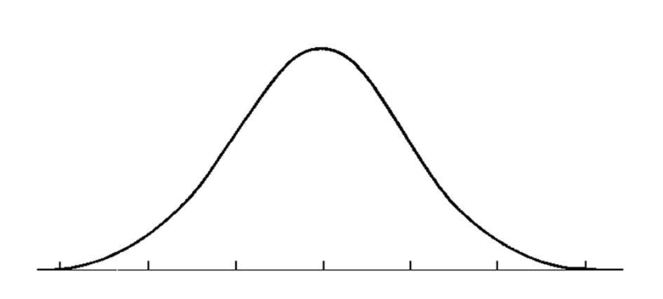

- The average life of a certain car enging is 110 000 km with a standard deviation of 12 000 km. What is the percent of engines that will last:

- Between 95 000 km and 115 000 km?

- Less than 100 000 km?
- A supermarket packages its ground beef in packs with an average weight of 2.2 kg and a standard deviation of 0.2 kg. If in one week the store makes 2000 packages of ground beef, how many will weigh less than 1.8 kg?

- The speeds of cars on a hiway are tested and are determined to have a mean of 80 km/hr and a standard deviation of 8 km/hr. What percentage of cars average more than 95 km/hr?

- The height of North American women is normally distributed with a mean of 162 cm and a standard deviation of 4 cm. In a group of 500 women, how many will be less than 155 cm tall?

