**Z-Scores**

* A **z-score** indicates the number of standard deviations that a data value lies from the mean.

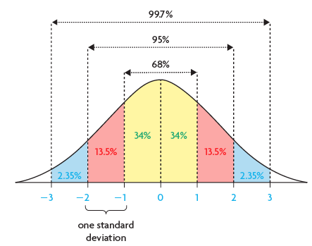

* A ***z*-score** indicates the number of standard deviations that a data value lies from the mean. It is calculated using this formula:



* A positive *z*-score indicates that the data value lies ____________the mean.
* A negative *z*-score indicates that the data value lies ___________ the mean.
* The area under the standard normal curve, to the _________ of a particular *z*-score, can be

found in a *z*-score table or determined using a graphing calculator.

* *Z*-scores can be used to compare data from different normally distributed sets (data that have different means and standard deviations) by converting their distributions to the standard normal distribution. (see above)
* Examples:

1) Determine the z-scores for each value of **x.** Sketch the **standard normal distribution.**

a) , ,  b) , , 

c) Your Turn p. 284

2) Determine the percent of data to the left of each z-score. Sketch the **standard normal**

**distribution.** Remember, the curve represents _______%

Given the z-score, use a z-score table.

a) z = 0.56 b) z = - 1.76

*How would you determine the percent to the right? _____________________________

c) IQ tests measure a person’s intelligence at a particular time. They are usually distributed with

a mean of 100 and a standard deviation of 15. If a person scores 105, how does this compare

with the scores of the general population?

**Calculator:** 2nd  Catalog normCdf. ENTER(lower bound, upper bound, mean, standard deviation)

**Note: here you are looking for the percent**

3) Using z-scores to determine data values (Including warranty problems)

a) Read example p. 287. Do Your Turn p. 288

**Calculator:** 2nd  Catalog invNorm ENTER (decimal value of percent, mean, standard deviation)

**Note: here you are given the percent and are determining the value of x.**

b) Read example p. 290. Do Your Turn p. 291

4) Solving a Quality Control Problem

Read example p. 288. Do Your Turn p. 290

**Calculator:** 2nd  Catalog normCdf. ENTER(lower bound, upper bound, mean, standard deviation)

**Note: here you are looking for the percent**