Math 20-2: U5L1 Teacher Notes
Exploring Data

Key Math Learnings:
By the end of this lesson, you will learn the following concepts:

- I will explore the similarities and differences between two sets of
data.

Review!!

- Outliers:

- Line Plots:

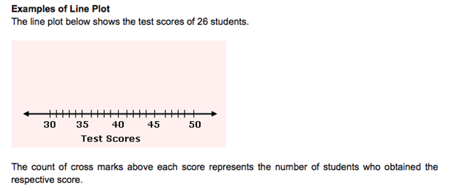

Mean, Mode and Median

The term central tendency refers to the __________ _____________ or perhaps a typical value of the data, and is measured using the __________, ____________, and ____________ .

Each of these measures is calculated differently, and the one that is best to use depends upon the
situation.

- Mean: the average of set of data

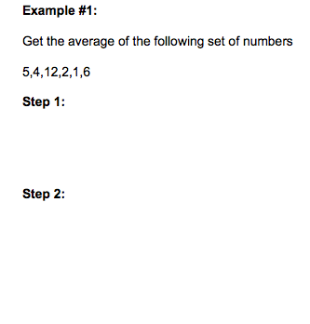

http://www.brightstorm.com/math/algebra/introduction-to-statistics/mean/

- Mode: When finding the mode of a set a data, first put the data in order from least to greatest although it is not necessary to do so. Then, Look for the most occurring item(s) or number(s)

For example, Find the mode of the following set:

15, 14, 8, 15, 16

http://www.brightstorm.com/math/algebra/introduction-to-statistics/mode/

- Median: When finding the median of a set of data, first put the data in order and then find the number located right in the middle.

For example, find the median for the following set:

S₁ = {15, 14, 11}

http://www.brightstorm.com/math/algebra/introduction-to-statistics/median/

Dispersion

- We often need to measure the extent to which scores in a dataset differ from each other. Such a measure is called the dispersion. The easiest measure of dispersion is range.

Range
- The range is calculated by simply taking the:

- However, the range only provides information about the __________________________ values and does not say anything about the values in between.

http://www.brightstorm.com/math/algebra/introduction-to-statistics/range/

Central tendencies
- We use the central tendencies, line plots and range to analyze sets of data.

Example
Turn to Page 239 of the textbook and complete #1 in Further Your Understanding.

Solution a:
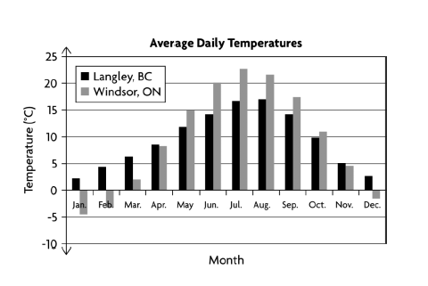
Solution b:
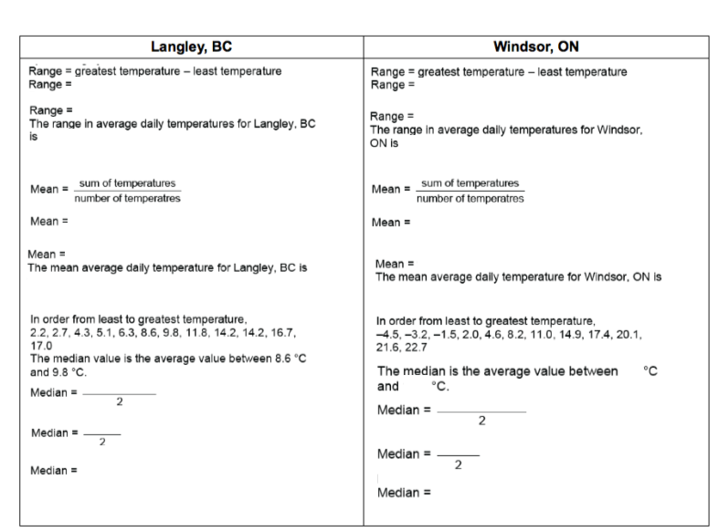

Solution C and D:

