Math 20-2: U5L3 Teacher Notes
Standard Deviation

Key Math Learnings:
By the end of this lesson, you will learn the following concepts:
- I can explain, using examples, the meaning of standard deviation.
- I can calculate, using technology, the population standard deviation of a data
set.
- I can explain, using examples, the properties of a normal curve, including the
mean, median, and mode, standard deviation, symmetry and area under the
curve.
- I can compare the properties of two or more normally distributed data sets.
- I can explain, using examples that represent multiple perspectives, the
application of standard deviation for making decsions in situations such as
warranties, insurance or opinion polls.
- I can problem solve that involves the interpretation of standard deviation.

Definition of Standard Deviation

Standard Deviation is a measure of how spread out numbers are.

Its symbol is(the greek letter sigma) _______

The formula is easy: it is the square root of the Variance. So now you ask, "What is the Variance?"

Variance
The Variance is defined as the:

To Calculate the Variance follow these steps:

1.

2.

3.

Example: (This example is from MathsisFun)

You and your friends have just measured the heights of your dogs (in
millimeters):

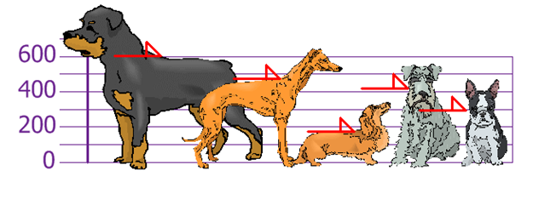

Find out the Mean, the Variance, and the Standard Deviation.

Solution:

Your first step is to find the Mean:

so the mean (average) height is ______ mm. Let's plot this on the chart: (next page)

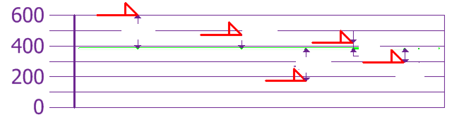

To calculate the Variance, take each difference, square it, and then
average the result:

The standard deviation is just the square root of the Variance, so

Click the icon for a Youtube video showing the steps to calculate the standard deviation and mean of a given data set

http://www.youtube.com/watch?v=DMOXzwC2vzg

Example:

Using the data {170, 300, 430, 470, 600} find the standard deviation using the formula and check using technology.

Solution:

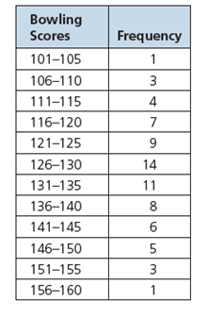

Example:
The bowling scores for the six players on
Ali’s team are shown at the right.

a) Determine the mean and standard deviation of the bowling scores for Ali’s
team, rounded to two decimal places.

b) Using the mean and standard deviation, compare Ali’s data from question 2 to the
team’s data.

Solution:
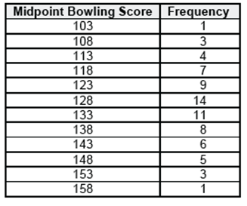

Using Standard Deviation to Interpret Data

Standard deviation is often used as a measure of _______________.

When data is closely clustered around the mean, the process that was used to generate the data can be interpreted as:

When data is concentrated close to the mean, the standard deviation is low.
When data is spread far from the mean, the standard deviation is:

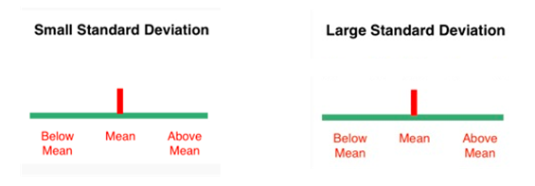

Example:

Marie, a Métis beadwork artist, ordered packages of beads from two online companies. She is weighing the packages because the sizes seem inconsistent. The standard deviation of the masses of the packages from company A is 11.7 g. The standard deviation of the masses of the packages from company B is 18.2 g.

a) What does this information tell you about the dispersion of the masses of the packages from each company?

b) Marie is working on an important project. She needs to make sure that her next order will contain enough beads to complete the project. Should she order
from company A or company B?

Solution:

Example:
Nazra and Diko are laying patio stones. Their supervisor records how
many stones they lay each hour.
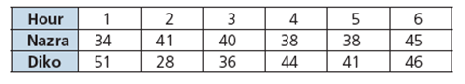
a) Which worker lays more stones during the day?
b) Which worker is more consistent?

Example:
The manager of a customer support line currently has 200 unionized employees. Their contract states that the mean number of calls that an employee should handle per day is 45, with a maximum standard deviation of 6 calls. The manager tracked the number of calls that each employees handles. Does the manager need to hire more employees if the calls continue in this pattern?

