Math 20-2: U5L4 Teacher Notes
The Normal Distribution

I can explain, using examples, the properties of a normal curve, including the mean, median, and mode, standard deviation, symmetry and area under the curve.

I can determine if a data set approximates a normal distribution, and explain the reasoning.

I can compare the properties of two or more normally distributed data sets.

I can problem solve that involves the interpretation of standard deviation.

I can solve problems that involve normal distribution.

Normal Distribution

Look below at the following frequency polygon charts:
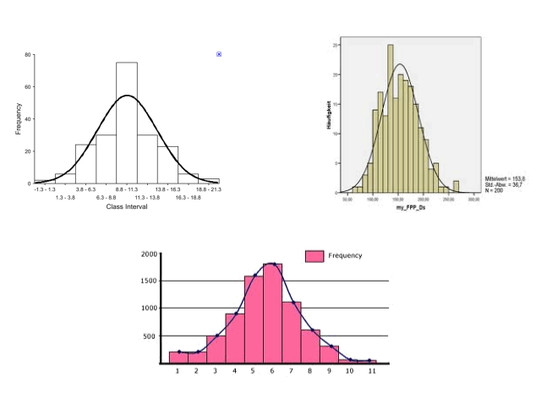

What do you notice about the approximate shape of the graph? What is this called?

Example:
The data set of 15 class marks has been ordered from least to greatest.

2, 4, 5, 6, 6, 6, 7, 7, 7, 7, 8, 8, 8, 8, 8, 8, 9, 9, 9, 10, 10, 11, 11, 11, 12, 12, 13, 13, 15

a. calculate the mean, median, and standard deviation;

b. create a frequency polygon; and

c. explain why the distribution is or is not approximately normal.

Properties of Normal Distribution

Since Normal Distribution is so common, certain properties hold true... You need to know these 6 points.

The 68 - 95 - 99.7% RULE:

Example:
The ages of members of a seniors curling club are normally distributed, with a mean of 63 years and a standard deviation of 4 years. What percent of the curlers is in each of the following age groups?

a) between 55 and 63 years old

b) between 67 and 75 years old

c) older than 75 years old

Example:
Is the data in each set normally distributed? Explain.

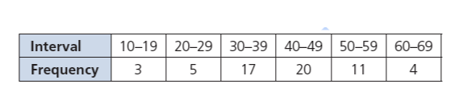

Example:
The results for the first round of the 2009 Masters golf tournament are given below.

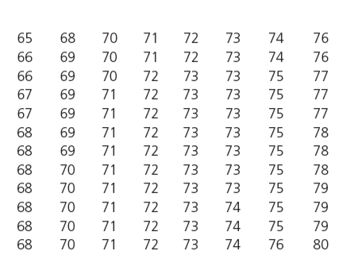

a) Are the golf scores normally distributed?

b) Explain how the measures of central tendency support your decision in part a).

