Math 20-2: U5L5 Teacher Notes
Z-Scores

Key Math Learnings:
By the end of this lesson, you will learn the following concepts:

- I can compare the properties of two or more normally distributed data sets.
- I can explain, using examples that represent multiple perspectives, the application of standard deviation for making decisions in situations such as warranties, insurance or opinion polls.
- I can problem solve that involves the interpretation of standard deviation.
- I can determine the z-score with or without technology and explain the z-score for a given value in a normally distributed data set.
- I can solve problems of normal distribution.

Z-Scores
The standard normal distribution is a normal distribution with mean of ______ and a standard deviation of ______. The area under the curve of a normal distribution is _____.

Z-scores can be used to compare data from different normally distributed sets by converting their distributions to the standard normal distribution.

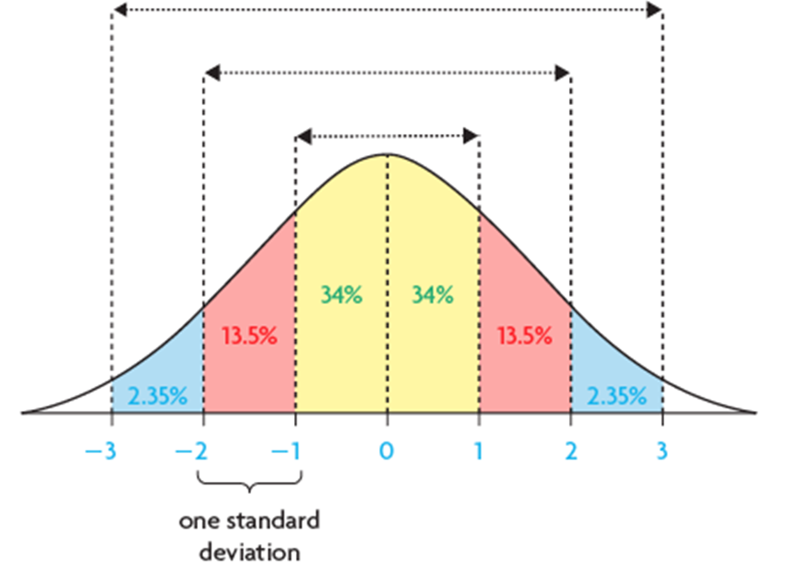
A z-score indicates the number of standard deviations that a data value lies from the mean. It is calculated using this formula:

A positive z-score indicates that:

A negative z-score indicates that:

The area under the standard normal curve, to the left of a particular z-score, can be found in a z-score table or determined using a graphing calculator.

http://www.khanacademy.org/video/ck12-org-normal-distribution-problems--z-score?playlist=Statistics

Example:
What is a z-score, how do you determine it, and what is it used for?

Solution: (summary of what we just went over)

Example:
Calculate the z-score for each value of x.
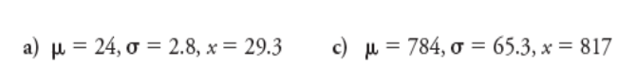
Solution:

Example:
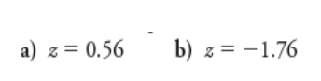

Solution:

a) z = 0.56

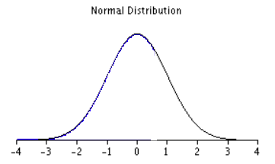

The z-score table on Page 580 - 581, gives you the percentage of the data to the left to the z-score. The z-score is separated at the hundredths place.
Start by looking at the column and finding 0.5 and then go over to the row
and look for 0.06. Find the point of intersection.

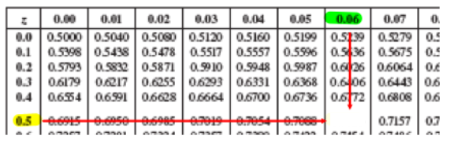

The z-score indicates __________% of the data is to the left of the z-score.

b) z = –1.76
The z-score table on Page 580 - 581, gives you the percentage of the data to the left to the z-score. The z-score is separated at the hundredths place. Start by looking at the column and finding -1.7 and then go over to the row and look for 0.06. Find the point of intersection.

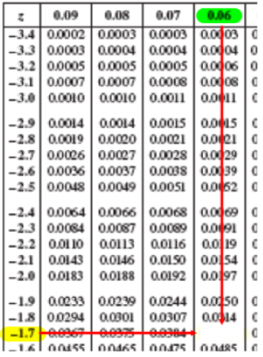

The z-score indicates _________% of the data is to the left of the z-score.

Example:

Determine the percent of the data between the z-scores.
z = 0.24 and z = 2.53
Solution:
1. Shade your region

2. Using the Table on Page 580 - 581 determine the percentages of data
to the left of the z-score.

3. Looking at the, we can see that in order to find the blue shaded region,
we must subtract the two percentages.
Example:
Determine the percent of the data greater than z-score of -0.31.

Solution:

