6.4 Vertex Form of a Quadratic Function

Name: Date:

Vertex Form: y = a(x – h)² + k, where h is the x-coordinate of the vertex and k is the y-coordinate of the vertex.

If the value of a is positive the parabola opens up and if a is negative the parabola opens down.

Ex. 1) Sketch the graph of f(x) = 2(x – 3)² – 4 and state the domain, range and equation of axis of symmetry.

Ex. 2) A parabola has a vertex of (12, 47.5) and a second point on the graph of (10, 85.3). Determine the equation that represents the function.

Ex. 3) A soccer ball is kicked form the ground. After 2 s, the ball reaches its maximum height of 20 m. It lands on the ground at 4 s.
- Determine the quadratic function that models the height of the kick.
- Determine any restrictions that must be placed on the domain and range of the function.
- What was the height of the ball at 1 s? When was the ball at the same height on the way down?

6.4 Vertex Form of a Quadratic Function

Name: Date:

The vertex form of a quadratic function has the form y = a(x – h)² + k. Using the graphs that are pictured below and their related formulas, determine the vertex of each graph, the axis of symmetry, and the way the parabola opens (up or down).

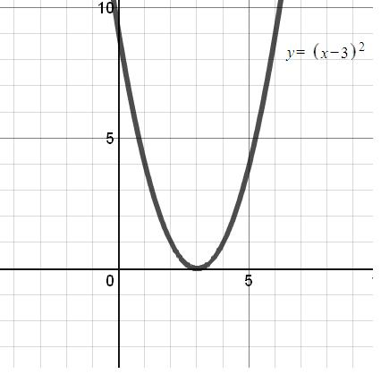 | Looking at the graph…  Vertex:  Axis of Symmetry:  Opens Up or Down?  Looking at the equation…  Value of a:  Value of h:  Value of k:
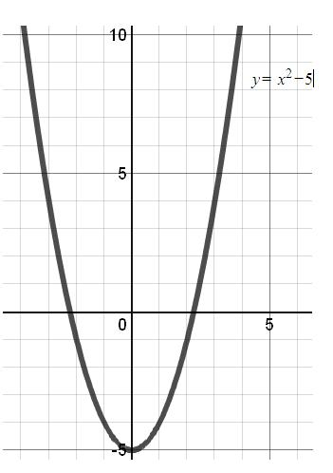 | Looking at the graph…  Vertex:  Axis of Symmetry:  Opens Up or Down?  Looking at the equation…  Value of a:  Value of h:  Value of k:
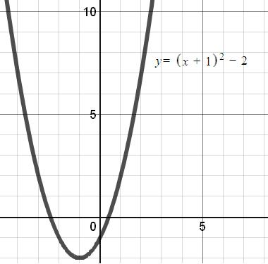 | Looking at the graph…  Vertex:  Axis of Symmetry:  Opens Up or Down?  Looking at the equation…  Value of a:  Value of h:  Value of k:
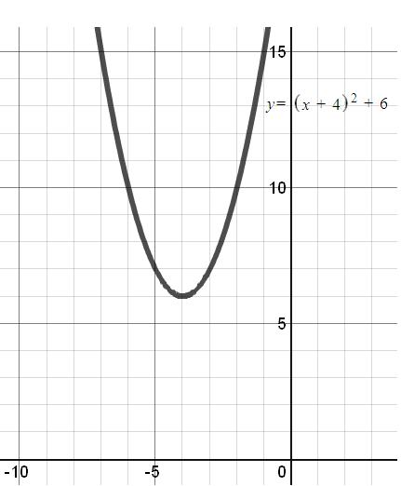 | Looking at the graph…  Vertex:  Axis of Symmetry:  Opens Up or Down?  Looking at the equation…  Value of a:  Value of h:  Value of k:
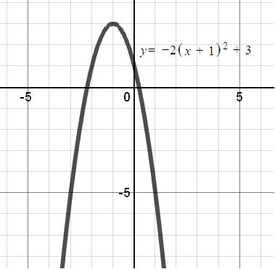 | Looking at the graph…  Vertex:  Axis of Symmetry:  Opens Up or Down?  Looking at the equation…  Value of a:  Value of h:  Value of k:
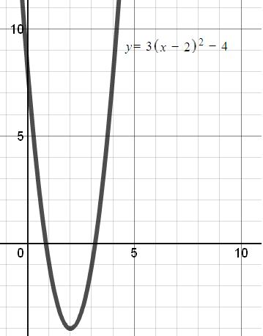 | Looking at the graph…  Vertex:  Axis of Symmetry:  Opens Up or Down?  Looking at the equation…  Value of a:  Value of h:  Value of k:

Look for relationships between the vertex form of the equation and the graph itself.
Describe any relationships that you see between the value of h and the vertex.

Describe any relationships that you see between the value of k and the vertex.

Describe any relationships that you see between the value of a and the direction the parabola opens up.

