Math 20-2: U7L1 Notes
Solving Quadratic Equations by Graphing

Key Math Learnings:
By the end of this lesson, you will learn the following concepts:

Determine with technology the x-intercepts of the quadratic function

Explain the relationship among the roots of an equation, the zeroes the corresponding function and the x-intercepts of the graph of the function.

Explain, using examples, why the graph of a quadratic function may have zero, one or two x-intercepts.

Solve problems by modelling a situation with a quadratic equation and solving the equation.

* * * *

What is a Quadratic Equation?

The roots of a quadratic equation are?

What do the words Solutions, Zeroes, and Roots have in common?

Using a Graphing Calculator to Solve Quadratic Equations
Method 1: Solving for the X-intercepts (Zeroes)

Using technology might be helpful to solve quadratic equations since it gives you the visual of the graph quite quickly.

Step 1: Manipulate the equation to be in standard form.
Step 2: Enter the equation into Y1.
Step 3: Adjust the window settings until you see the vertex of the parabola and the x-intercepts.
Step 4:Use the ZERO command to find the roots -- 2nd TRACE (CALC), #2 zero
Step 5: Left bound? Move the spider as close to the root (where the graph crosses the x-axis) as possible. Hit the left arrow to move to the "left" of the root. Hit ENTER. A "marker" _ will be set to the left of the root.
Step 6: Right bound? Move the spider as close to the root (where the graph crosses the x-axis) as possible. Hit the right arrow to move to the "right" of the root. Hit ENTER. A "marker" _ will be set to the right of the root.
Step 7: Guess? Just hit ENTER
Step 8: Repeat the entire process to find the second root

Using a Graphing Calculator to Solve Quadratic Equations
Method 2 -- Solving for the Points of Intersection

When the quadratic is not in standard form you can use a different method for solving the equation. Summarize the steps below:

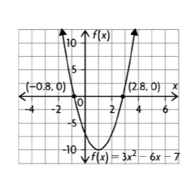
Example
Solve the equation by graphing the corresponding function and determining the zeros.

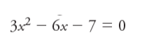

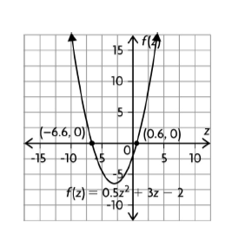

Example
Solve the equation by graphing the corresponding function and determining the zeros.
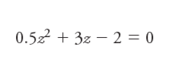

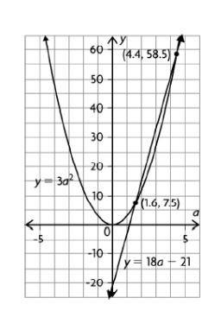

Example

Solve the equation by graphing the corresponding function and determining the zeros.
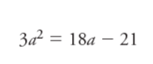

Example
A ball is thrown into the air from a bridge that is 14 m above a river. The function that models the height, h(t), in metres, of the ball over time, t, in seconds is
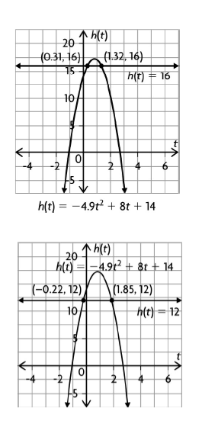
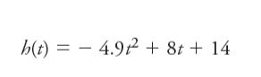
a) When is the ball 16 m above the water?
b) When is the ball 12 m above the water? Explain.
c) Is the ball ever 18 m above the water? Explain how you know.
d) When does the ball hit the water?

Example
Solve the equation by graphing the corresponding function and determining the zeros.

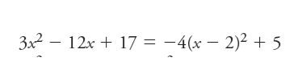

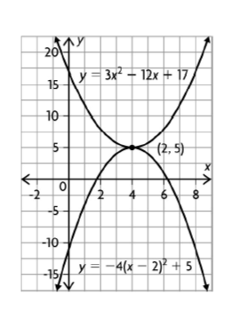

SUMMARY
• A quadratic equation is

• If a quadratic equation is in standard form
– you can:

• If the quadratic function is not in standard form

– you can graph the expression on the:

– the x-coordinates of the

• For any quadratic equation, there can be:

