Math 20-2: U7L2 Notes
Solving Quadratic Equations by Factoring

Key Math Learnings:
By the end of this lesson, you will learn the following concepts:

Determine, by factoring, the roots of a quadratic equation, and verify by substitution.

Express a quadratic equation in factored form, given the zeros of the corresponding quadratic function or the x-intercepts of the graph of the function.

Solve problems by modelling a situation with a quadratic equation and solving the equation.

* * * *

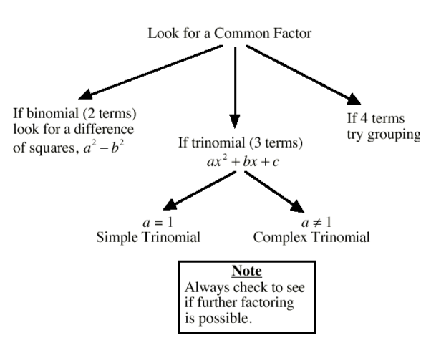

ALWAYS!! FIRST - Factor out the common factors (GCF) if possible.

Trinomials - Method 2
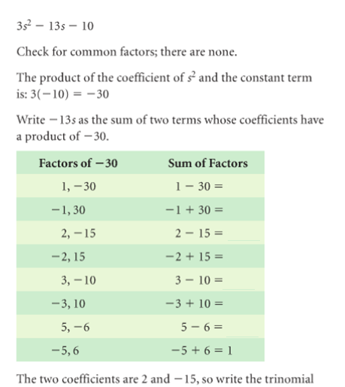

Binomials
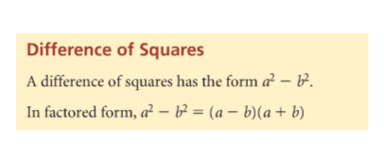
Example:

Solving Quadratic Equations

To solve a quadratic equation by factoring:

Step 1:

Step 2:

Step 3:

Example:

Example: Solve by factoring. Verify each solution.

Note: the factor ‘a’ is equal to ____
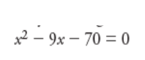

Example: Solve by factoring. Verify each solution.
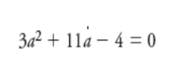

Example: Solve by factoring. Verify each solution.
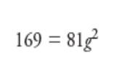

Example: Identify and correct any errors in the following solution:

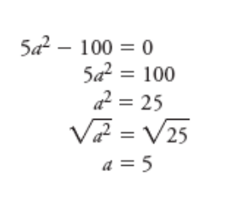

Example:

Samuel is hiking along the top of First Canyon on the South Nahanni River in the Northwest Territories. When he knocks a rock over the edge, it falls into the river, 1260 m below. The height of the rock, h(t), at t seconds, can be modelled by the following function:
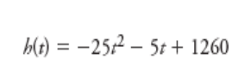

a) How long will it take the rock to reach the water?

b) What is the domain of the function? Explain your answer.

SUMMARY

• To factor an equation, start by writing the equation in standard form.

• You can set each factor equal to zero and solve the resulting linear equations. Each solution is a solution to the original equation.

• If the two roots of a quadratic equation are equal, then the quadratic equation is said to have one solution.

