Math 20-2: U8L1 Teacher Notes
Comparing and Interpreting Rates

Key Math Learnings:
By the end of this lesson, you will learn the following concepts:

- Interpret rates in a given context, such as the arts, commerce, the
environment, medicine or recreation.
- Determine and compare rates and unit rates.
- Make and justify a decision, using rates.
- Represent a given rate pictorially.
- Draw a graph to represent a rate.
- Explain, using examples, the relationship between the slope of a graph
and a rate.
- Describe a context for a given rate or unit rate.
- Identify and explain factors that influence a rate in a given context.
- Solve a contextual problem that involves rates or unit rates.

RATES

A rate is a ratio that:

A unit rate compares:

http://www.khanacademy.org/video/finding-unit-rates?playlist=Developmental+Math

Comparing Rates

Rates can be represented in a variety of ways. The representation you
choose should depend on your purpose. You can compare rates by
writing them as

Slope and Rates
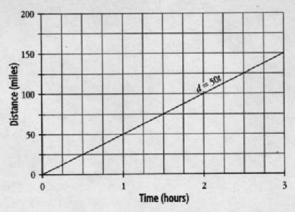
• In a graph that shows the relationship between two quantities, the
slope of a line segment represents the average rate of change for
these quantities.

• The slope of a line segment that represents a rate of change is a
unit rate.

Example
Compare the two rates and determine the lower rate.
whole chickens: $3.61/kg or 10 lb for $17.40

Example
Compare the two rates and determine the lower rate.
driving speeds: 30 m/s or 100 km/h

Example
Shelley has two choices for a long-distance telephone plan:
• her telephone company, which charges 4¢/min
• a device that plugs into her Internet modem, which costs $19.95

with an additional charge of 1.5¢/min Shelley makes, on average, 50 min of long-
distance calls per month. Which option would be cheaper on an annual basis? Justify
your decision.

Example
A hotel shuttle bus takes David from the airport to his hotel. Use the distance versus time graph to the right to create a story that describes David’s bus trip.

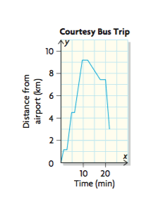

Example
The following table shows the a mount of greenhouse gases emitted by fossil fuel
production in Canada from 1990 to 2006. During which period was the amount
emitted increasing at the greatest rate? Justify your decision.

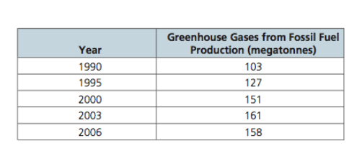

Page 450 # 2, 3, 4, 6, 7, 8, 10, 13

