Math 20-2: U8L2 Teacher Notes
Solving Problems that Involve Rates

Key Math Learnings:
By the end of this lesson, you will learn the following concepts:
- Interpret rates in a given context, such as the arts, commerce, the
environment, medicine or recreation.
- Solve a rate problem that requires the isolation of a variable.
- Determine and compare rates and unit rates.
- Make and justify a decision, using rates.
- Describe a context for a given rate or unit rate.
- Identify and explain factors that influence a rate in a given context.
- Solve a contextual problem that involves rates or unit rates.

Strategies For Solving Rate Problems

When you are given a rate problem that involves an unknown, you can solve the
problem using a variety of strategies.

1. Pair of equivalent ratios

To be equivalent ratios, the units in the numerators of the two ratios:

2. A Multiplication Strategy

Problems that require conversions between units:

3. Write a Linear function

When a Rate of Change is Constant:

Example
Mario borrowed $1000 and paid $40 simple interest. If he borrowed the money for
eight months, what interest rate was he charged?

Example

Describe a situation in which each rate might be used. Identify any factors that could influence the rate in this situation. -1.5 °C/km

Example

Describe a situation in which each rate might be used. Identify any factors that could influence the rate in this situation. $4.99 /ft²

Example

Melanie wants to defrost a frozen roast, which weighs 2.68 kg, in her
microwave. To find out how much time she needs, she looks in a
cookbook. She reads that 2 lb of meat takes 15 min to defrost. How
long, to the nearest minute, should she set the timer for?

Example
Manpret has taken a job as a nurse in the community health centre in Tuktoyaktuk,
Northwest Territories. She plans to ship her car, furniture, and personal effects to
Tuktoyaktuk by barge from Vancouver. She has found these shipping rates online:

• light-duty vehicles: $0.2015/lb
• furniture and personal effects: $0.2734/lb

Manpret knows that her car has a mass of 1250 kg. She estimates that she has roughly
550 lb of furniture and personal effects. Calculate her cost to ship these items to her
destination.

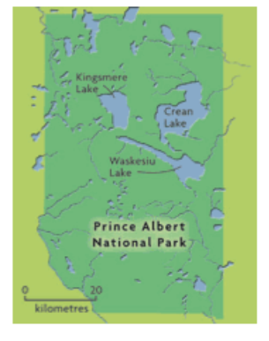
Example
The map to the right shows Prince
Albert National Park in
Saskatchewan. The scale of the map
is 1.3 cm to 20 km.

a) Estimate the area of the park in
hectares. One hectare (1 ha) is
equivalent to 10 000 m².

b) The annual cost to monitor and
fight forest fires in this region is about
$48/ha. Estimate the annual fire
management expenditure for the
park.

