Math 20-2: U8L3 Notes
Scale Diagrams of 2-Dimensional Objects

Key Math Learnings:
By the end of this lesson, you will learn the following concepts:
- Explain, using examples, how scale diagrams are used to model
a 2-D shape
- Determine, using proportional reasoning, the scale factor, given
one dimension of a 2-D shape
- Determine, using proportional reasoning, an unknown dimension
of a 2-D shape given a scale diagram or a model.
- Draw, with or without technology, a scale diagram of a given 2-D
shape, according to a specified scale factor (enlargement or
reduction).
- Solve a contextual problem that involves a scale diagram.

Scale Diagrams

Scale diagrams can be:

To create a scale diagram, you must determine an appropriate
scale to use. This is called the ______________ ______________.

The scale factor represents the ratio of:

http://www.youtube.com/watch?v=Q7AWGlLePuw
http://www.youtube.com/watch?v=XtkU4VkWh8I

Determining Scale Factor

An easy way to determine the scale factor, k, used in a scale diagram, we use the following guideline.

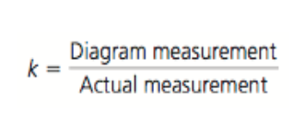

D.O.A. Diagram over Actual

How Does Scale Factor Affect the Original Shape

When a scale factor is between 0 and 1

When a scale factor is greater than 1

http://www.youtube.com/watch?v=ciIcmysb67A

Example

The Garry oak is a tree that is found on Vancouver Island. The original acorn
for these scale diagrams was 1.9 cm long. Determine the scale factor that was
used for each diagram. (You will need to measure the acorn in the textbook on
page to get the correct answer)
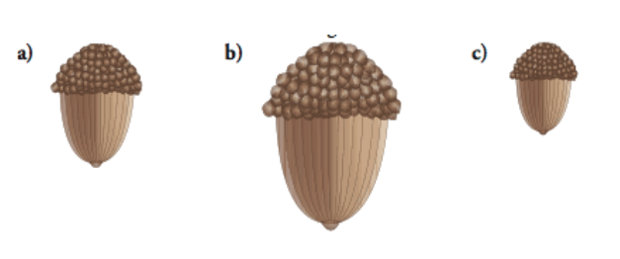

Example
This top view of a hex-nut must be enlarged by a
scale factor of 250% for a display at a trade
show.

a) Measure the necessary distances on the
diagram.

b) Determine what the corresponding distances
on the enlarged diagram should be.

c) Draw the scale diagram of the hex-nut.

Example
A billboard measures 4.5 m by 3.5 m. Draw a scale diagram of the
billboard that fits in a space measuring 20 cm by 15 cm.

