Math 20-2: U8L4 Teacher Notes
Scale Factors and Areas in 2-D Shapes

Key Math Learnings:
By the end of this lesson, you will learn the following concepts:

- Explain, using examples, how scale diagrams are used to model a 2-D shape
- Determine, using proportional reasoning, the scale factor, given one dimension of a 2-D shape
- Determine, using proportional reasoning, an unknown dimension of a 2-D shape, given a scale diagram or a model.
- Draw, with or without technology, a scale diagram of a given 2-D shape, according to a specified scale factor (enlargement or reduction).
- Solve a contextual problem that involves a scale diagram.
- Determine the area of a 2-D shape, given the scale diagram, and justify the reasonableness of the result.
- Explain, using examples, the effect of a change in the scale factor on the area of a 2-D shape.
- Explain, using examples, the relationships among scale factor, area of a 2-D shape and surface area of a 3-D object
- Solve a spatial problem that requires the manipulation of formulas.
- Solve a contextual problem that involves the relationships among scale factors and areas

Review of Area of 2-Dimensional Shapes

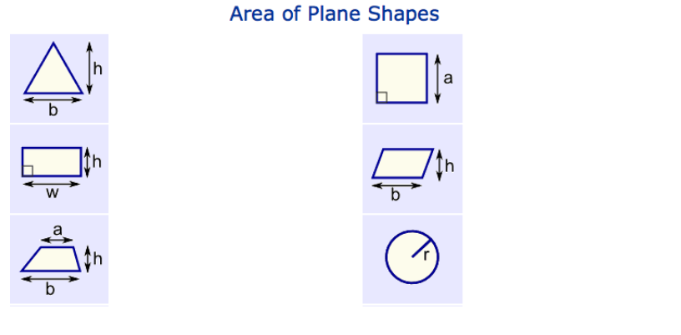

Area Scale Factor (ASF)

In Lesson 3 we learned that the linear scale factor (LSF) = k

‘k’ is the number that is ______________________________________ of the polygon to determine the reduction or enlargement of the shape. Let's investigate what will happen to the area if we enlarge or reduce a shape by a factor of k.

INVESTIGATE
Part A: Consider the two similar rectangles below.

The scale factor is 2 since the larger rectangle is 2 times as long and 2 times as tall. That is, the lengths are in a 1:2 ratio. Yet the area of the larger rectangle is:___________________________________

1. Calculate the area of both rectangles.
2. Divide the larger area by the smaller area.
3. What is the ratio of the areas?

Part B:
Consider these two similar rectangles below.

1. What is the linear scale factor?
2. What is the area of the blue rectangle? The red?
3. What is the area of the red divided by the area of the blue?
(That is, what is the ratio of the areas in fraction form?)
4. What do you notice about the linear scale factor and the area
scale factor?
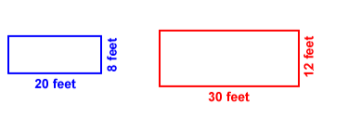

Part C: Look at these two triangles.

1. Explain why these two triangles are
similar.
2. What is the scale factor?
3. What is the area of the blue triangle?
The red?
4. What is the ratio of their areas in
decimal form? (Divide the larger by the
smaller.)
5. What do you notice about the linear scale
factor and the area scale factor?

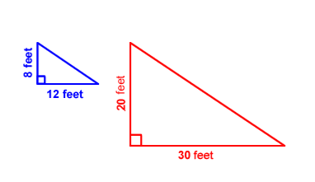
From the Investigation we can conclude that if two 2-D shapes are similar and their dimensions are related by a scale factor k, then the relationship between the ___________ of the similar shape and the ____________ of the original shape can be expressed as:

By manipulating the formula above, the area of a similar 2-D shape and the area of the original shape are known, then the scale factor, k, can be determined using the formula

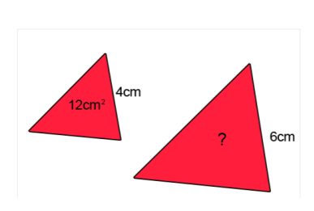
Example
Area scale factor can apply to any shape provided you have at least there of the quantities (areas or lengths) For example here are two triangles;

Solution:
To find the area of the large triangle, you will need to first find the linear/length scale
factor as the

Step 1. In general to find the scale factor we divide the large quantity with the small quantity.

Then Step 2 we would find the Area scale factor (ASF) by squaring the linear scale
factor (LSF);

Step 3 we would multiple the area scale factor with the small area to find the area for
the large triangle.

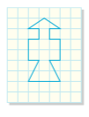
Example
Determine the area of each figure after it is enlarged by a scale factor of 2.

Solution:

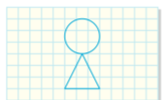
Example
Determine the area of each figure, to the nearest
tenth of a square unit, after it is reduced by a
scale factor of 1/3.

Solution:

Example
A rectangular display, with the dimensions 2 m by 3 m, is located in the lobby of city
hall to show the citizens the layout for the new People’s Park. The display was created
using a scale ratio of 1:120.

a) The parks department estimates that the city spends $0.75/m² to maintain a park from spring through fall. Estimate the cost to maintain People’s Park.

b) A rectangular model, with the same dimensions, was used to represent Meadow
Park. The scale ratio used was 1 : 250. Estimate the cost to maintain Meadow Park.

Example
Determine the scale factor that relates each pair of similar shapes.
